Thank you to ABMU staff for foodbank donations
Wednesday, 23 August 2017
Nearly 5,000 meals have been provided for children in Swansea over the past two weeks, with many of the ingredients supplied by kind hearted staff at ABMU hospitals who answered an appeal for urgent foodbank donations.
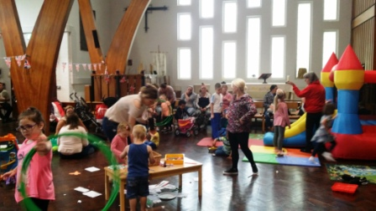
A thank-you event took place at the lunch club in St Teilo's Church, Portmead, Swansea, for organisations and individuals across the city who donated to the appeal, or helped to make the school holiday meals for so many children living in the less affluent areas of the city. Pasta, baked beans, spaghetti etc had been sorted when they arrived at the foodbanks and diverted to go for hot meals at the lunch clubs. Carolyn Harris, MP for Swansea East, who launched the appeal, said the response had been amazing and thanked ABMU staff for their donations. Other organisations who donated included South Wales Police, local supermarkets, local businesses, and Scouting groups (not a complete list).

Staff at Singleton, Morriston, Cefn Coed and Neath Port Talbot hospitals donated so much that not all of it could be collected from sites straight away because there was not enough storage space at the Swansea foodbanks. The Princess of Wales Hospital donations were delivered to Bridgend foodbanks.

Some of the ABMU donations were diverted to the Neath Port Talbot Council for Voluntary Services, who were also appealing for foodbank donations.
The Swans Community Trust, who provided transport, also delivered some hospital donations to a range of other foodbanks across the city, not just the ones directly involved in the appeal. The foodbank collection is now likely to be repeated by the health board next year.

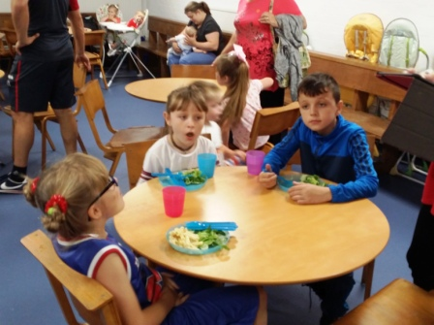 | 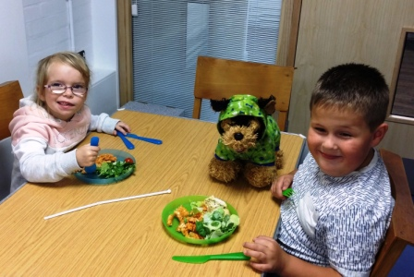
Children enjoying their pasta meals at the St Teilo's lunch club.
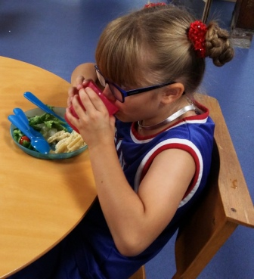 | 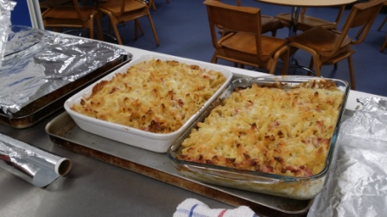

Source: Abertawe Bro Morgannwg University Health Board

