Hari and health hero John at the launch of 2018 national awards
Tuesday, 14 August 2018
Health hero John Clifford has been there for every milestone in nine-year-old Hari Kieft’s life.

The paediatric physiotherapy technical instructor helped Hari take his first steps and he is now helping him to ride his bike without stabilisers.

This support and dedication to his role has meant the world to Hari and his family, from Neath.

And it was one of the reasons why John was crowned the Clinical Support Worker of the Year 2017 in the national Our Health Heroes Awards.
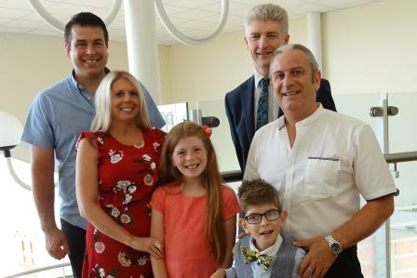
In fact, he so impressed the organisers that they chose Neath Port Talbot Hospital, where John works, to launch the 2018 awards.

Hari Kieft with sister Olivia and parents Richard and Cerianne, along with Skills for Health Chief Executive John Rogers and John Clifford (far right)

Now John, Hari and the Kieft family are among those urging others to nominate the next batch of health heroes.

The awards are run by not-for-profit workforce development body Skills for Health.

They showcase the work done by the huge numbers of healthcare workers who are not doctors and nurses but whose work is still vital to patients.

Nominations have now opened for the 2018 awards, with the winners being crowned in November at the OXO Tower in London in November.

John, from Neath, remembered being “shell-shocked” to hear his name called out as the winner of his category last year.

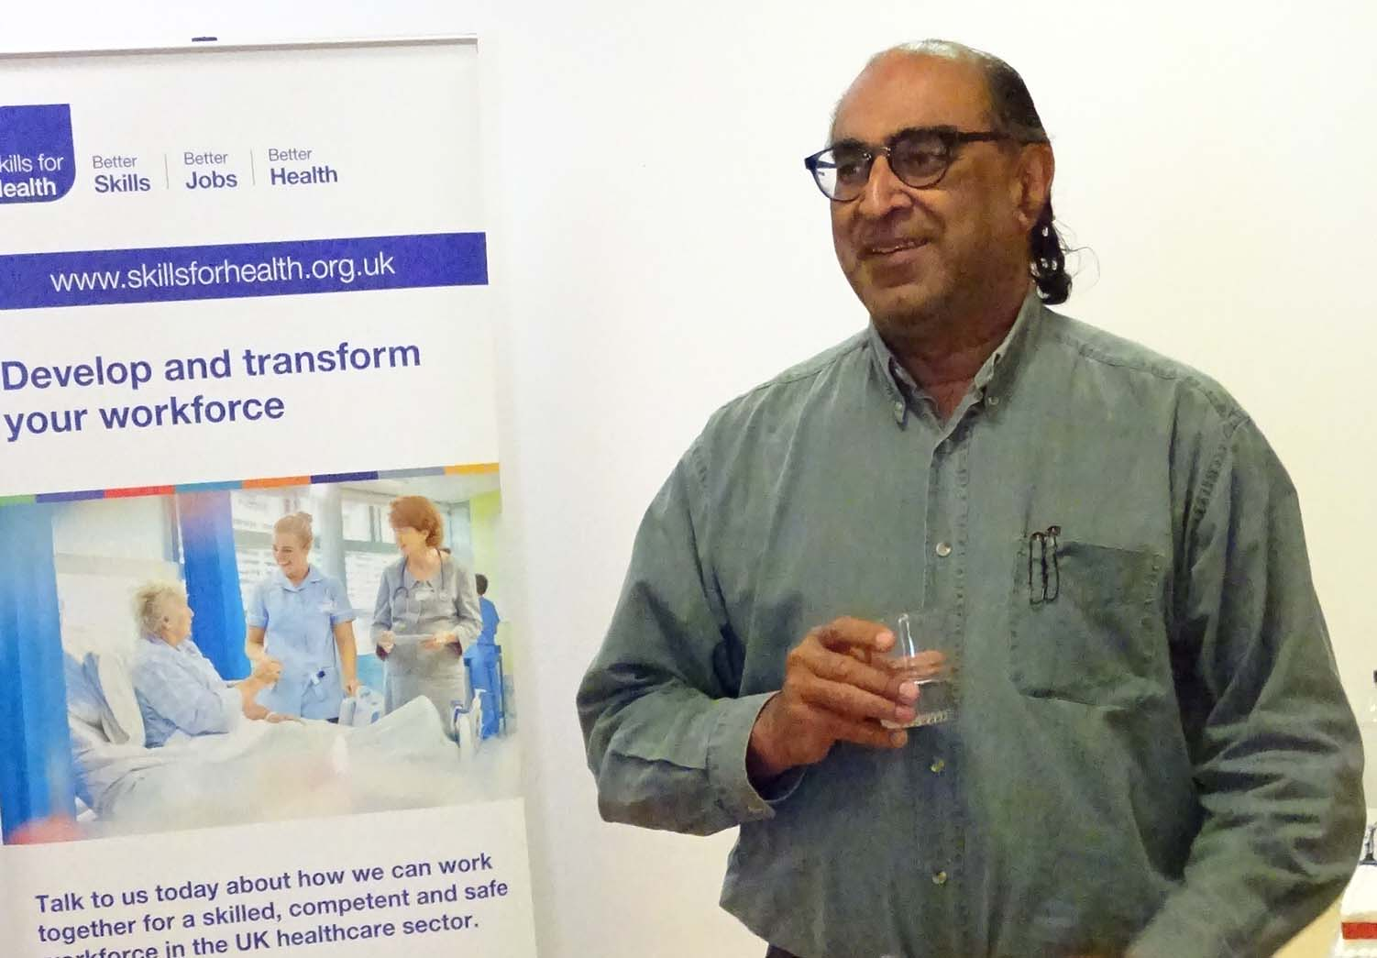
The ex-miner, who retrained in child development and later physiotherapy after the mines closed, said: “I think working in the NHS is not like a normal 9 to 5 job. It becomes like a vocation.
“I felt so proud to even be nominated and even prouder to be the UK winner.”
Professor Pushpinder Mangat
It is the third year Skills for Health has run the awards, with chief executive John Rogers explaining that nominations have rocketed each year.
Addressing the awards launch, Professor Pushpinder Mangat, ABMU Interim Medical Director, said his ethos was that every employee was part of a team.

“Every person is a valued member. We are all heroes who need to keep learning and keep improving because our patients need us.”

Glyn Jones, Regional Organiser for awards sponsor UNISON, said: “One of our key campaigns is our One Team campaign to make sure that everyone who works in the health service is valued whether they work directly with patients or not.”

Mr Jones likened many staff to the camera operators, property people and wardrobe technicians on major movies, saying they were “unseen but absolutely vital”.

Hari was one of the guests at the launch, along with parents Richard and Cerianne Kieft, and his 10-year-old sister Olivia.

Cerianne said John had not only been supportive of Hari, who has had diplaegic cerebral palsy since he was 18 months old, but supports the whole family, even getting Olivia involved with his therapy.

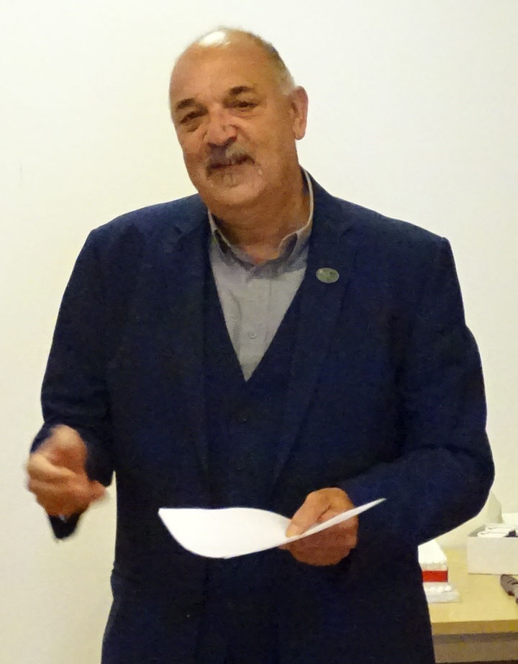
Glyn Jones

She said: “Due to the cerebral palsy Hari will have physio throughout his life, so it’s important that those relationships are built.

“Hari also had major spinal surgery at two and a half so John rehabilitated him then.

“Hari also has heart difficulties and vision difficulties – he’s under a lot of hospitals but Neath Port Talbot is his favourite.

“He has helped Hari take his first steps. Hari jumped for the first time on the trampoline with John and the next thing is to ride his bike completely without stabilisers.

“John has also helped him with the skills needed for sports day in school.

“We want the best for our children and John is the best.”

Source: Abertawe Bro Morgannwg University Health Board

