New qualification boosts occupational therapy support
Wednesday, 1 August 2018
Patients will get even better support on the road to recovery thanks to a new qualification.

Twenty five occupational therapy technicians working across ABM University Health Board have achieved the Agored Cymru level three diploma in occupational therapy support, which has enhanced their skills.

At a ceremony in Neath Port Talbot Hospital, where former Wales rugby star Rupert Moon presented the learners with certificates, staff spoke of the value of undertaking the qualification.
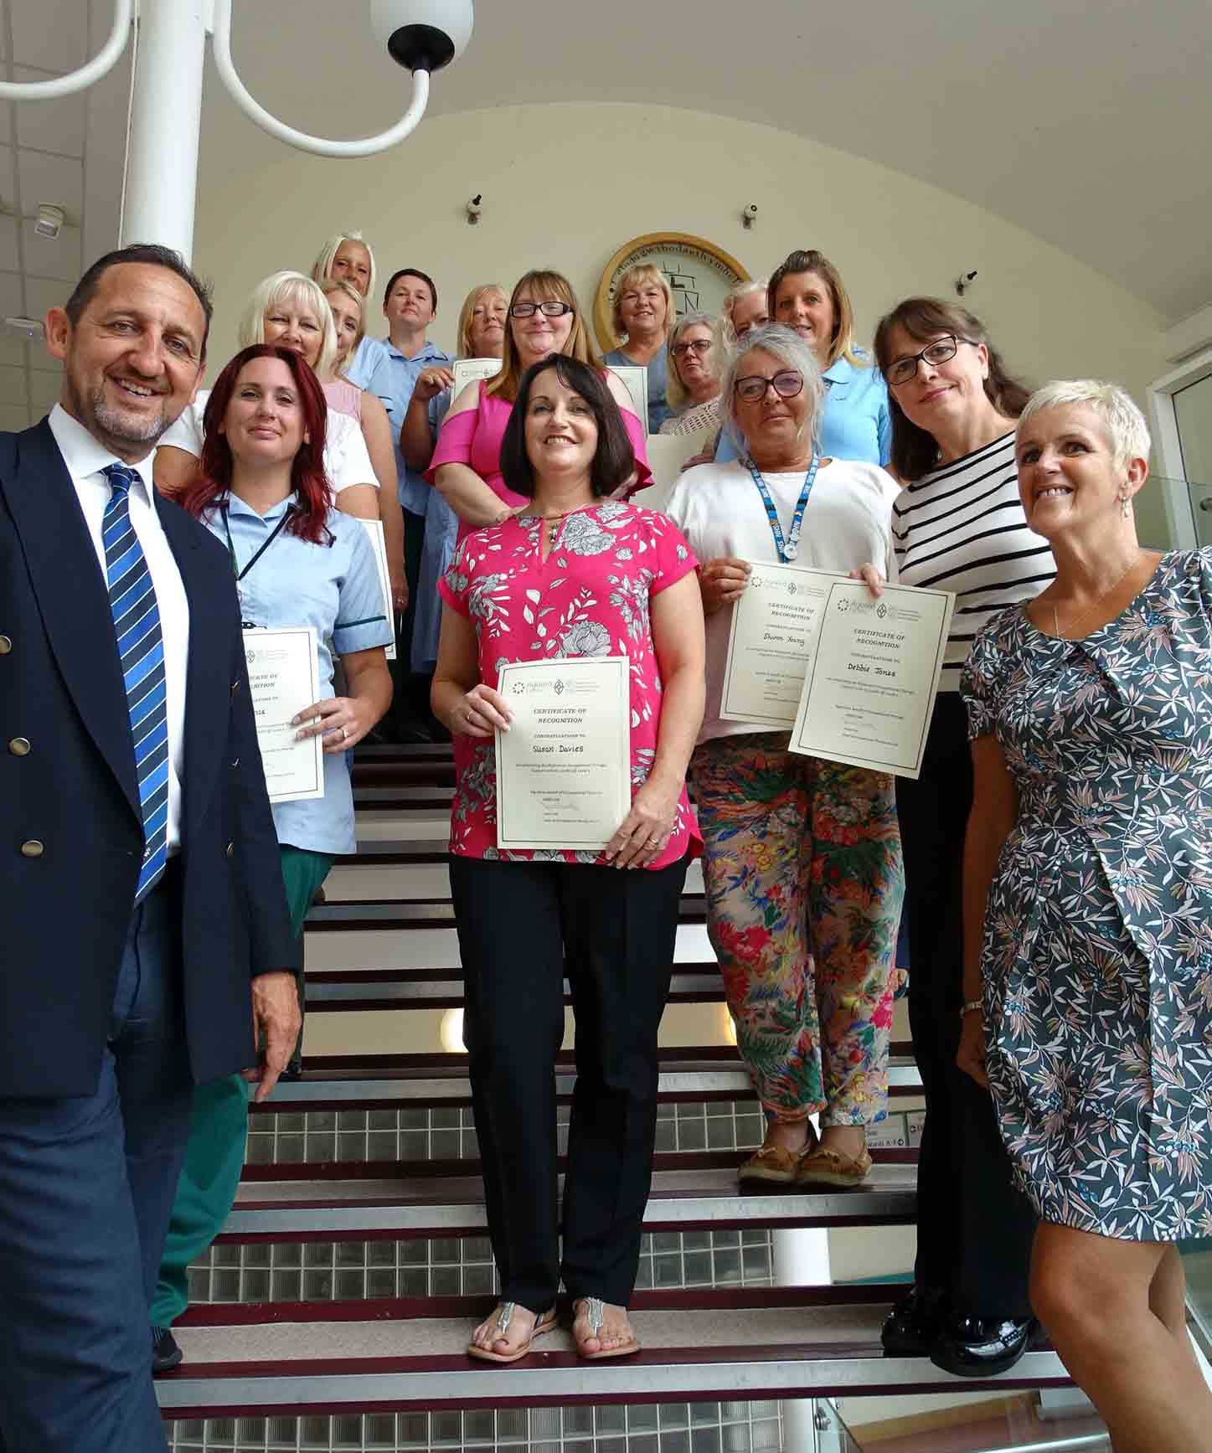
Jenna Evans, who is based at Singleton Hospital in Swansea, said achieving the qualification has helped her to better herself and given her the opportunity to progress with her career.

Neath Port Talbot Hospital-based Alison Claire Williams admitted they had all faced challenges in completing the study on top of busy jobs and family commitments.

But she felt the diploma has enabled her to “think outside the box” and “to appreciate the value of occupational therapy in enabling patients to get back to doing activities that are important to them”.

Above: Rupert Moon, is pictured with (l-r) Sian Price, Sue Davies, Sharon Young, Debbie Jones, Bernie Etherington. (Middle row) Jackie Jones, Claire Wright, Tracey Harvey, Angela Medwell-Cole, Claire Harries. (Back row) Jenna Evans, Heidi Barnett, Alison Claire Williams, Sheridan Lewis and Pat Bennett

Students also came from the Princess of Wales Hospital in Bridgend, Morriston Hospital’s emergency department, community services in Neath Port Talbot and Bridgend and mental health services.

Debbie Owen, deputy head of occupational therapy, told the audience in the lecture theatre the qualification had allowed staff to develop their knowledge and skills, which added further meaning to their roles and helped them plan a fulfilling career.

The next cohort of staff will complete the diploma at the end of September and all new staff to the service are able to commence work on the qualification.

Debbie also recognised the work that assessors have provided supporting the learners’ work.

A presentation was also made by Jane Martin, a recently-retired occupational therapist from the mental health and learning disabilities service. She charted the development of the occupational therapy service and the training offered to support staff.

The main presentation was given by Rupert. Using a personal account of his life journey, from childhood to representing Wales, he recognised the importance of lifelong learning.

He also praised occupational therapy staff for the dedication and commitment they provide during every working day.

The event was closed by Janet Ivey, head of occupational therapy services. She thanked the learners and assessors for all of their hard work, adding that they would be an “inspiration” to others in the service.

Learners who could not attend the ceremony but have achieved the qualification were Natalia Kudla, Debbie Perkins, Karen Bevan, Margaret Taylor, Louise Taplin, Jo Poupon, Lisa Evans, Claire O’Kelly and Diann Richards.

Source: Abertawe Bro Morgannwg University Health Board

