Patient request leads to 'Meet the Matron' sessions
Thursday, 30 August 2018
A patient’s request for the return of matron has led to a new initiative aimed at reassuring patients and their families.

ABMU’s lead nurse for community hospitals Sarah Taylor, pictured below, sprung into action after reading the comment on a feedback form.

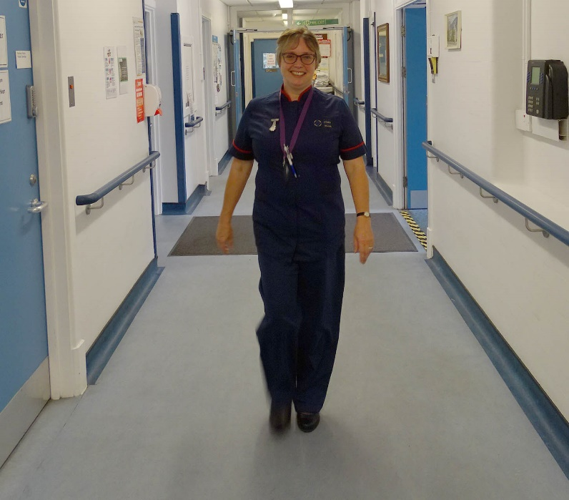
“It said, ‘Please bring back matron!’. That was all they had written,” she said.

“I thought, ‘I haven’t gone anywhere, I’m still here. But I’m obviously not visible enough.”

As the lead nurse for Gorseinon Hospital in Swansea and Maesteg Hospital in Bridgend county, Sarah’s position is that of matron although her official title is lead nurse, which has led to some confusion.

“They don’t equate that with matron,” she added.

As a result she has established regular, two-hour Meet the Matron sessions at both hospitals.

During that time patients and their families can meet Sarah in person and without an appointment to discuss or request anything.

“It’s going back to the old philosophy of ‘matron will sort it out’,” she said.

“In fact I’m not doing anything that wouldn’t be done anyway, but I can provide reassurance and double check that it has been done.”

One of the first people to benefit from the informal meetings is 87-year-old patient John Courtney from Loughor, pictured below with Sarah.

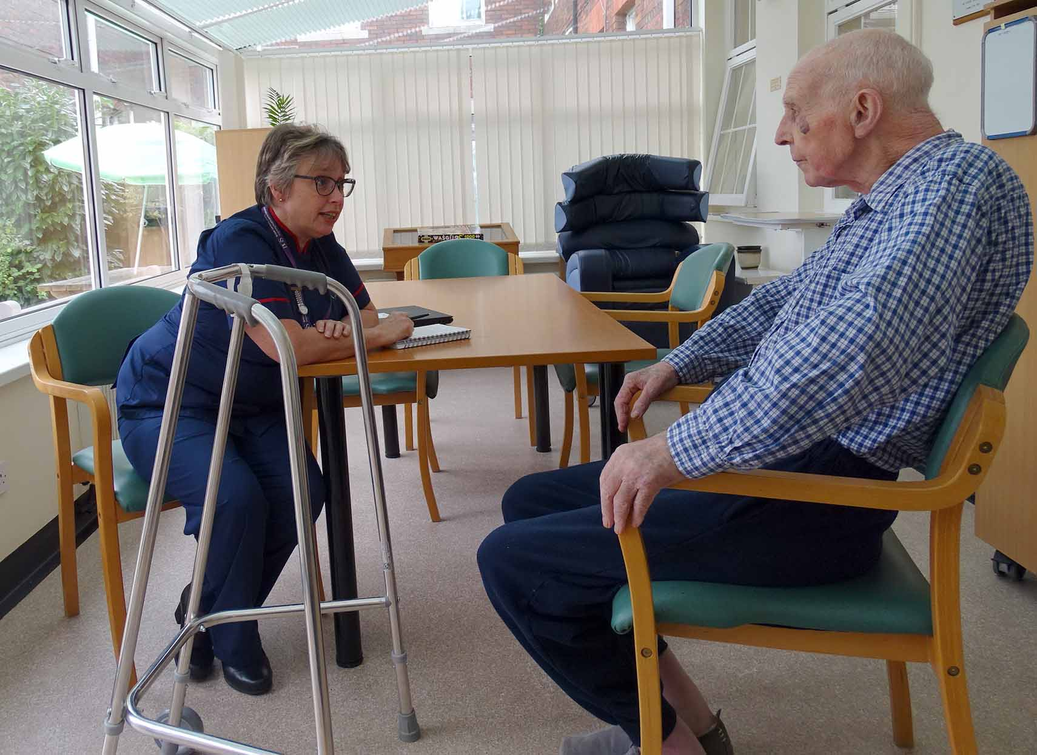
As an inpatient at Gorseinon Hospital following kidney stones he was concerned he would miss out on a regular injection for an unrelated prostate issue, which would normally have been administered in his home by a district nurse.

Sarah, who conducts the drop-in sessions in the day room, was able to reassure John that she would check it had been entered into his notes.

“He said he’d spoken to the nurses so it would already be on his chart, but he’s reassured because he feels he’s now spoken to matron and matron will get it done.”

Other queries dealt with by Sarah during the first two drop-in sessions at Gorseinon have included queries regarding patients about to leave hospital, concerns about medication changes and even a request to have the roof of a veranda, which patients sit under outside the wards, cleaned.

“In the first session one family came forward because they wanted to say how good all the staff had been,” added Sarah.

“I’m just making myself available. This requires time but it could also save a lot of time if I can handle potential issues and nip them in the bud.”

Unit Nurse Director Primary and Community Services Jason Crowl said: “We recognise and understand that when in hospital, any patient and their family can feel overwhelmed at times.

“Listening and responding to patient feedback on what matters to them and how we can work together is really important.

“We are confident this initiative will help improve patient experience and provide support towards helping patients in their recovery.”

- Meet the Matron sessions will take place in Gorseinon and Maesteg hospitals. Notices confirming the day and time will be placed around the hospitals and on the wards in advance of the sessions. Everyone is welcome.
Source: Abertawe Bro Morgannwg University Health Board

