Safe sex and screening urged after fivefold rise in syphilis cases
Friday, 24 August 2018
Sexual health chiefs are urging people to play safe after a fivefold rise in diagnosed cases of syphilis across South West Wales.

The proliferation of online dating sites and apps is believed to be one of the main reasons for the increase.

There have been 56 confirmed cases across Swansea, Neath Port Talbot and Bridgend since April this year – 16 of them in the last two weeks alone.
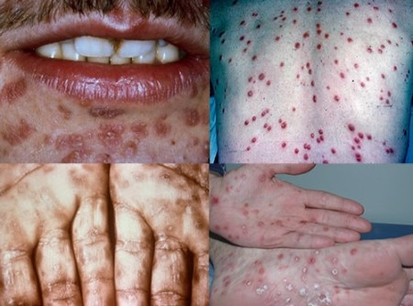
This compares to April-September last year when there were 11 cases, and just eight during the same period of 2016.

Right: some of the symptoms of syphilis

Although most of the patients diagnosed were men, several women have also tested positive.

Anyone who has had unprotected sex recently is being advised to attend one of ABMU’s sexual health clinics for screening.

Sexual health lead nurse Joanne Hearne said: “There has been an increase in syphilis generally across Wales.

“But we have seen a significant rise across the health board area, particularly over the last six weeks.

“It is possible that the heatwave earlier in the summer led to people becoming more sexually active.

“We also believe social media and the growth of dating websites and apps is another contributory factor.”

Sexual health sister Carly Porter added: “We have found that some diagnosed patients find it a lot more difficult to contact previous sexual partners as they have met them through a dating app. In some cases, they may have then deleted their profile.

“As a result, many people may be unaware they have the infection.”

Symptoms of syphilis can include small painless sores or ulcers, blotchy red rashes, small skin growths or white patches in the mouth. It may also cause tiredness, headaches, joint pains and swollen glands.

However, some people may experience no symptoms at all – making it all the more important for them to be screened.

This takes just a few minutes, and includes a blood test and sample of fluid taken from any sores using a swab.

If tested positive, syphilis is very easy to treat with a penicillin injection or a two week course of antibiotics. However, if left untreated, it can spread to the brain or other parts of the body, causing serious, long-term problems.

Carly said: “We cannot emphasise enough how important it is to practise safer sex with the use of condoms to prevent infection.

“If anyone is feeling uneasy following unprotected sex we would advise them to attend a screening at their local sexual health clinic, so we can treat them quickly and simply.”

ABMU provides a free, confidential and friendly sexual health service at a range of locations across the health board area.

For further advice or to make an appointment please call the freephone telephone number 0300 5550279 or visit http://www.wales.nhs.uk/sitesplus/863/page/39310

Further advice is available at the Frisky Wales website: http://www.friskywales.org/

Source: Abertawe Bro Morgannwg University Health Board

