Specialist palliative care unit undergoes revamp thanks to donations
Friday, 17 August 2018
A specialist centre at Princess of Wales Hospital will celebrate its 21st anniversary with a big makeover thanks to the generosity of wellwishers.

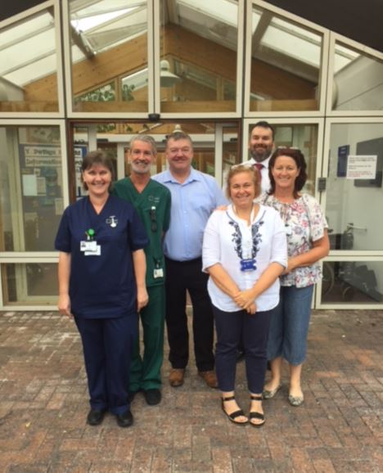
Palliative care inpatient unit Y Bwthyn Newydd, which opened in 1997, will have improved kitchen facilities for both patients and families, a larger family room and new fixtures and fittings.

l-r Ward Sister Helen Williams, Health Care Support Worker Dean Brimicombe, Acting Service Group Manager Les Hammond, Palliative Care Consultants Dr Pola Grzybowska and Dr Idris Baker and Ward Manager Karen Robinson

Patients, family members and the public have made donations from completing challenging runs to cake sales.

Some families and individuals have chosen to donate and support Y Bwthyn Newydd over many years, sometimes due to personal experiences or by selecting it as a chosen charity.

Ward Manager Karen Robinson said: “As a team we are really excited to have a start date for this work, which we have been planning for a number of months and saving for many years.

“We are profoundly grateful to everyone who has given donations to the unit over the years, which have made this ‘refresh’ possible.”

In order to complete the work as quickly as possible, the in-patient unit will temporarily relocate for up to six weeks from 30th August.

The specialist beds will be located in Ty Olwen in Morriston Hospital. Patients in Princess of Wales Hospital and the community will continue to receive support from the hospital and community palliative care services.

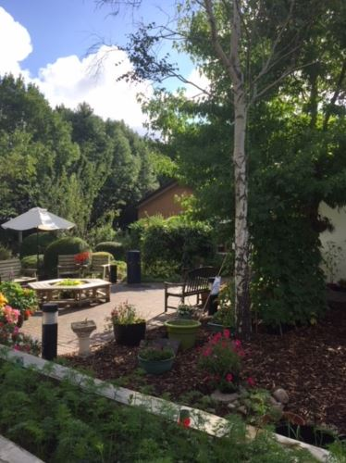
The palliative care day centre will relocate to Y Rhosyn in Neath Port Talbot Hospital, where those attending will continue to have access to a wide range of therapeutic activities including exercise and relaxation groups and complementary therapies.

The Good to Grow gardening group at Y Bwthyn Newydd will continue to be held weekly, with provision for indoor activities if required.

The garden at Y Bwthyn Newydd where the Good to Grow gardening group is held (right).

The Y Bwthyn Newydd team say they are committed to minimising disruption to the service over this period, and to maintaining a high standard of care to patients and families.

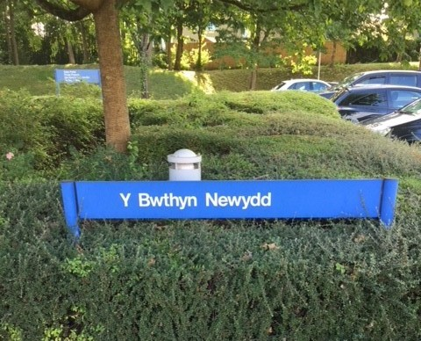
Consultant Dr Pola Grzybowska said: “We are delighted to be working closely with our colleagues in Ty Olwen. We will continue to offer a high standard of care, for patients and their families in all settings. We will also use this as an opportunity to share each other’s best practices.”

Source: Abertawe Bro Morgannwg University Health Board

