Aladdin cast pay a flying festive visit to children’s wards
Thursday, 21 December 2017
He may be a long way from the sunshine of Benidorm but panto star Tony Maudsley couldn’t have been happier spending time with young patients at Morriston Hospital.

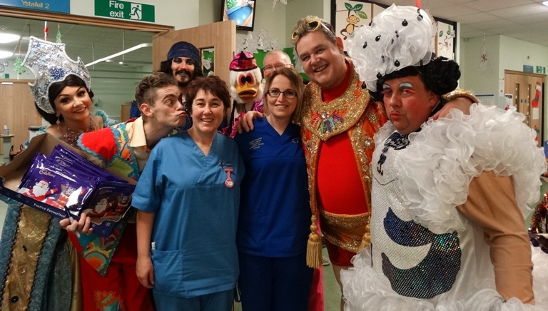
Joined by his fellow stars from this year’s production of Aladdin at Swansea’s Grand Theatre, he headed to the children’s wards to meet youngsters and their families.

He said: “I am very happy to be here today, it is lovely to meet all the staff and to try to cheer up the children a little bit.”

Tony said he wasn’t surprised quite so many of the staff and parents wanted to say hello and pose for picture with him as he toured Oakwood, Ward M and Dyfed Ward.

“I really am enjoying my time in Swansea, it is a very friendly city. I am only staying a five- minute walk from the theatre but it takes me half an hour to get there because everyone want to chat,” he said.

Tony is playing the Genie in Aladdin alongside Swansea panto favourite Kevin Johns who delighted patients by arriving in his traditionally eye-catching Widow Twankey outfit.
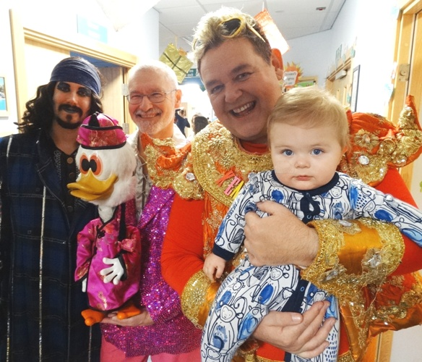
Stefan Pejic, Dooby Duck, Tony Maudsley with Frankie Evans.

Kevin, who is clocking up his 20th consecutive season at the Grand, said: ”This is always the best job of the panto season. I love bringing the gang from the show here, seeing these children puts everything into perspective.

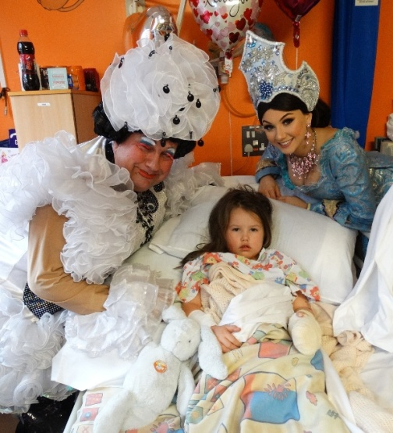
“We are really pleased to be here, these wards are very special places – particularly at this time of year.”

Returning to the cast of a Grand panto this year meant a return to the hospital for Neath-born Stefan Pejic, who plays the dastardly Abanazar, and Matt Edwards, fresh from his success on Britain’s got Talent, who is playing Wishee Washee.

Also spending time with the children, signing autographs and handing out goodies were Princess Jasmin, played by Daisy Twells, and Dooby Duck.

Kevin Johns and Daisy Twells with Sophie Oddy at Dyfed Ward.

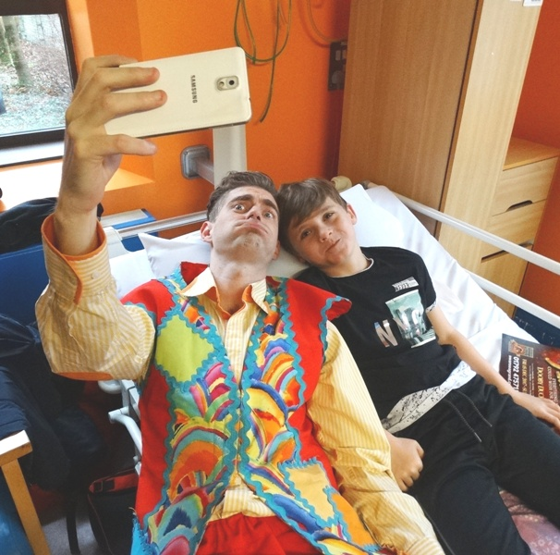
Hospital play specialist Jan Williams said: “The visit brightens up their day and helps them to forget the reason they are here in hospital.
“The children have no choice about why they are in here but visits like this certainly add a bit of extra sparkle to their day.
“It gives them a boost and it is good for staff as well!”

Matt Edwards gets a selfie with Nixon Powell at Dyfed Ward

Source: Abertawe Bro Morgannwg University Health Board

