Artwork donated to chemotherapy unit in patient's memory
Thursday, 7 December 2017
An eye-catching work of art is taking pride of place at Singleton Hospital in memory of a patient who lost his fight against cancer last year.

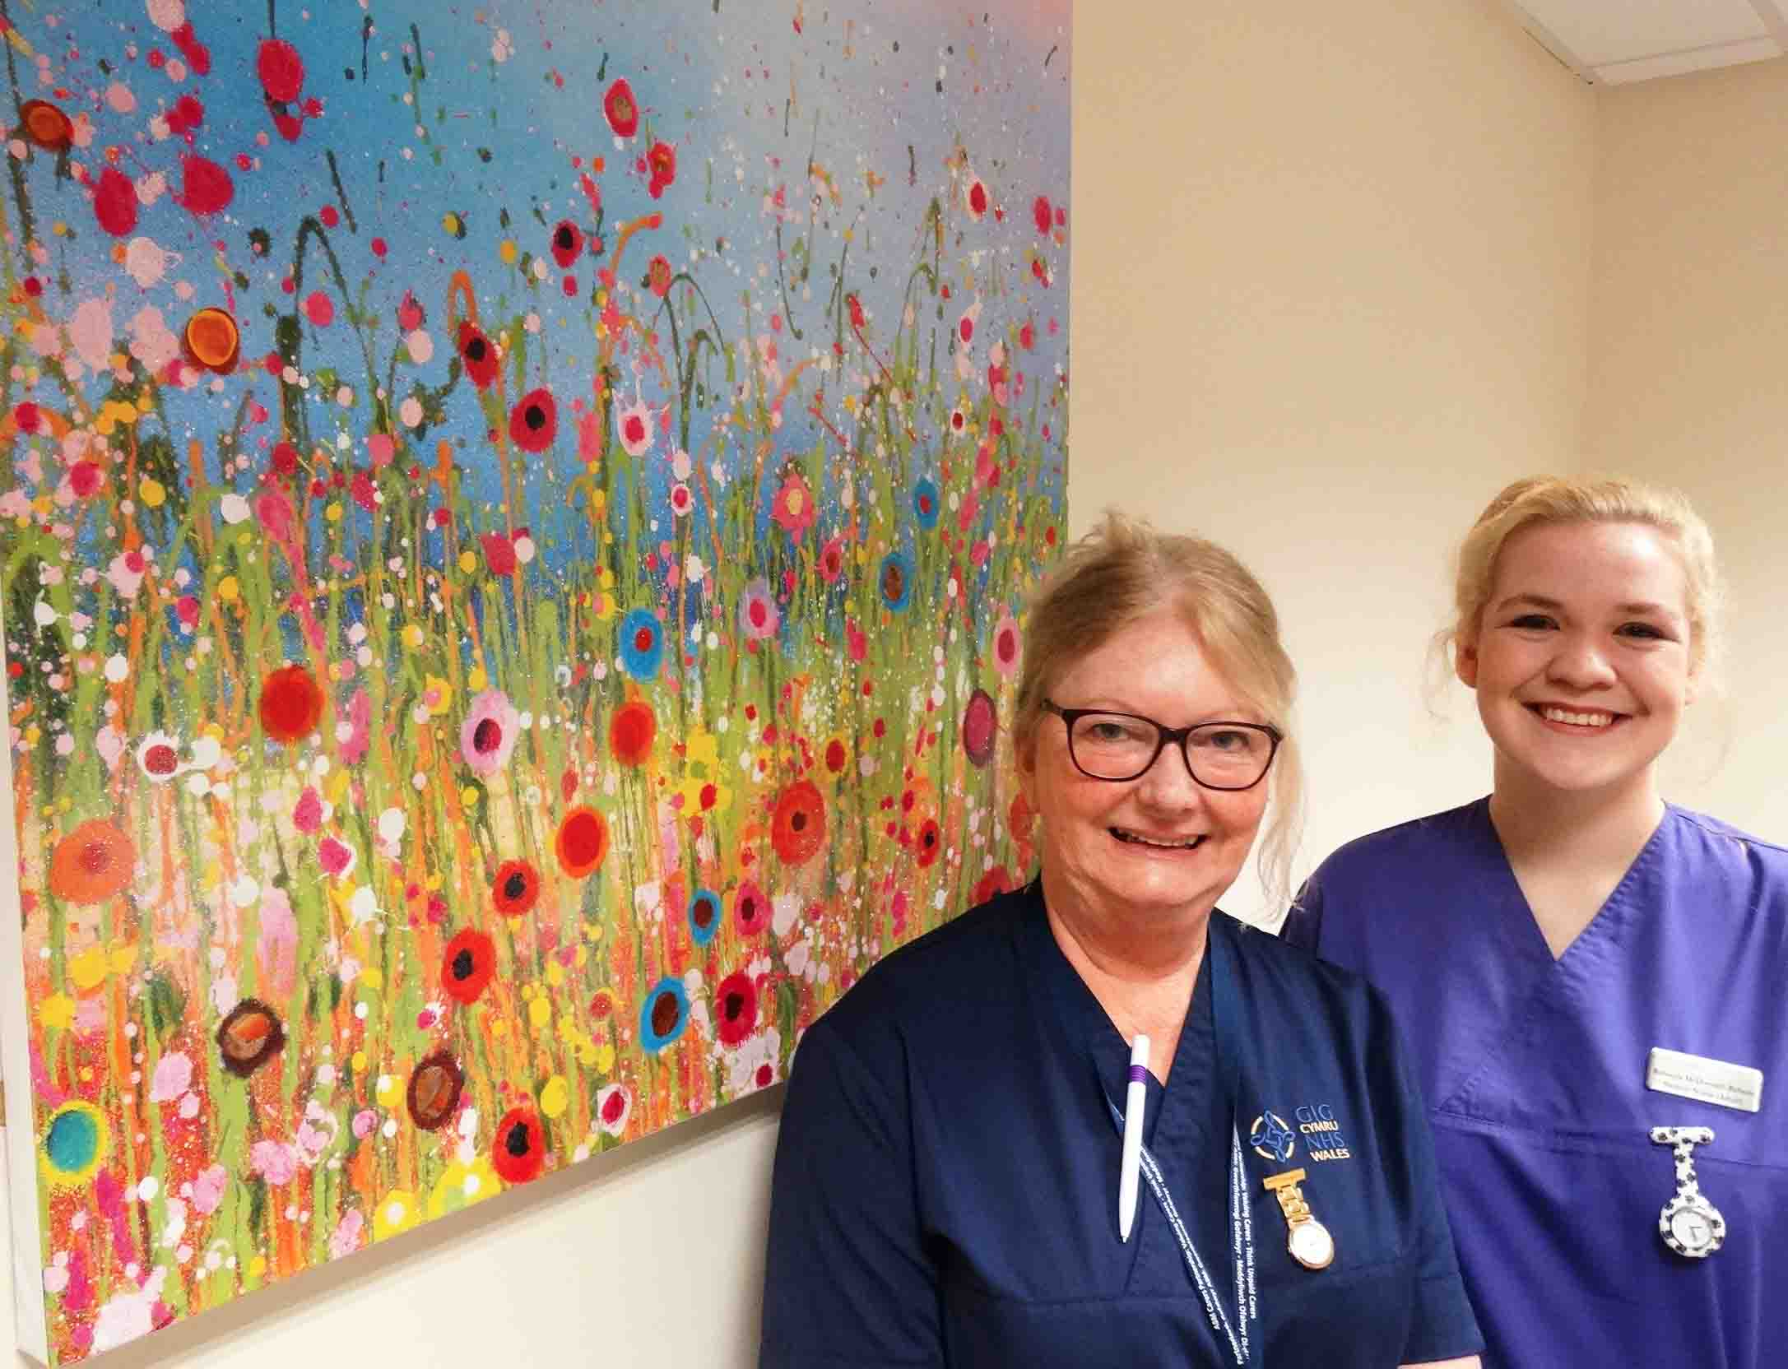
Dad-of-three Geoff Marquis, from Pontlliw, passed away last November, 22 months after he was diagnosed with pancreatic cancer.

He was aged 63 and worked as a manager within Neath Port Talbot Council’s environment division.

Sister Jenny Daly and student nurse Rebecca McDonnell-Roberts with the artwork donated in memory of former patient Geoff Marquis

Geoff had extensive treatment in the Chemotherapy Day Unit, part of the South West Wales Cancer Centre at Singleton, where he got to know staff well over the months – particularly unit manager, Sue Rowland.

Last year a room in the unit was transformed into a dedicated area for patients to have counselling and benefits advice.

Sue and her team were also keen to redecorate and refurbish the pre-assessment room to make it feel more tranquil and less clinical.

Sue said: “Donations from a patient helped us purchase modern and comfortable furniture.

“We needed some pictures or artwork to finish off the room and make it feel calm for patients attending at a very stressful time.

“We had recently lost Geoff, who was a long-term patient, and his wife Diane wanted to give something back to say thank you for his excellent care and also something to remember him by.

“We discussed the pre-assessment room and Diane went away to think about what she would like to buy in Geoff’s memory.”

When Diane saw an abstract painting of flowers, You Make Loving Fun by renowned artist Yvonne Coomber, she knew it was perfect.

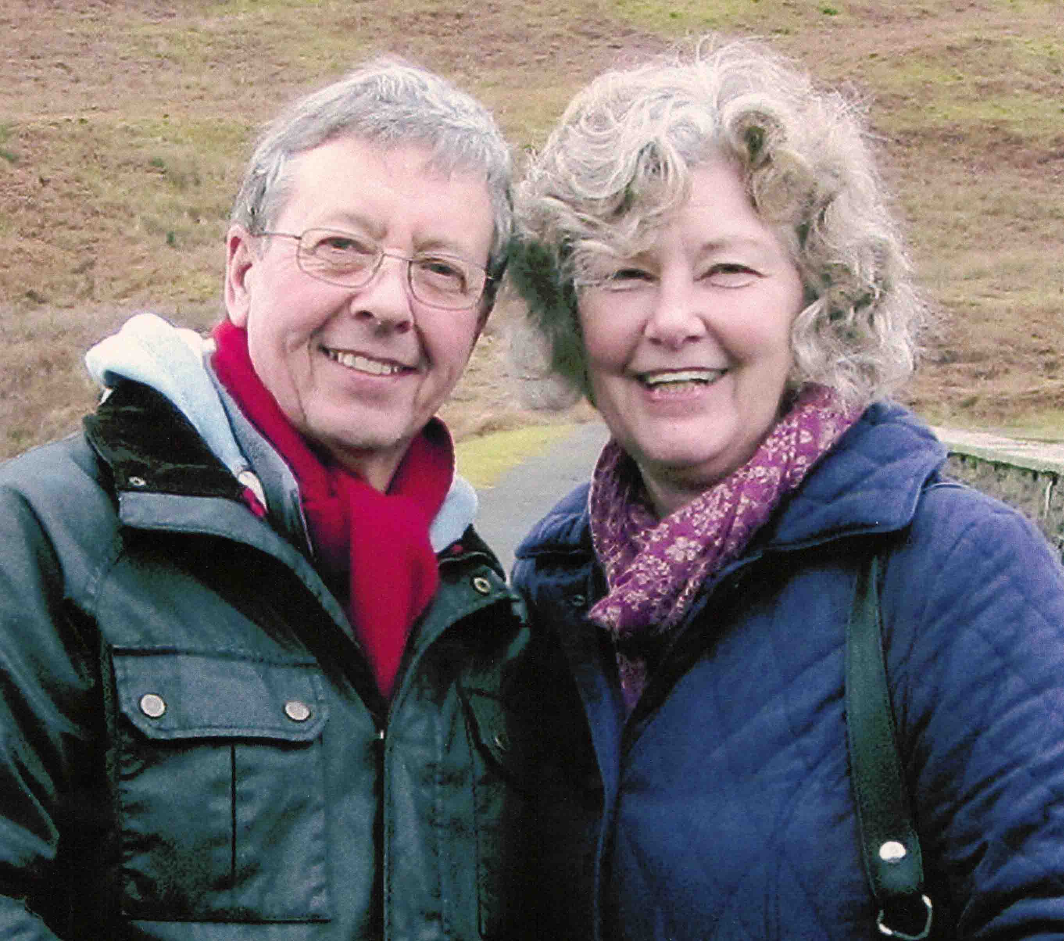
Diane (pictured right with Geoff) said: “Geoff was full of energy and always happy and positive. When I saw Yvonne Coomber’s work I knew this was a fitting memorial to him because it was so vibrant and full of life.

“Geoff loved life and having treatment gave us an additional 18 months together.

“Sue shared Geoff’s love of nature and she got to know him well. Sue is a superb photographer and they would joke about his Box Brownie and his attempts to take photographs.

“They had a lot of things to talk about and Sue also helped him overcome his fear of needles, which is what you need when you’re having chemotherapy.”

When Diane suggested the artwork, Sue instantly loved it and felt it would be perfect for the pre-assessment room.

The limited-edition printed canvas was hand-finished with oils, gold leaf and glitter by the artist, who also titled, numbered and signed it.

It was provided by Fizz Gallery in Clevedon, which waived any profit as one of its employees was previously a chemotherapy pharmacist.

Sue said: “As a team we often don’t realise just how much of an impact our care has on people.

“We are so grateful to Diane for the beautiful canvas.

“It makes the room bright and cheerful for patients and their families attending at such a stressful and emotional time.

“The canvas is also a very fitting tribute to Geoff and his love of nature.”

Source: Abertawe Bro Morgannwg University Health Board

