Buying slippers for Christmas? Don’t be a slipper tripper
Monday, 11 December 2017
Hitting the shops over the next few days for a bit of Christmas shopping? If slippers are high on your gift list for an elderly relative, please think carefully about the style you choose, because loose or sloppy-fitting footwear can significantly increase the risk of a fall.

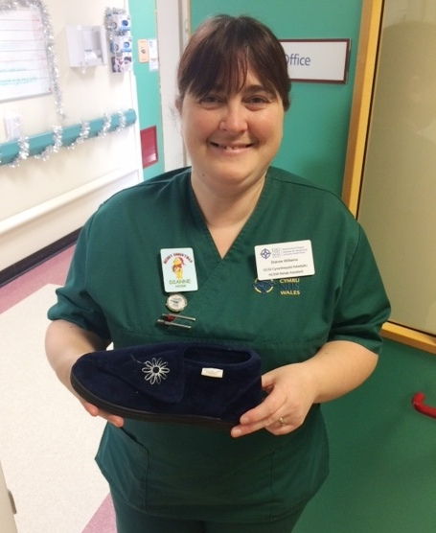
Did you know that falls are the number one cause of injury and injury-related deaths for older people? Last year, more than 4,000 people aged over 75 were admitted to ABMU hospitals after suffering a fall. And while not all of these falls were linked to ill-fitting slippers or shoes, a worrying number would have been.
To ensure they are steady on their feet, older people need slippers which grip the foot well - ideally with a Velcro fastener - and have a firm, slip-resistant sole. (See left, healthacare support worker Dianne Williams with the correct style of safe slipper) Avoid loose or backless slippers.

Low, broad heels are also best. And, old, worn slippers which are past their best should be replaced, as they no longer provide the support needed.

Lesley Jenkins, who is the director of Neath Port Talbot Hospital, said:

“Slippers are a traditional and welcome gift at Christmas, and all over South West Wales they will be handed over to family and friends on Christmas morning.

“But people often don’t realise when they choose the slippers that there is more to consider than if they are an attractive style or look warm and comfy.

“If the slippers are for an older person, you should consider how safe they are to wear. Loose or sloppy-fitting slippers must be avoided as they could easily contribute to a nasty fall.

“Having the right footwear is so important, especially for our frail and elderly patients. Badly fitting slippers and shoes can increase the risk of falling, which in turn can have a huge impact on someone’s recovery.

“Our nursing and therapy staff would all be happy to advise you on what sort of footwear is best.”

Janet Ivey, Head of Occupational Therapy added these additional tips:

- Don’t wear slippers without backs or that are loose and worn out
- Avoid sandals and shoes with high heels
- Make sure your trousers or skirts don’t trail on the ground
- Avoid walking on slippery floors in socks and tights
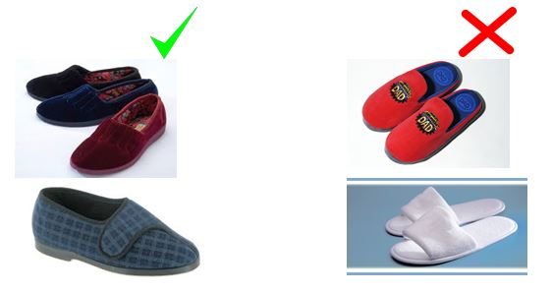

For more information or support contact

- Podiatry Open Access for New Patients – 0300 300 0024
- Physio Direct on 01639 683054
- Neath Port Talbot Hospital Falls Prevention Service- 01639 862604

If you are elderly, or have elderly friends and relatives, here is some additional general advice to reduce the risk of a fall which you might find useful.

10 practical ways to reduce your risk of having a fall

1. It's never too late to start exercising Balance is a skill you can keep or recapture at any age.

2. Exercise regularly This keeps the balance 'tuned up' and bones and muscles strong.

3. Exercise within your limits Problems such as diabetes, arthritis or asthma should not stop you exercising. Your physiotherapist can tailor a specific exercise program for you.

4. Maintain good posture Good spinal care throughout your life will assist your balance.

5. Walking aids Walking aids such as sticks and frames should be correctly prescribed and fitted - not borrowed from other people.

6. Choose proper footwear Firm fitting, flat shoes improve your stability.

7. Take extra care on uneven ground Surfaces such as gravel and grass are more challenging to the balance.

8. Good vision helps your balance Be careful if lighting is poor and avoid walking in the dark.

9. Be aware of home hazards Slippery mats, dangling electrical cords and clutter can turn your home into an obstacle course.

10. Have a 'Falls Emergency Plan' Know how to summon help if you do have a fall. Ask your physiotherapist to show you the easiest way to get up off the floor.

Source: Abertawe Bro Morgannwg University Health Board

