Caring ABMU midwives’ hard work in the national spotlight
Tuesday, 5 December 2017
The dedication of ABMU staff to mothers before and after they give birth has led to success in a top national health award and put them in the running to win two others.

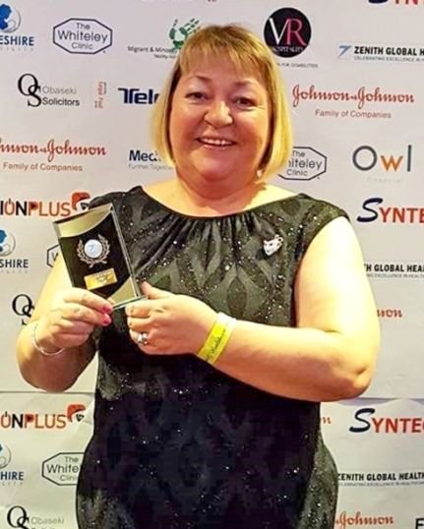
Ann Saunders, specialist midwife for substance and alcohol abuse based at Neath Port Talbot Hospital, developed clinics providing specialist antenatal care for substance misusing pregnant women.

Her work with this group of mums-to-be led to her winning the Excellence in Nursing and Midwifery category at the Zenith Global Healthcare Awards.

She said: ”I was very surprised but very proud to have won because I have always had a passion for care within the substance misuse genre and feel the service we now offer is really making a difference.

“It is truly multidisciplinary, encompassing midwifery, obstetric, specialist prescribing service, and external agencies.

“For many women, and their partners, pregnancy is their opportunity to access care for the first time and bring some stability to their lives before they become parents.”

Another example of collaborative working has seen midwives from the multi-agency Jig-So team in Swansea reach the shortlist for this year’s prestigious RCM Annual Midwifery Awards along with support worker Julia Atterbury who works with mums-to-be at Neath Port Talbot Hospital’s antenatal clinic.

The awards celebrate the profession’s best and brightest talent and this year the expert judges say their task of selecting finalists was made harder by the unprecedented number of quality entries.
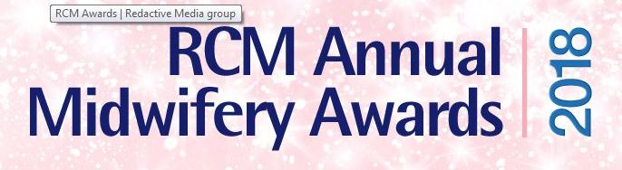
These included the Jig-So team which is up for the Reducing Inequalities Award. Jig-So is a joint ABMU and Swansea Council project, running since May 2016.

It sees a team of Flying Start midwives, nursery nurses, family facilitators and early language development workers supporting teenagers and young women aged up to 25 years during pregnancy.

The family facilitators and early language development workers can support these families up to the child’s third birthday.

The team’s aim is to build on the strengths, skills and knowledge of the family to help them to be healthy, grow and thrive for the future. It can also provide interventions to families where complex social factors may stop them from reaching their full potential.

Jig-So lead midwife Wendy Sunderland-Evans said: “The whole team is delighted to be shortlisted. The way we work and the unique service we provide to young families are prime examples of the benefits of multi-agency working and how this is pivotal in meeting the requirements of the new Well-being of Future Generations (Wales) Act 2015.”

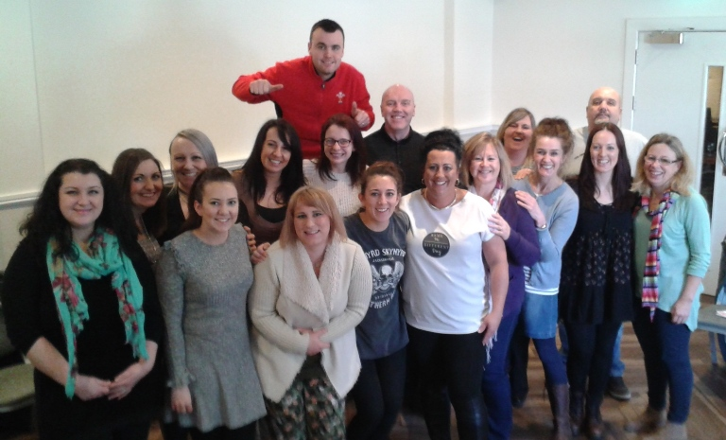
Members of Swansea’s multi-agency Jig-So team. The midwives who work as part of it are shortlisted at the RCM Awards

Her passion for breastfeeding and talent for explaining its benefits to pregnant women have led to Julia Atterbury being shortlisted for the Maternity Support Worker of the Year title.

She was nominated by midwives Margaret Birch and Kate Evans who credit Julia with helping to improve breastfeeding rates in Neath Port Talbot by five per cent.

Margaret said: “Julia uses the 20-week scan appointment as an opportunity to start a conversation with pregnant women about feeding. She introduces the subject of breastfeeding, provides information and advice and it has been really well received – she has a really good way with parents-to-be.”

Former nursery nurse Julia said her own experience of breastfeeding has made her determined to help other new mums.

She said: “I am passionate about it and I want them to understand and feel supported when it comes to breastfeeding.

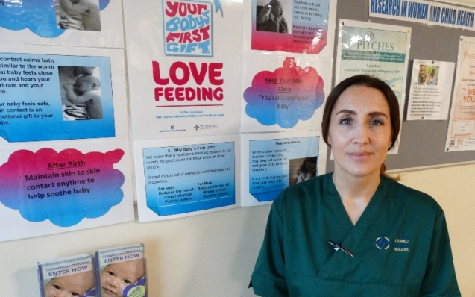
“I started out providing smoking cessation advice and this has led to me talking to women about breastfeeding as well as other ways they can begin to bond with their unborn baby.

Julia Atterbury at Neath Port Talbot Hospital.

“I am so pleased to be shortlisted because it really is recognition for the work we are all doing here to help mothers before and after they give birth.”

Midwives Sally Roberts and Julie Morgan, representing Jig-So, and Julia and Margaret Birch headed to London this week to make presentations to the judges. The winners will be announced at an awards ceremony at The Brewery, London on Tuesday 6th March.

Sue Jose, ABMU’s deputy head of midwifery said: “Congratulations to Ann, her achievement has really given her service the kind of nationwide attention it deserves.

“We are also very proud to have two shortlisted entries in this year’s RCM Awards and wish everyone involved the very best of luck.

“These successes demonstrate perfectly the kind of dedication and enthusiasm all our midwifery staff have for helping families.”

Gill Walton, Chief Executive of the Royal College of Midwives, said: “The standard of entries has been extremely high so to get this far is an outstanding achievement.

“It shows how much innovation there is in our maternity services, and how hard midwives, maternity support workers and the wider team is working to deliver the safest and best possible care. I wish Sally, Julie and maternity support worker Julie the best of luck at the awards ceremony in March.”

More information on the awards is at http://www.rcmawards.com/awards-day
Source: Abertawe Bro Morgannwg University Health Board

