Celebration to say thanks for healthcare volunteers’ massive contribution
Monday, 11 December 2017
A special seasonal celebration brought together hundreds of ABMU’s army of volunteers to thank them for their hard work throughout the year.

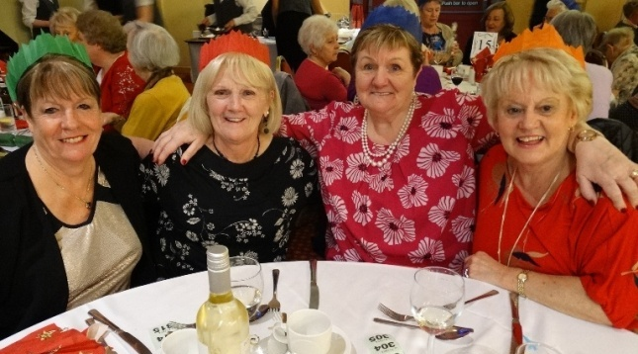
They were the guests of honour at the event to honour the contribution of volunteers of all ages who man desks, help staff, serve drinks and provide a warm welcome at hospitals and clinics throughout the health board.

ABMU volunteers get in the festive spirit at the celebration held to thank them for their contribution during 2017.

Thanking them at the festive lunch held at Aberavon Beach Hotel, ABMU Chairman Andrew Davies said all 450 volunteers provided vital support to patients and their families.

Director of Therapies and Health Science Christine Morrell described the volunteers’ work as “putting the icing and hundreds and thousands on top of our cake”.
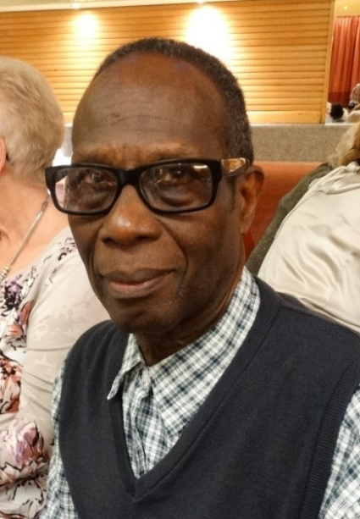
She told them: “You do the things that we can’t do. The rich diversity of volunteers also helps us to develop our services. Your contribution is a hugely valuable and ABMU is better for your input.”

The celebration was attended by volunteers of all ages who carry out a variety of different roles. Some have been giving their services for decades while others like Keith Elcock (left) are more recent recruits.

He decided to become a volunteer at Port Talbot Resource Centre after moving to the area.

“I thought it would be a good way to get to know people and contribute something to the wider community. I have met some wonderful people. I help patients when they come in and do anything I can to assist them. It is very rewarding,” he said.
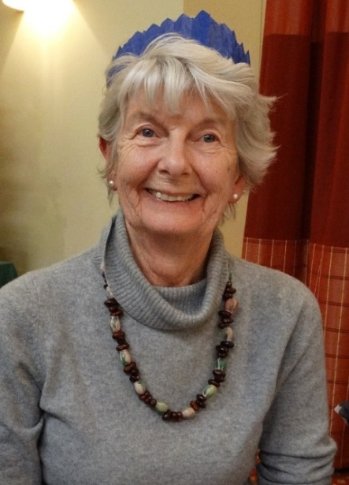
Chaplaincy volunteer Margaret Edwards (right) supports antenatal, postnatal and gynaecology patients at Singleton Hospital.

She described being a volunteer as a privilege. “I feel it is necessary to care for the body, mind and the spirit. Even for those without faith it is sometimes enough just to have someone there.

“When we see people in hospital they are worried and there’s a fear of the unknown, so we are there to offer support and comfort at those difficult times.”

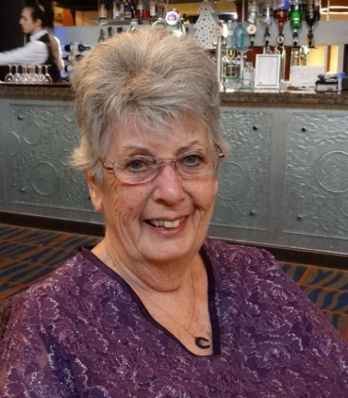
Feeling part of a team is one of the things that makes Wendy Jones (left) value her days helping at the Regional Cardiology Unit at the Princess of Wales Hospital.

“The staff are wonderful, I feel included and trusted. I welcome patients, show them where they need to go, fetch them drinks, basically anything that helps the staff.

“I needed something to do after my husband died, I didn’t want to just vegitate, now I feel I am useful and I have met so many interesting people. I love it.”
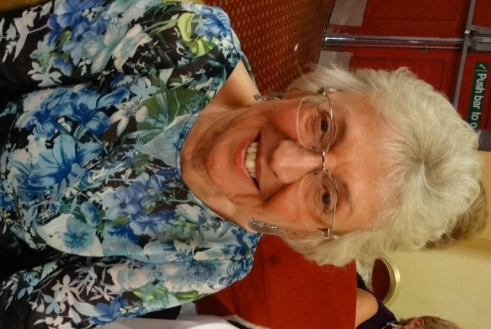
Janice Thomas (right) had been volunteering with the Red Cross for five years. When the charity withdrew its services from Singleton Hospital earlier this year she knew she wanted to continue so swapped across to become a health board volunteer instead.

She can be found on the front desk as well as in the endoscopy unit and the chemotherapy day unit where her late partner received treatment.

She said: “I wanted to give something back and to help people. I became a volunteer because I felt I had something to offer. We all need a little help sometimes.

“You are one of the first people patients see when they come in, they are often frightened so need to see a reassuring face.

“If you are thinking about being a volunteer you’ve got to want to do it and be happy when you do it otherwise it would be pointless.”

Volunteer services manager Joanna Parry said ABMU is always eager to enlist new recruits.

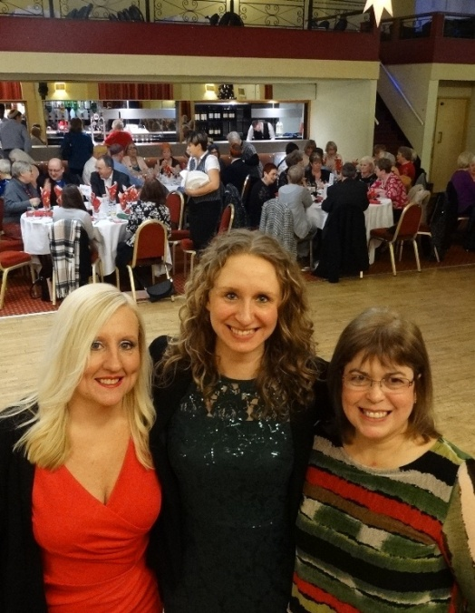
She said: “We want to thank our existing volunteers for all their hard work, we like looking after them because they are our greatest asset.

“We want to grow our volunteer team – not just the number but also expand the services they provide and the different ways people can volunteer.

“We’ve got lots of exciting projects planned for the future.

Volunteer services manager Joanna Parry (centre) with volunteer co-ordinators Julia Griffiths and Glenda Phillips at the celebration lunch.

“Research proves that volunteering is good for us so at this time of year as people begin to consider their New Year resolutions we’d love them to think about making one to become a volunteer in 2018!”

If you would like to find out more about volunteering opportunities get in touch with volunteer.centre@wales.nhs.uk or call our Volunteer Centre on 01656 753781

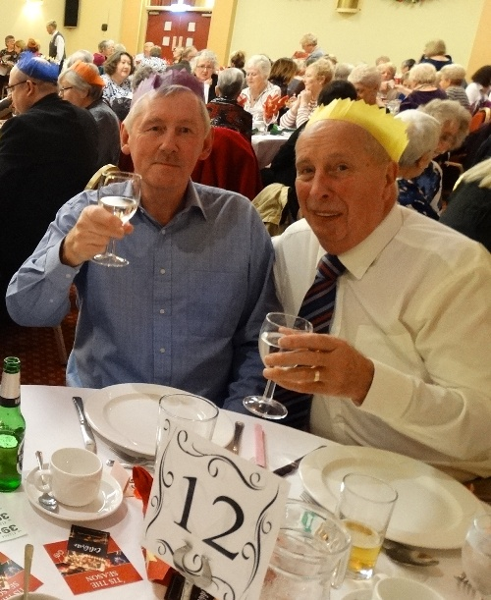
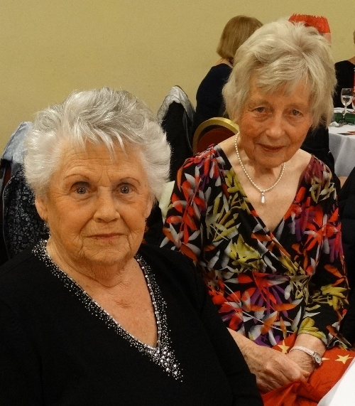
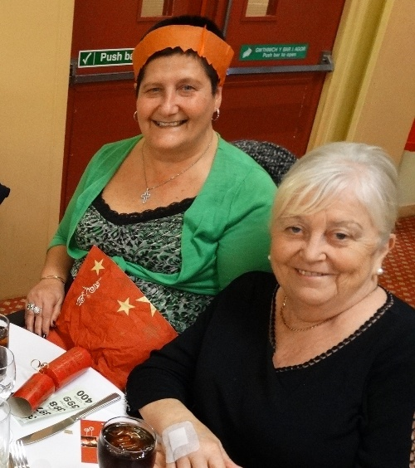
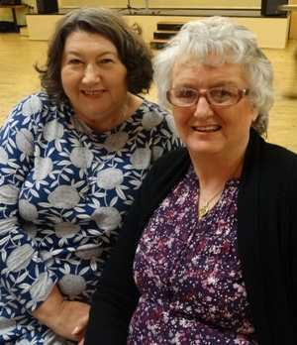

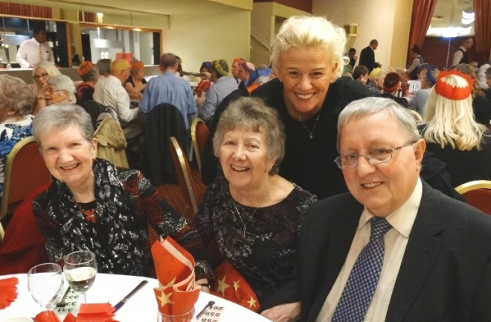
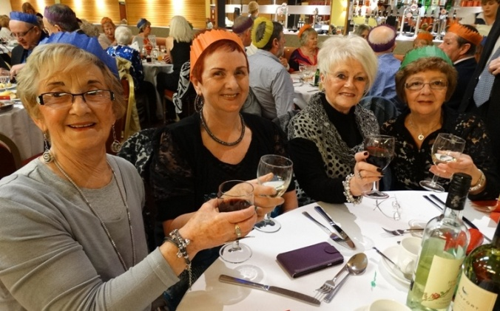
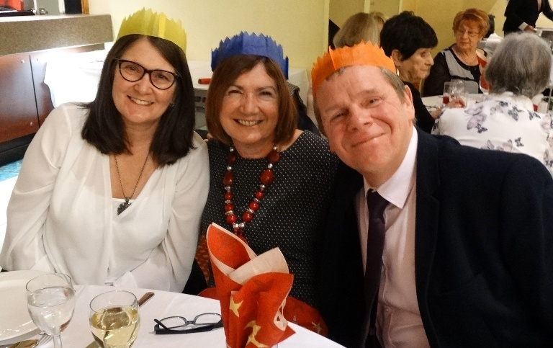

Source: Abertawe Bro Morgannwg University Health Board

