Chris wins lifetime honour for years dedicated to vulnerable patients
Friday, 8 December 2017
More than 30 years devoted to patients with learning disabilities has seen an ABMU nurse honoured with a lifetime commitment award by the Paul Ridd Foundation.

Christopher Griffiths was among the winners at the Baglan-based charity’s annual awards ceremony which celebrated good work going on to improve healthcare for people with a learning disability.

He was recognised not only for his long-standing commitment to learning disability but also for being instrumental in creating the All-Wales Care Bundle, a guide designed to help staff ensure vulnerable patients receive appropriate care during a stay in hospital.

In his citation, the charity paid tribute to his years of hard work: “Chris has continuously inspired us through his passion and unwavering dedication, showing a genuine desire to improve the lives of people with learning disabilities and his support for the Paul Ridd Foundation has been invaluable.”
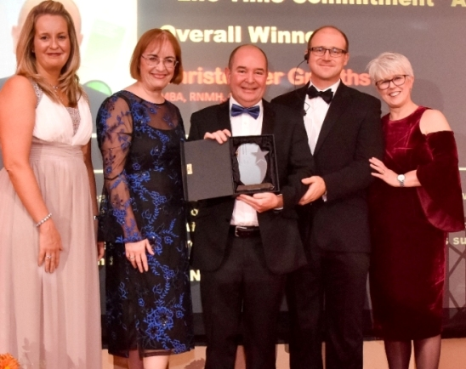
He trained as a learning disabilities nurse in 1982 and has spent most of career working in the community before becoming a consultant nurse in 2005. He has also passed on his expertise, lecturing to nursing students in Cardiff and Swansea.

Christopher Griffiths (centre) with his award and Melanie Davies, Prof Jean White, Jonathan Ridd and Jayne Rowlands.

Chris, who leads ABMU’s Primary and Acute Learning Disability Service, has a special interest in meeting physical health care needs of people with a learning disability and remains passionate about addressing inequalities in their health care.

He said: “I was surprised and delighted to receive the award. It is a testament to the remarkable progress the Primary and Acute LD Liaison Service is making to the care of people with a learning disability. I am so proud to be part of that.”

Chris was presented with his award by Jayne Nicholls and Jonathan Ridd, who founded the charity in memory of their brother Paul, who died at Morriston Hospital in 2009.
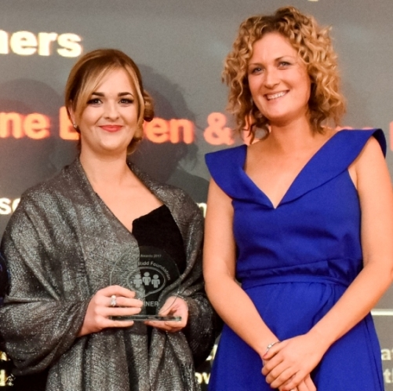
Nurse Director for Mental Health and Learning Disability Hazel Powell said she was delighted that Chris had been honoured.

She said: “This is a very well-deserved recognition of the significant contribution Chris has made throughout his career to improving services for people with learning disability – in particular to improving the experiences and health outcome of those w accessing acute hospital care.”
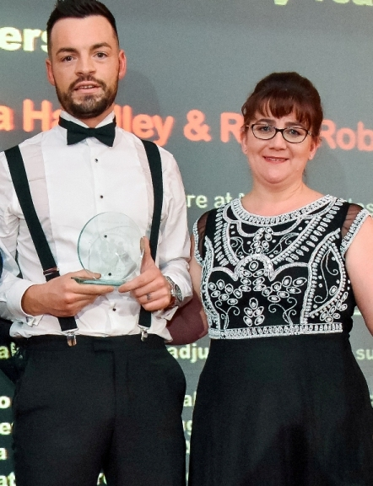
Other ABMU winners at the ceremony, which took place at the Aberavon Beach Hotel, included Morriston Hospital ITU nurses Leanne Bowen and Leanne Mooney (left, top), emergency theatre coordinators Nicola Handley and Ross Robinson (left, below) as well as Karen Carpanini, Sian Berry and Sue Johnson, sister, staff nurses and learning disability champions at the Day Surgery Unit at Princess of Wales who were all honoured in the Learning Disability Team category.

Sister Karen Carpanini and staff nurse Sue Johnson receive their Learning Disability Team award. Unable to attend the ceremony was learning disability champion Sian Berry.

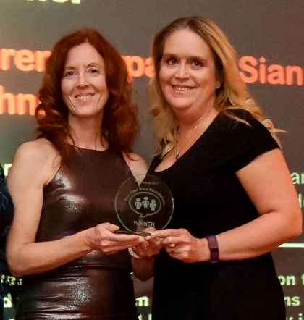
The Hospital Champions Award was won by senior staff nurse Cath Thomas for her work making the theatres at Neath Port Talbot Hospital learning disability friendly and her passion for finding a way to deliver superb treatment for patients with LD.

Sarah Rees, who works with Bridgend Community Support Team helping patients through their secondary care pathway and discharge, won the Primary Care and Community Support Award.
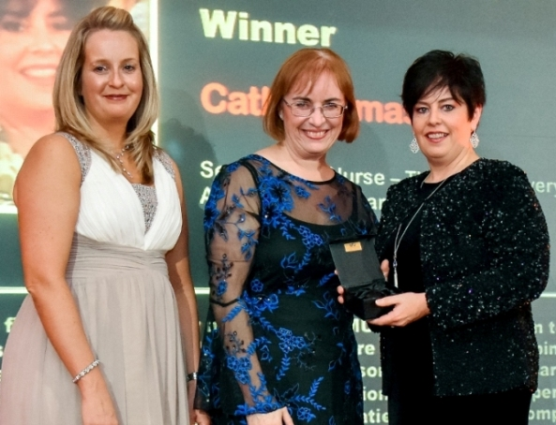
Cath Thomas, winner of the Hospital Champions Award with Melanie Davies and Prof Jean White.

The awards were presented by Chief Nursing Officer for Wales Jean White and RCNi Nurse of the Year Melanie Davies who is a sister on Ward G at Morriston Hospital and a trustee of the foundation.

They also honoured the members of staff who were Highly Commended at the awards - community learning disability nurse Joanne Hammett, staff nurse Amy Mainwaring, staff nurse Yvette Williams, intensive care unit manager Julie Keill, staff nurse Perdie Boyle and homeless and vulnerable adult nurse Janet Keauffling.

The evening included awards for Family and Carers, Paul Ridd Foundation Ambassadors and First Response.

The event also featured a fundraising silent auction with lots including exclusive art work and signed shirts from rugby star Liam Williams and footballer Gareth Bale.

Jonathan Ridd and Jayne Rowlands of the Paul Ridd Foundation said: “A huge congratulations and well done to all the winners and highly commended entries. Thank you for your continued efforts to improve the way people with learning disabilities are treated and for reminding others to always see the person not the disability.”
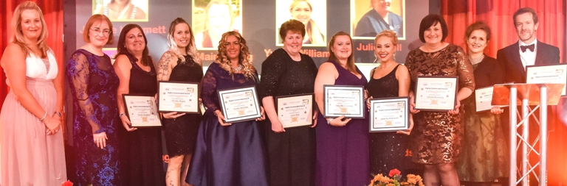

ABMU staff who were highly commended for their work at the awards.

Source: Abertawe Bro Morgannwg University Health Board

