Church’s boost to help support parents of young patients
Friday, 29 December 2017
When your child is admitted to hospital the last thing you’re likely to think about is toiletries but now parents can access essential supplies to help them freshen up, thanks to Swansea churchgoers.

They have donated special packs including travel size toothbrushes and toothpaste, deodorant and tissues to Morriston Hospital’s children’s wards.

The packs were the idea of Bethan Germon, whose daughter Lydia’s medical condition means she frequently has to spend time in hospital.

Now Bethan and her husband David have enlisted help from the congregation at their church – Hope Church in Fforestfach - to put the packs together.

She said: “We like to think that we are fairly organised parents but it is very easy to forget about your needs when your child is ill.

“Often there is nowhere nearby or open where you can buy simple toiletries or you might not have the money with you to buy them.
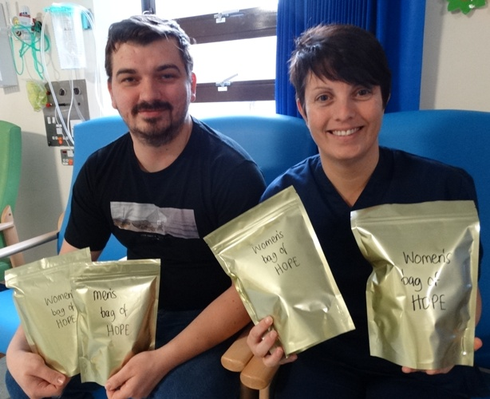
“The packs are designed to take one problem away for parents when their child is in hospital.”

Besides the toiletries the packs also contain a top tips list which the couple have put together based on their own experiences.

David Germon and ward sister Sarah James with some of the packs ready for parents.

She added: “It has details of where the nearest shops are, where you can get something to eat, basically a rough guide for parents on the ward. We have also put our contact details in so parents of children with a disability have somebody else in the same boat to talk to.”

So far around 20 of the packs, which have been designed for men and women, have been distributed to parents at Morriston.

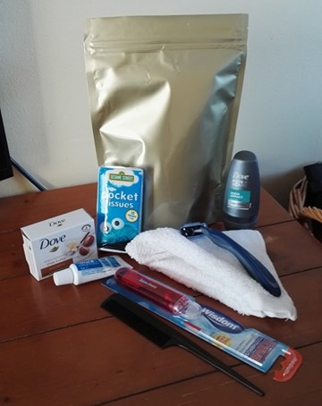 | 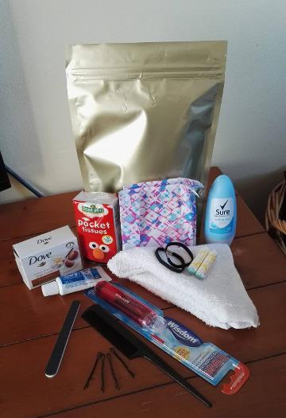
Sister Sarah James, of Oakwood Ward, said: “We think this is a fantastic idea and we are very grateful. It really helps us to be able to hand these packs out to parents when they are at their most worried. It is a very practical way to help other parents.

“We do carry a small supply of toiletries but we have to buy these out of our ward’s funds and then have to rely on staff to restock. These packs mean those funds can be used for patient care.”

Although the idea was kicked off in the run-up to the festive period, the Germons are now hoping to keep the scheme going throughout the year, thanks to ongoing fundraising.

David added: “Our plan is to have proper labels printed, perhaps get sponsorship, but we want this to carry on because the need is there all the time.

“When your child is hospital you may not want to have to leave their bedside to go and find some razors or toothpaste.

“We are hoping that those parents who have benefited from one of the packs will then give back to the scheme and donate towards more packs.”

Anyone who would like to find out more about the Bags of Hope scheme should click here

Source: Abertawe Bro Morgannwg University Health Board

