Couple’s fundraising pays off for cancer patients
Monday, 18 December 2017
A Swansea couple who have dedicated years to fundraising for patients with head and neck cancer have just handed over their latest donation.
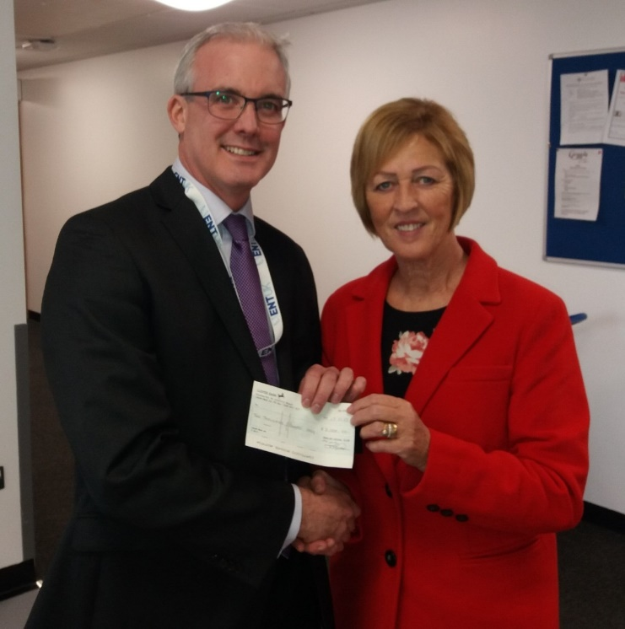
Susan Honey visited Morriston Hospital to present consultant head and neck surgeon Conor Marnane with a cheque for £2,000 (right).

The money was raised by patrons of Penlan Social Club at a series of events organised by Mrs Honey and her husband David who has been treated for cancer himself.

Mr Marnane said: “We are so grateful to Mr and Mrs Honey and the club members for this generous donation to the Head and Cancer Endowment Fund.

“They have supported our fundraising efforts for a number of years and the money they and others have raised is used to support the treatment and care of patients with head and neck cancer.”

He said donations like this meant the team had recently been able to buy extra diagnostic equipment and suction machines. They had also provided funding to facilitate advanced training for members of the head and neck team.

“All of this will significantly benefit head and neck cancer patients in the long term, “ added Mr Marnane.

Source: Abertawe Bro Morgannwg University Health Board

