Family celebrating triple world title joy
Monday, 4 December 2017
ABMU’s Laurie Williams has every reason to be feeling on top of the world – he has just lifted a karate world championship crown alongside his two sons.
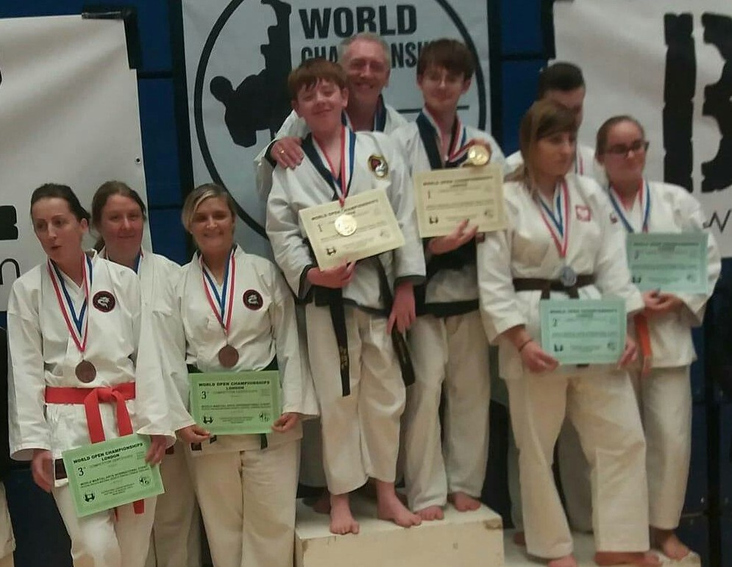
Laurie, 17-year-old Tom and Jack, aged 12, won the team kata at the TY-GA World Championships held at Crystal Palace in London.

Laurie, Jack and Tom Williams on the winners’ podium at this year’s World Championships.

Although it is the third time Laurie, who is senior project manager in the informatics directorate based at the health board’s Baglan HQ, has claimed a world championship, this was Jack’s first world title.

Karate is now a real family affair for the Williamses. Laurie, his sons and mum Kathryn are all black belts and even run their own club in Treforest.

Their success is all the more remarkable as the couple only took up karate to keep up with Tom.

Laurie said: “When he was seven Tom was very small and very shy so we started taking him to karate.

“It helped him gain confidence and as he became proficient in the art, eliminated his shyness.

“I could see that it was going to be a long-term thing for him, so I started training – as did my wife and my younger son Jack once he turned four.”

Laurie added: “The rest of us had several world titles but Jack had only won silvers and bronzes at world level, so we decided on a big push for titles in team kata - synchronised sequences of movements that show off fighters’ skills - this year.

“We won the UK Black Belt team kata title in March and trained very hard for the World Championships and it certainly paid off.”

Even though Jack was only 12, the trio still had to compete in the Senior Adults Division against some of the top teams from around the world, making their win even more satisfying said Laurie.

“To cap a really memorable day Jack also went on to win the sparring division,” said his proud dad.

“Karate is a wonderful sport. It is something that all ages can take part in together and has changed our lives.”

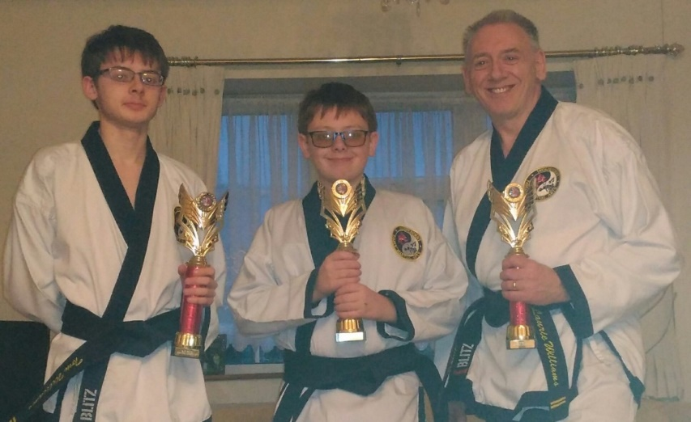
The TY-GA World Championships is held every November in London and attracts fighters and teams from all over the world and donates profits from the tournament to Cancer Research.

Tom, Jack and Laurie Williams with the UK title trophies they won earlier this year.

Source: Abertawe Bro Morgannwg University Health Board

