Golfers raise funds for Breast Care Unit
Thursday, 14 December 2017
A generous donation of £1600 has been raised for Neath Port Talbot Hospital’s Breast Care Unit.

Garry Johnson from Neath decided to raise money for the unit after his wife, Diane was diagnosed with breast cancer. Garry said “I was so pleased with the care my wife received following her operation that I decided to raise money for the unit”.

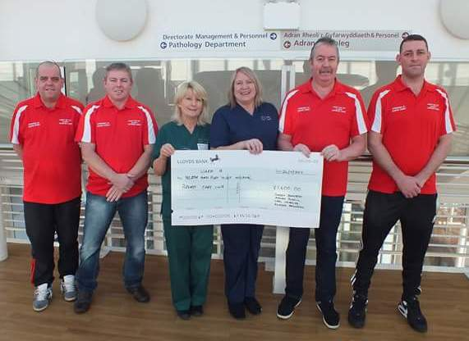
Pictured (l-r) Richard Packington, Adrian Powell, Health care support worker Katrina Greenhalgh, Ward A Sister Lisa Thomas, Garry Johnson and Carl Nicholas.

The fundraiser took place at Mond Valley golf course in Clydach where Garry was joined by Carl Nicholas, Richard Packington and Adrian Powell who all played three rounds of golf in one day.

Adrian’s wife, Andrea has also suffered with cancer, which makes the cause one close to their hearts.

Unit manager Lisa Thomas said “Myself and ward A are so grateful to these amazing men for giving up their time to raise these funds for us at Neath Port Talbot Hospital. We are truly touched by their hard work and the kind generosity of those who donated”.

Source: Abertawe Bro Morgannwg University Health Board

