Golfers tee off to provide major boost for ward
Wednesday, 6 December 2017
Fundraisers have given a Morriston Hospital ward a major boost in memory of a much-loved golfer.

Representatives from the Aled Wyn Evans Memorial Charity visited Ward S to meet staff and hand over a cheque for £2,500.

The money was raised at a golf day held at the Celtic Minor Club in Ystradgynlais which saw a host of teams enjoying a round before an evening of entertainment, raffles and an auction.

It is the fourth year the event has been held as a tribute to 40-year-old Aled, who died in Portugal at the end of 2012. His wife Tracey and his family have since decided to do something to help other patients in local area in his memory.

As Aled was such an enthusiastic golfer they decided a fundraising golf day would be the perfect legacy and since then they have collected £17,000 for good causes which has been donated to some local charities.

Organisers say they are grateful for the support they have received from Garnant and Celtic Minor golf clubs as well as the community, golfers and all those who have entered teams or handed over donations.

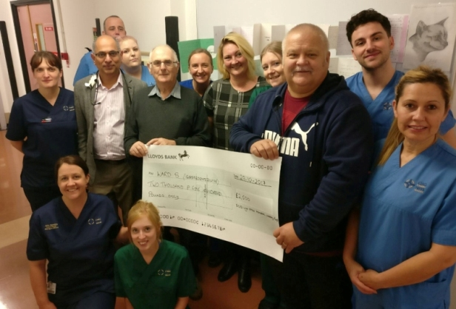
Pictured (from bottom, left) at the presentation are Bethany Joseph, Amy Saunders, Tanya Fuller, Dr Umakant Dave, Richard Young, Sammy Watkins, fundraiser Roy Evans, Helen Thompson Jones, fundraiser Donna Hilton, Clary Anne Malsen, fundraiser Wyn Jones, Jose Rubio and Melanie Hall.

Ward S is a specialist gastroenterology ward looking after patients with bowel, stomach, liver and other related problems including patients with inflammatory bowel disease (IBD).

This year the charity was particularly keen to support the ward for very personal reasons – one member of Aled’s family has been under the care of Dr Umakant Dave for many years and was treated on the ward and two other members of the family also suffer with (IBD).

Gastroenterology clinical nurse specialist Helen Thompson Jones said: “We are so grateful to the charity for this wonderful donation in memory of Aled.

“Everyone who helped raise the money can be reassured it will be spent to improve patient care on the ward. We are very lucky that we have such wonderful support from the community and such a significant amount really will make a big difference to us.”

Consultant gastroenterologist Dr Umakant Dave said: “It is really humbling to see hard work and generosity of the family to support local gastroenterology services.”

Source: Abertawe Bro Morgannwg University Health Board

