Health Secretary finds out more about services during tour of ABMU
Wednesday, 20 December 2017
Award-winning ABMU staff and their frontline colleagues have been giving Welsh Health Secretary Vaughan Gething a first-hand look at their work.

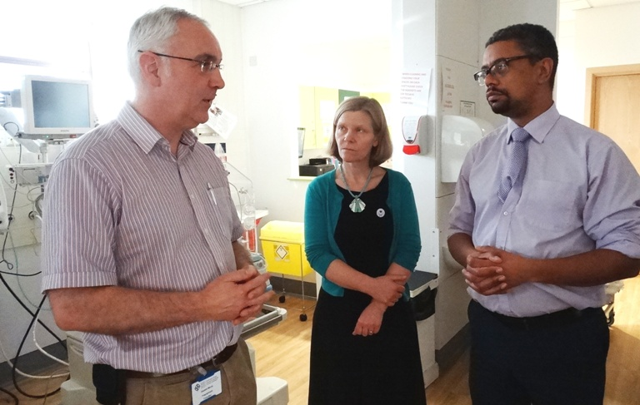
He wanted to find out more about an initiative by Singleton Hospital’s neonatal team to improve the way antibiotics are used to treat newborn babies as part of his on-going plan to meet winners and finalists at this year’s NHS Wales Awards.

Cabinet Secretary for Health Vaughan Gething with consultant neonatologist Geraint Morris and ABMU Vice-Chair Emma Woollett.

During a three-site visit to the health board, Mr Gething watched a presentation about the Managing Antibiotics Wisely project by consultant neonatologist Geraint Morris who explained how reducing inappropriate antibiotic use may also improve babies’ health later in life.

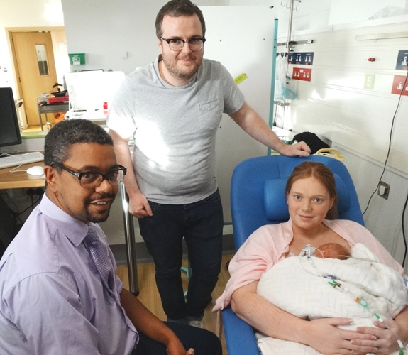
The project has seen a 43 per cent reduction in antibiotic use – double the original target and sustained over 12 months – with the unit recording one of its lowest death and serious illness rates of recent years.

Vaughan Gething meets Richard Knight and Kayleigh O’Sullivan with their daughter Frankie in the neonatal unit.

The Cabinet Secretary was also given the opportunity to tour the neonatal intensive care unit which is the first in Wales to offer Family Integrated Care, allowing parents to be involved in looking after their newborn babies.

He chatted to new parents who are practising FiCare and found out just how beneficial they have found it.

Mr Gething had another chance to talk patients about their care when he dropped in on a session by the Pulmonary Rehabilitation Service held at Forge Fach Community Resource Centre in Clydach.

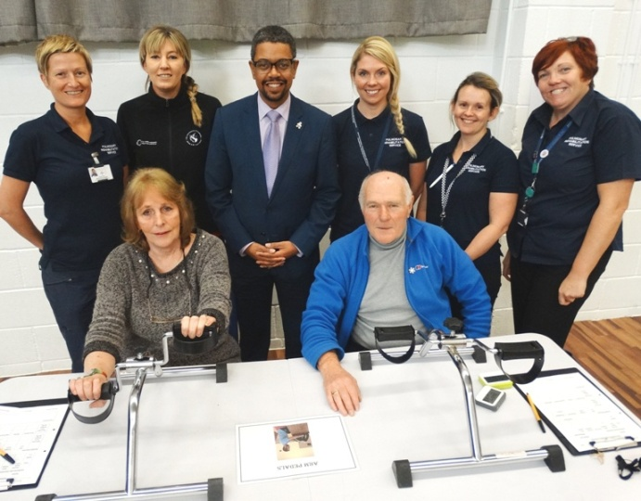
The service, set up with funding from the Welsh Government, sees multidisciplinary teams based around ABMU running specialised courses for patients to help them cope with their symptoms and improve their quality of life.

Patients and members of the Pulmonary Rehabilitation Service with Vaughan Gething.

The six-week courses include exercise programmes as well as lifestyle advice. Clinical lead for pulmonary rehabilitation Nicola Perry-Gower introduced the Cabinet Secretary to patients who were now planning to keep up their new healthier habits.

Earlier in the day Mr Gething was at Morriston Hospital and visited the children’s wards as well as finding out more about current demands facing its Emergency Department.

He was given a tour by consultant Dr Mark Poulden and the hospital’s interim Medical Director Dr Mark Ramsey who explained the ongoing demands on the department and the decision-making process to prioritise the most serious cases.

He also held a meeting with frontline nursing staff to hear at first-hand about their experiences of working in ED and the pressures they currently face during such a busy period.
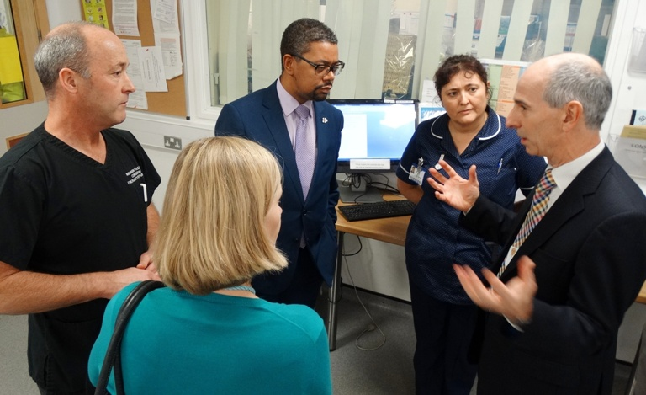
Dr Mark Ramsey (right) with Dr Mark Poulden, Mr Gething, Emma Woollett and head of nursing for emergency care Becky Gammon.

ABMU Vice-Chair Emma Woollett, who accompanied Mr Gething on his visits, thanked him for coming along and spending the day meeting health board staff and patients.

“I think it has been tremendously appreciated,” she said.

Mr Gething said: “I’m really keen to go round and see the people who have been nominated for NHS Wales Awards but also because there’s a whole range of staff that I may never get to see otherwise.

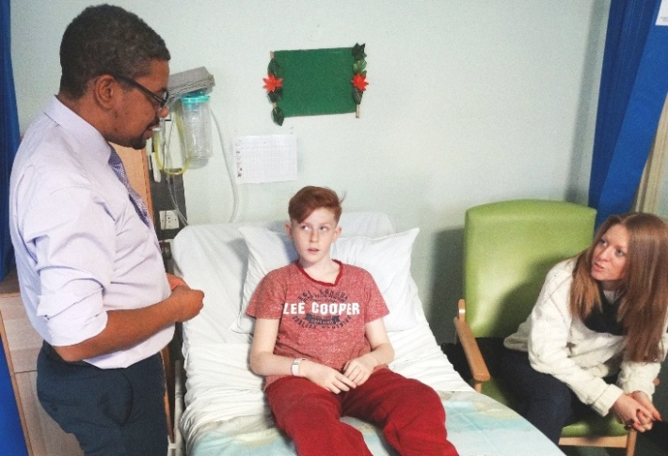
“I’ve found today extremely interesting. The more I understand about the services, the more it helps me.

“I appreciate the time everyone has given up. I have really enjoyed my day.”

Health Secretary Vaughan Gething in Oakwood Ward where he met 13-year-old Ieuan Gray and his family.

Source: Abertawe Bro Morgannwg University Health Board

