Kind-hearted Morriston cardiac team sends gifts to Ukraine children
Friday, 8 December 2017
They really are a big-hearted bunch in Morriston Hospital’s cardiac outpatient department.

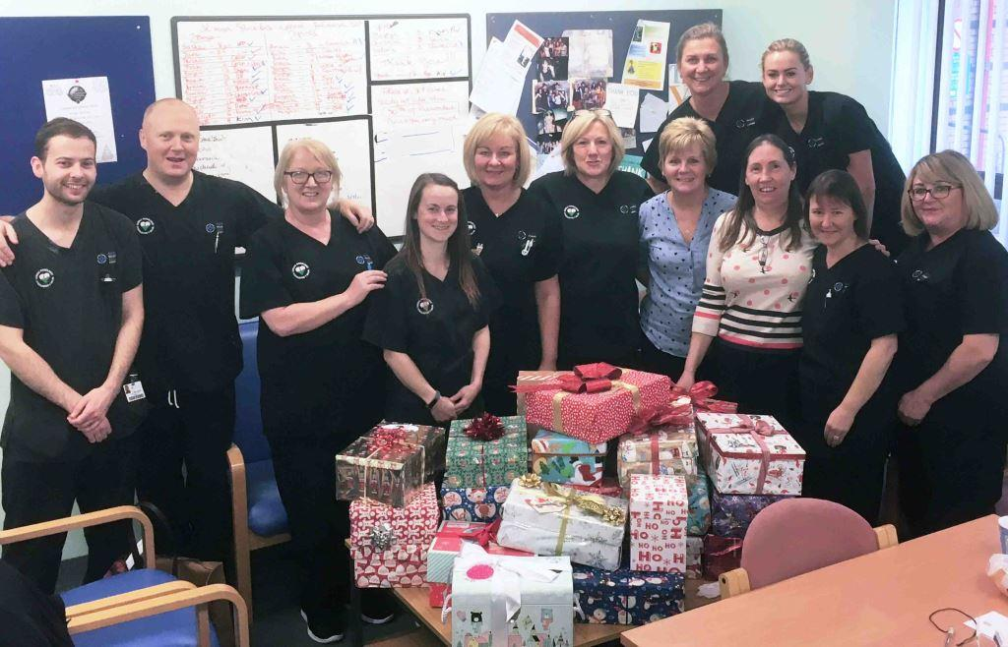
Staff there have collected more than 30 boxes full of festive presents, sweets, and warm hats and scarves.

These will be sent to children in Ukraine, all of whom have lost their father in the war against Russia.

It was the second year running cardiac outpatient staff have supported the appeal, which is organised by highly specialised cardiac physiologist Bohdana Bahlay, who is originally from Ukraine.

Bohdana has worked in Morriston since 2003, first as a student then, since 2006, as a full-time employee.

She is also a member of non-profitable charity group Voice of Ukraine Wales, which was founded in 2014.

“My colleagues took part in the Christmas Box appeal for the second time this year,” Bohdana said.

“I provided them with the names and ages of children, and each of my colleagues chose one and sometimes two children to prepare a shoebox for.

“This year we have 32 boxes. They will be sent to our contacts in Ukraine, who will distribute them directly to the children ready for Saint Nicholas Day, which is on December 19th.”

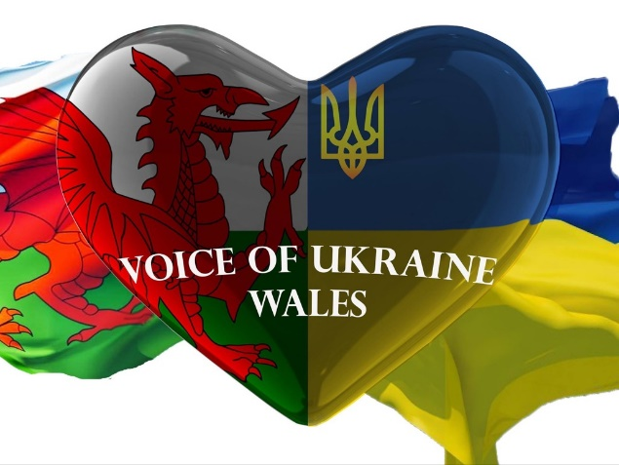
In Ukraine, St Nicholas - Svyatyy Mykolay – is the patron saint of children. On December 19th youngsters traditionally receive gifts, which St Nicholas leaves under their pillow while they are sleeping.

Altogether, Voice of Ukraine Wales will send more than 160 boxes to children in four counties in Ukraine ahead of the 19th.

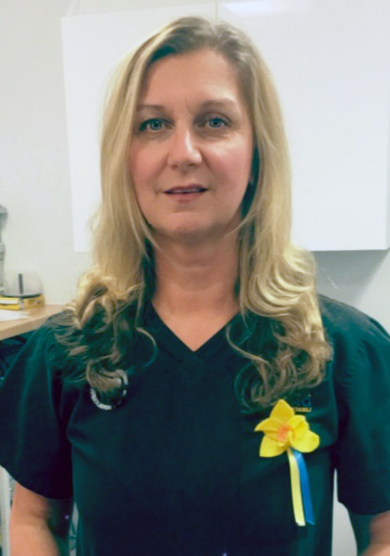
Bohdana (pictured right) said more than 700kg of warm clothes, blankets, shoes, toys, sweets and more would also be sent to an orphanage in the so-called "grey zone" which is on the border with occupied territories.

She said all this was only possible thanks to great support from friends, colleagues and neighbours of Voice of Ukraine members.

Bohdana added: “I am truly touched by the kindness, generosity and support shown by my colleagues in particular, and the people of Wales in general. Diolch yn fawr!”

Source: Abertawe Bro Morgannwg University Health Board

