Mum’s idea creates hospital soft play area
Friday, 22 December 2017
A new dedicated play area especially for youngsters visiting loved ones in hospital has been officially opened at Morriston Hospital.

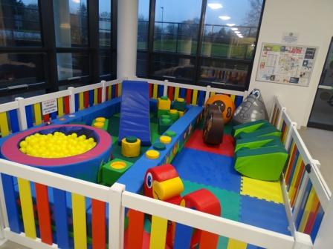
The area, in the main entrance hall, is somewhere where parents can take their children when visiting loved ones in hospital that is away from the wards. This is the result of a fundraising effort by Rachael Hughes, the wife of a patient and Morriston Rotary Club.

When Rachael’s husband Craig was in Morriston hospital earlier this year his little girl Melissa had to spend many hours at his bedside and it made mum Rachael realise that other families like theirs would welcome somewhere for children to play that was away from a busy ward.

Her idea was warmly welcomed by Morriston hospital’s Nurse Director Nicola Williams who has been working closely with Rachael to make her idea a reality.

Now, thanks to a fundraising campaign which collected a total of £5,100, the area, complete with a ball pit and soft play animals was declared open at a special celebration held at the hospital.

Mrs Hughes from Treboeth said: “We have raised a total of £3,600 ourselves and the Rotary Club contributed £1,500. The money was raised by hosting coffee afternoons, Morriston Comprehensive school held a non-school uniform day and cash tins were put in local shops, bars and restaurants”

Fun days were also held over the Summer in Crazy town, Gorseinon and at Morriston memorial hall where young volunteers from Morriston Play Scheme were face painting and putting glitter tattoos on youngsters.

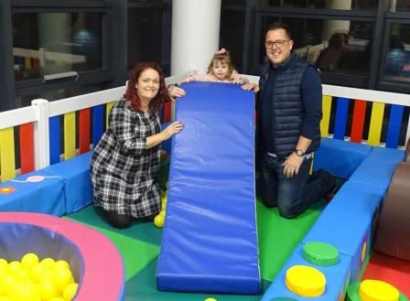
Picture: Rachael Hughes with daughter Melissa and husband Craig.

Nicola Williams said: “I just wanted to say a massive thank you to Rachael for all of her hard work, fundraising for this fantastic soft play area and also to Morriston Rotary Club who have supported Rachael in this and helped make it a reality.

“Without them both, we wouldn’t have this play area. It will mean so much for families with young children who have relatives in hospital who will now be able to come and spend some time away from ward areas and keep the little ones happy.”

Rachael added: “Morriston as a community have been absolutely brilliant and so generous. This soft play area would’ve totally transformed our experience as a family during Chris’ four months in hospital and I was desperate to get this in place as soon as possible”.

Source: Abertawe Bro Morgannwg University Health Board

