Party time for familiar faces at hospital unit
Friday, 15 December 2017
It was a case of friends reunited as former patients and their families returned to the Neuro Rehabilitation Unit at Neath Port Talbot Hospital for a festive celebration.

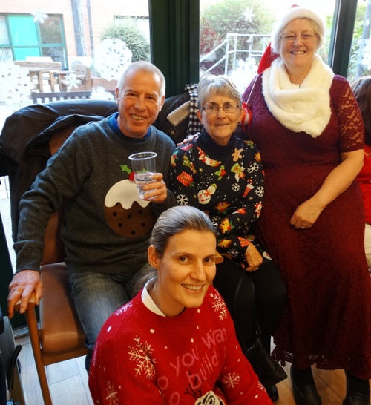
The unit, which looks after people from across the region as they recover from head injuries, hosts an annual Christmas party for those who have been treated there.

Unit manager Ann Ball said: “The party is a real highlight of our year. Patients can sometimes be here with us for quite a long time while they recover and we get to know them very well so it is always wonderful to see them again.

“All the staff really enjoy catching up with them and seeing how much progress they have made.

“It is also a chance for them to be reunited with their friends who are still here in the unit.”

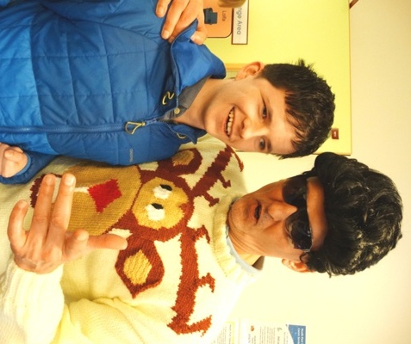
Joined by their families, the special guests enjoyed Christmas food and music and also had the chance to enter a raffle organised by ward clerk Jo Lewis. Featuring prizes donated by local businesses, all proceeds raised will go towards helping the unit’s patients.

Unit manager Ann Ball (above) joins guests at the Christmas party.

Former patient Nathan Davies makes his first return to the unit after discharge and is greeting by Elvis, alias physiotherapy technical instructor Lyndon Roderick

 | 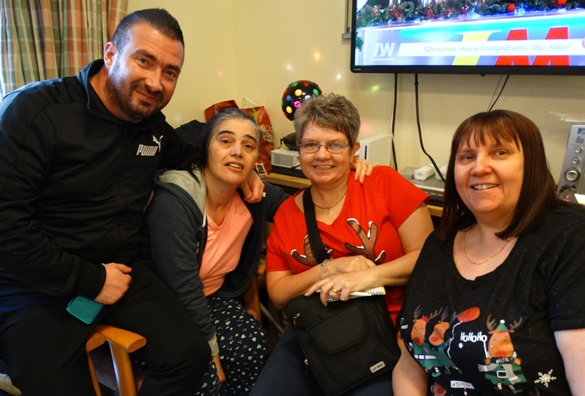 | 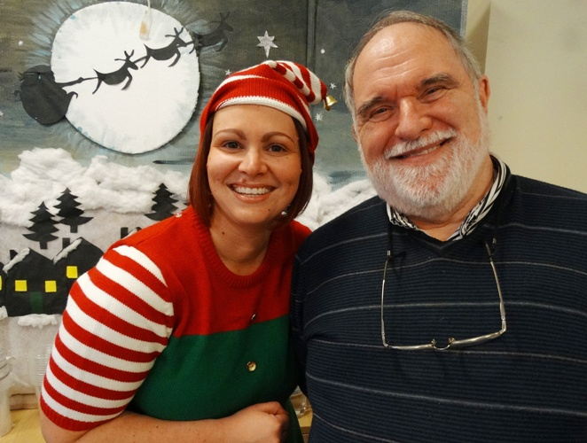

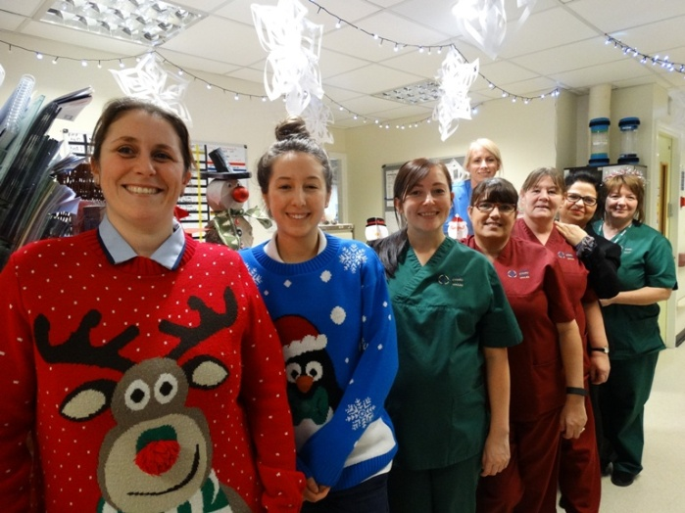

Source: Abertawe Bro Morgannwg University Health Board

