Santa spreads Christmas cheer as service celebrates with special party for patients
Friday, 22 December 2017
Festive fundraisers Leighton Edwards and wife Ruth have been finding out for themselves how the money they’ve raised over the years has been helping patients.

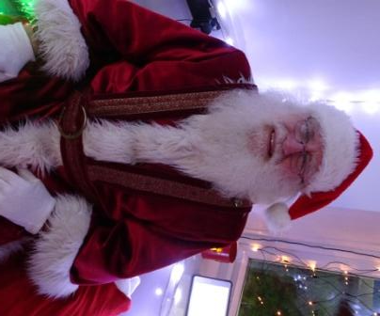
The couple from Glais visited Morriston Hospital’s Traumatic Brain Injury Service to meet some of the people who have benefited from their generous donations over the years.

Parents may not recognise Leighton’s face but he’s been Father Christmas at Wyevale Garden Centre in Llansamlet for many years.

Some of the money he raises doing his yuletide duties goes to the Traumatic Brain Injury Service (TBIS) Charitable Fund at Morriston – and over the years he has handed over close to £30,000.

Over the years Leighton has helped various local charities but for the past six years the couple have chosen to support the service in memory of their son Tom who was treated by the team.

Leighton said “What we do is so helpful to us. It’s therapeutic knowing that we’re giving something back to those who helped us and our son Tom. The service transforms people’s lives and the staff go above and beyond their job role”.

Ruth said “This service is amazing and the staff here help patients see what they have, not what they have lost. They are like one big, happy extended family”.

Leighton shaves off his beard after Christmas every year in a sponsored shave and all the money raised is also donated to the service, before he grows it to do it all over again the following year.
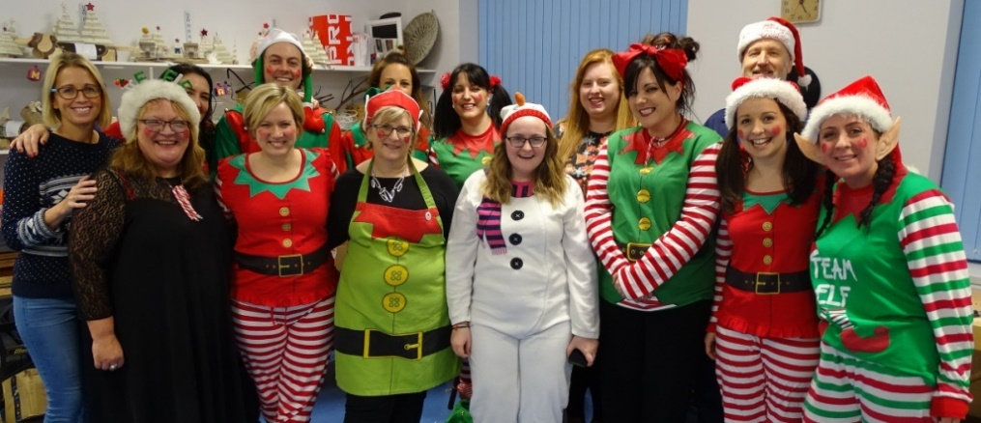
Staff at the Traumatic Brain Injury Service

Clinical psychologist Dr Zoe Fisher said “Ruth and Leighton don’t just contribute to our service financially but they also give us their time, ideas and enthusiasm.

“We are beyond grateful to have met such special people.

“The money they have raised has been used to fund assistive technology, photography and outdoor projects for patients. The money has also allowed us to develop a group space in our garden to support future neurorehabilitation projects.

“We would like to thank Ruth and Leighton from the bottom of our hearts for everything they have done for those living with brain injuries in ABMU and for our team.”
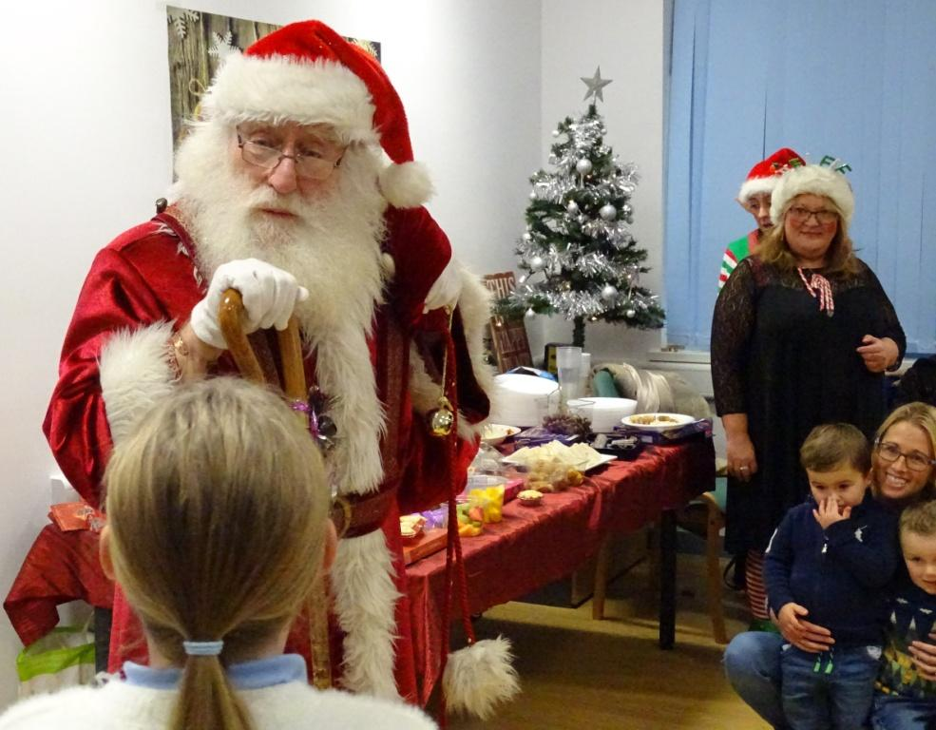
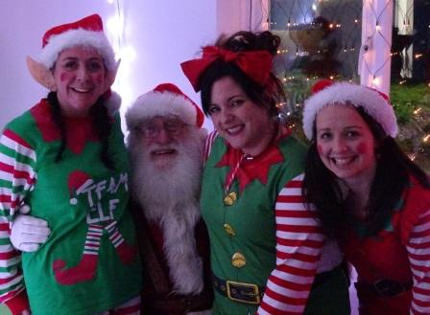
L-R – Medical secretary Suzanna Thomas, Father Christmas, Dr Zoe Fisher and speech therapist Hannah Davies.

Source: Abertawe Bro Morgannwg University Health Board

