Staff rewarded for making a difference during bumper celebration of great healthcare
Thursday, 21 December 2017
The health staff who brought care, support and smiles to ABMU patients throughout the year have been recognised at a series of award ceremonies to highlight their achievements.

The latest Patient Choice Awards saw seven separate events held to honour a total of 255 staff working across the health board area who had all been nominated by patients and their families.

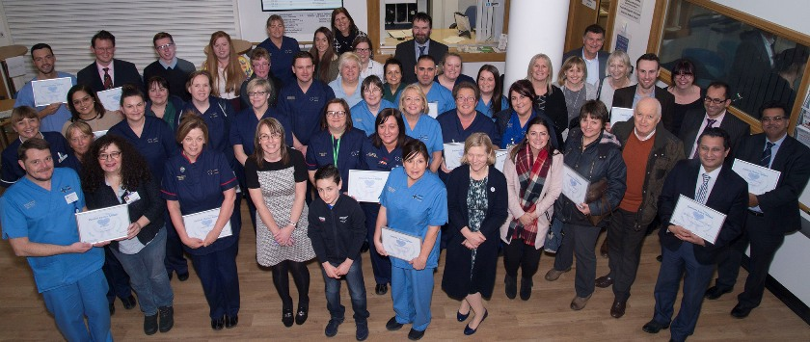
The winners of the 106 awards came from a wide range of disciplines including consultants, doctors, domestics, nursing staff, therapists and clerical staff but they were all united by the contribution they had made to the public.

The Patient Choice Awards were launched in 2015 to give patients, carers, relatives and visitors the chance to say thanks to a member of staff or team they feel have made a real difference and provided outstanding care.

It was that kind of care given to Michele Evans by the teams who supported her and her family during her unsuccessful battle against cancer that led to her widower Morgan nominating them for an award.

He said: “There were plenty of occasions when staff went above and beyond in their duties. Michelle had an incredibly tough time in the last three weeks of her life and the nurses and doctors fought ever so hard to keep her comfortable and pain free.”

Mr Evans nominated Vicky Lloyd and all the district nursing team, Dr Howells, Professor John Wagstaff and registrar Dr Ashley Poon King, Macmillan skin cancer specialist nurse David Phillips, Dr Gareth Watts and clinical nurse specialist Daniel Holmes at Ty Olwen and the whole of Ward 12 at Singleton Hospital

He added: “All too often we hear of the NHS's failings and I'm desperate to share my story because quite frankly without a lot of these staff the NHS and most certainly ABMU just wouldn't be able to function.

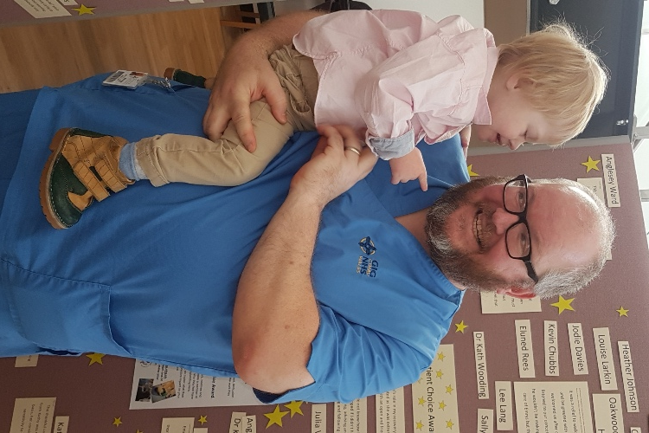
“We don't say thanks enough as a nation and I will try to change that if I can.”

Emrys with deputy charge nurse Kevin Chubb at the awards.

Bringing a smile to the faces of staff and guests at the Morriston event was two-year-old Emrys Morris-Guy whose mum Sarah nominated a host of staff her family encountered following his birth and diagnosis with Downs syndrome and a congenital heart defect and during his ongoing times of ill health.

“Without all of their support over the last 16 months, I don't know where we would be. We faced losing him on many occasions… but we were wishing he would be well enough to return to Oakwood.”

After spending time at hospitals in Bristol and Cardiff, Emrys was eventually transferred back to Swansea.

“This to us was the best news ever. It was a relief to walk in and see familiar faces and be greeted with open arms.

“All the staff welcomed us after our rocky journey. hey listened to our concerns after we thought that he wouldn't be making it home ever. They took care of Emrys but they also took care of us.”

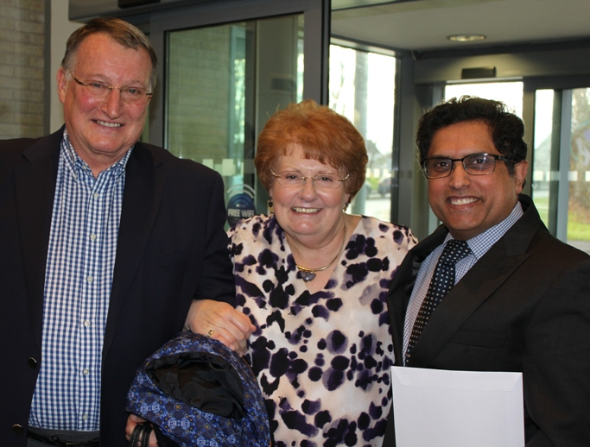
Consultant surgeon Amit Chandratreya with patient John Owen and his wife at the Princess of Wales Hospital event.

Also honoured was Lenny Williams, from Morriston’s Ward J who was nominated by the grandchildren of a patient whose reduced mental capacity meant he could no longer recognise them.

They said: “For us this was devastating. And then in came Lenny.

“We can honestly say we have never met anyone quite like Lenny before. As a healthcare support worker, Lenny had a way of connecting with our grandfather, where even we as family were failing.”

Besides the comfort he showed their grandad, they said the main reason for the nomination was “somehow, in all the despair and hopelessness we were facing, with his cheeky-chappie attitude, Lenny was able to make us smile, and even laugh, when we didn't want to, or didn't think we could”.

The Rheumatology Day Unit, under sister Ceri Ilsley, were singled out by patient Louise Pye whose progressive disease requires regular visits to Princess of Wales Hospital.

She said: “They have looked after me for many years and quite honestly I don't know how I would survive without them.

“It is a lovely feeling knowing that every one of the team knows me by name, and cares if I am thriving.”

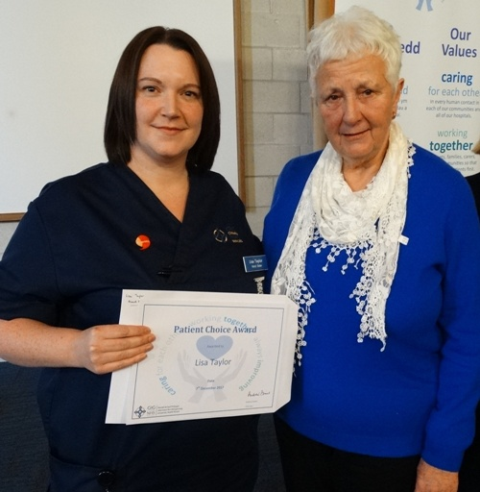
Putting forward the Neuro-Rehabilitation Ward at Neath Port Talbot Hospital, one long-term patient described their experience during their seven- month stay: “I received fantastic nursing care of the highest calibre. I didn’t ever press my button without it being answered immediately, this was very important because I was recovering from near complete paralysis.

“There is lots of adverse publicity about the NHS but I wanted to state that from my perspective, with this hospital, it is completely wrong.”

The awards provided a chance for an emotional reunion between Barbara Somerford, of Swansea, and Lisa Taylor, sister on Ward 8 at Singleton Hospital (above left).

Mrs Somerford nominated Lisa for an award for the care she showed her late husband Derek.

She said: “Lisa recognised my anxiety and distress, she would always be at the entrance of the ward as I arrived each day, she would greet me with a reassuring smile and take my arm.

“She would walk with me to his bedside and make sure everything was ok before leaving us to deal with the day.”

This year’s events also saw the youngest patient to make a nomination – nine-year-old Ben Hole who wanted to recognise staff nurse Debbie Criddle who looked after him at the Paediatric Assessment Unit.

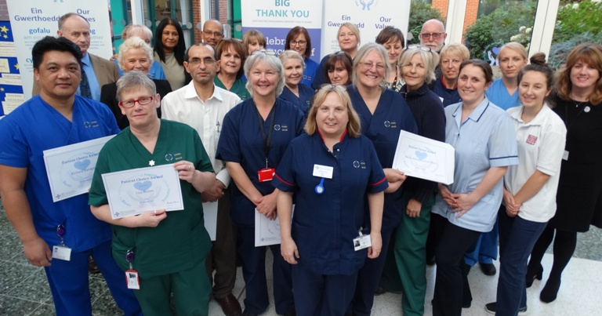
Ben said: “Debbie was very kind and funny and cheered me up. She was very honest and told me that my medicine would taste disgusting, which it did, but would make me better. “

Patient Choice Award winners at Neath Port Talbot Hospital.

ABMU Vice-Chairman Emma Woollett said: “These events are about recognising our staff who strived to provide high quality patient care every day, but for some patients this means so much, going the extra mile and providing exceptional care; who live our values and put the patients at the centre of everything they do.

“Thank you to all the patients, relatives and visitors who provided such outstanding feedback.”

She also congratulated staff on their achievements and added: “You should feel proud of the work you all do and the impact you have on the people in our care and their families.”

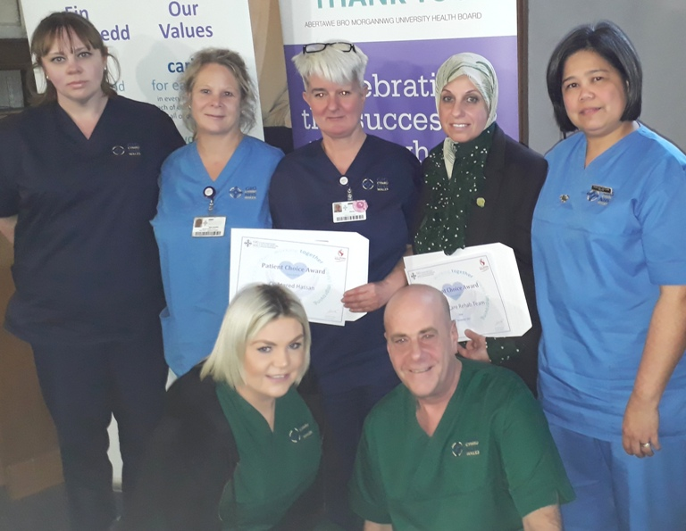
Staff from Gorseinon Hospital who received a Patient Choice Award.

Other award recipients were: Katrin Bilgram and Dorina Perhaita, POWH Ward 6 and Dr Rebecca Vincent, Angela Davies, Cerys Morgan, Dawn Kelly, Tabitha Oosterhouse, Leila Howells, Maternity Services NPTH (midwifery manager Chris Doran), Maternity Services POWH (sister Angela Hopkin), Michelle Allen, Stacey Leyshon, Luke Hathaway, Rod Williamson, Alan Ashcroft, Caroline Morris, Sue Johnson, POWH Short Stay Unit (sister Linda Wall), Kerry Castle, Sateesh Gokhale and POWH Ward 9 (sister Annette Riddoch), Matthew Wills, Michelle Webb, Sian Jones, Ian Phillips, Kirsty Jones, Mary Morris & Ophthalmology Team, Mark Freeman, Lee Cook, Abigail Davies, Karen Jones, Sophie Cornish, Aaron Wong, Martin Sevenoaks, Sriranj Kannoly, POWH Ward 4 (sister Delyth Darroch), Dawn Howes, Jane Griffiths, Amit Chandratreya, Linzi Thomas and team, Singleton Ward 10 (matron Sandra John), Robert Hill, Cheryl Tobin, Amit Kandhari, Laura Jones, Maha Mansour, Elin Whiskerd, Ellie Brown, Emily Horlock, Emma Renshaw, Erica Lewis,Gemma Leach, Grace Lewis, Julia Collins, NICU Unit (ward manager Katie Swain), Robyn Tayler, Sarah Thomas, Zac Roy, Claire Bell, Nicola Wainwright, Julie Gilbert-Coombs, Leanne Ashford, Singleton Ward 12, Victoria Jones, Clive Weston, Jordanna McCarley Roberts, Kirsty Hillier, Sara Widlake, Deborah Brook, Paula Bidder, Lisa Bevan, Richard Bacagan, Ujjal Choudhuri, Angharad Higgins, Diane Williams, Firdaus Adenwalla, Elderly Day Unit (sister Lynne Hall), Karen Thomas, Urology Specialist Nurse Team, NPTH Ward A (matron Vanessa Jones), Morriston Ward S, Amy Saunders, Bal Sanghera, Bindumol George, Caroline Morton, Claire Thomas, Kathy Love, Rhian John, Sarah Morris, Sophie Coslett, Stacy Davies, Stuart Davies, Susan Cave, Perdie Boyle, Lucy Davies, Morriston Ward F, Cardiac HDU and ICU, Aprim Youhana, Mandy Adams, Ira Goldmith Cardiac Short Stay Unit, Cyril Evans Ward, Julie Barnes, Paul Kenny, Morriston Ward B (junior sister Helen A Davies), Morriston Ward D, Sharon Davies, Pembroke Ward, Joanna Johnstone, Julia Warwick, Angela Morgans, Kate Harvey, Amar Ghattaura & Pembroke Surgical Team, Andrew Davies, Caroline Rees, Kathy Evans, Georgina Van De Pol, Balan Natarajan, Ffion Thomas, Amy Evans, Anna Hamilton, Arlene Davies, Jayne Howells, Katherine Wilson, Neil Fenn, Allyson James, Cara Joseph, Tom Fenn, plastic surgery outpatients department, Morriston Ward T, Burns Unit, Eleund Rees, Heather Johnson, Jo Morris, Jodie Davies, Judith White, Kath Wooding, Sharee Holland, Chris Bidder, Kevin Chubbs, Danielle Beynon, Lee Lang, Lorraine Brant-Bowen, Louise Larkin, Oakwood Paediatric HDU, Oakwood Ward, Rachel Lewis, Rachel Rees, Sally Matthews, Ty Olwen, Morriston Ward G, Oana Chirila, Christien Buchwald, Professor Bilal Al-Sarireh, Nadine Jones, Michelle Griffiths, Nicola James, Katherine Reed, Michelle Griffiths, Nicola James, Morriston Ward J, Christine Davies, Kalyan Dhar, Nagindra Das, Kerryn Lutchman-Singh, Thomas Bragg, Mark Jenkins, Ross Robinson, Morriston Ward H, Howard Allen and Margaret Armishaw, Morriston Clydach Ward, Emma Humphreys, Kathy O’Brien, Maria Ocampo (Amor) and Ben Boreham, The Grove Medical Centre, Bonymaen House, Acute Clinical Team, Gorseinon Hospital Team, Dr Gail Thomas, Liz Clarke- Smith and the Old Age Psychiatry team, Onnen Ward North Hub, District Nursing Team, Cwmfelin Health Centre, Andy Benford, Alison Stone, Central Hub Social Work Team, Karen Jones, Emma Price, Sian Dando , Singleton Ward 6, Louise Thomas, Alex Grimstead, Nicola Blackmore, Nicola Fox, Ceri Roche, Cheryl Piles, West Hub reablement team and domiciliary care team, Sam Watkins, Shirley Robart, Sue Huggleston, Rob Burnard, Maria Doyle, West Cross Day Service and the Rose Cross House Team.

Source: Abertawe Bro Morgannwg University Health Board

