Swans add star power to Morriston staff's fundraising calendar
Thursday, 28 December 2017
Swansea City stars have brought three months of guaranteed sunshine for nurses working in Morriston Hospital.

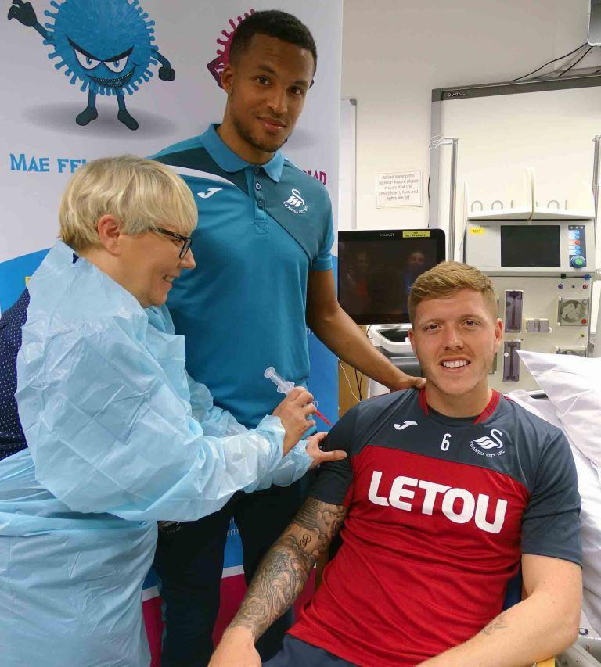
Three of the Premiership club’s famous names visited the Intensive Therapy Unit to take part in a fundraising photo-shoot.

Defenders Martin Olsson and Alife Mawson were joined by former striker turned club ambassador Lee Trundle. They happily mingled with staff, signing autographs and posing for photographs.

Alfie Mawson helps promote the importance of flu jabs, with Martin Olsson and Morriston Hospital head of nursing Ceri Matthews

Then it was down to the sort-of serious work of modelling for a calendar which the ITU team are producing to raise money for social activities.

ITU sister Melanie Phillips said: “We have a problem with staff retention, like many other places, and we want to break that cycle.

“We’re a huge unit and we want to do some team-building. The calendar is part of that and it started making a difference before we’d even finished it – everyone has been talking about it.

“We held a talent night to raise money to print the calendar. The money we raise from sales of the calendar will go to the nurses of the unit so we can organise some special days.

“We’ve been to Glastonbury, we’ve had a Wimbledon day, and we’ll be doing nice things for the staff at Christmas.”

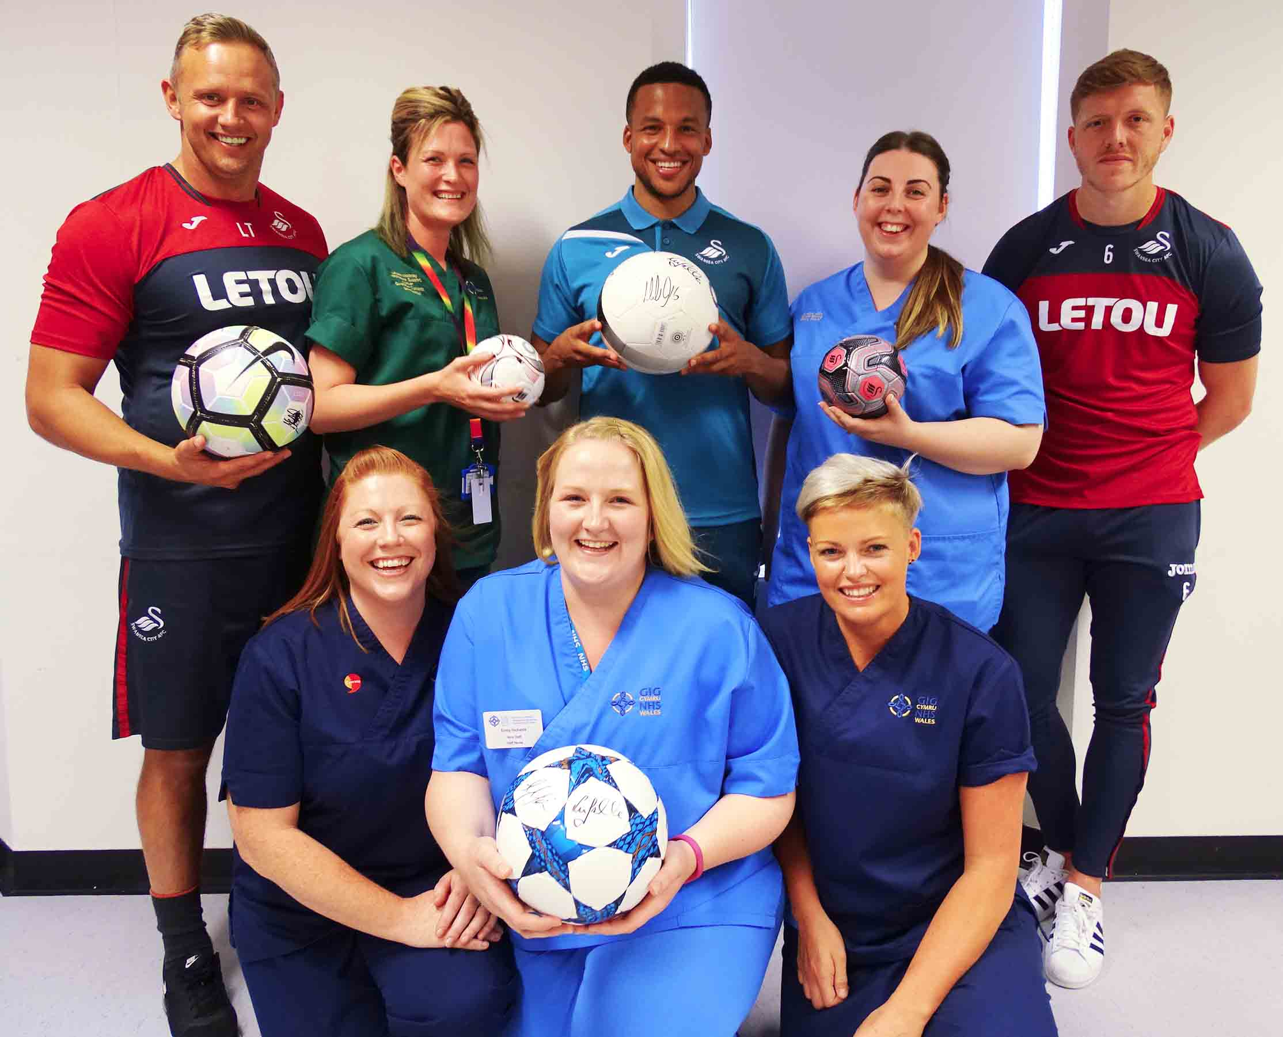
Right: Lee Trundle, Martin Olsson and Alfie Mawson with some very happy ITU staff

Staff nurse Leanne Bowen emailed the Swans to ask if they would support the calendar and was delighted when the club agreed.

Leanne said: “It’s about improving morale. With the nature of the job it can be quite a sad place to work and we’re bringing a bit of positivity and happiness back to try to keep people here.

“Relatives often want to give us money, to thank us for the care we’ve given. So now they can buy a calendar, knowing it will go directly to the staff and be something for all of us.”

Staff featured in other photographs for the calendar, with themes including Halloween for October, Festival of Light for November and a Christmas grotto for December.

For April, staff went to a farm owned by a staff nurse Ed Smale for a photoshoot that also involved the farm animals and Ed’s children. Some of the other staff’s children also feature in the calendar.

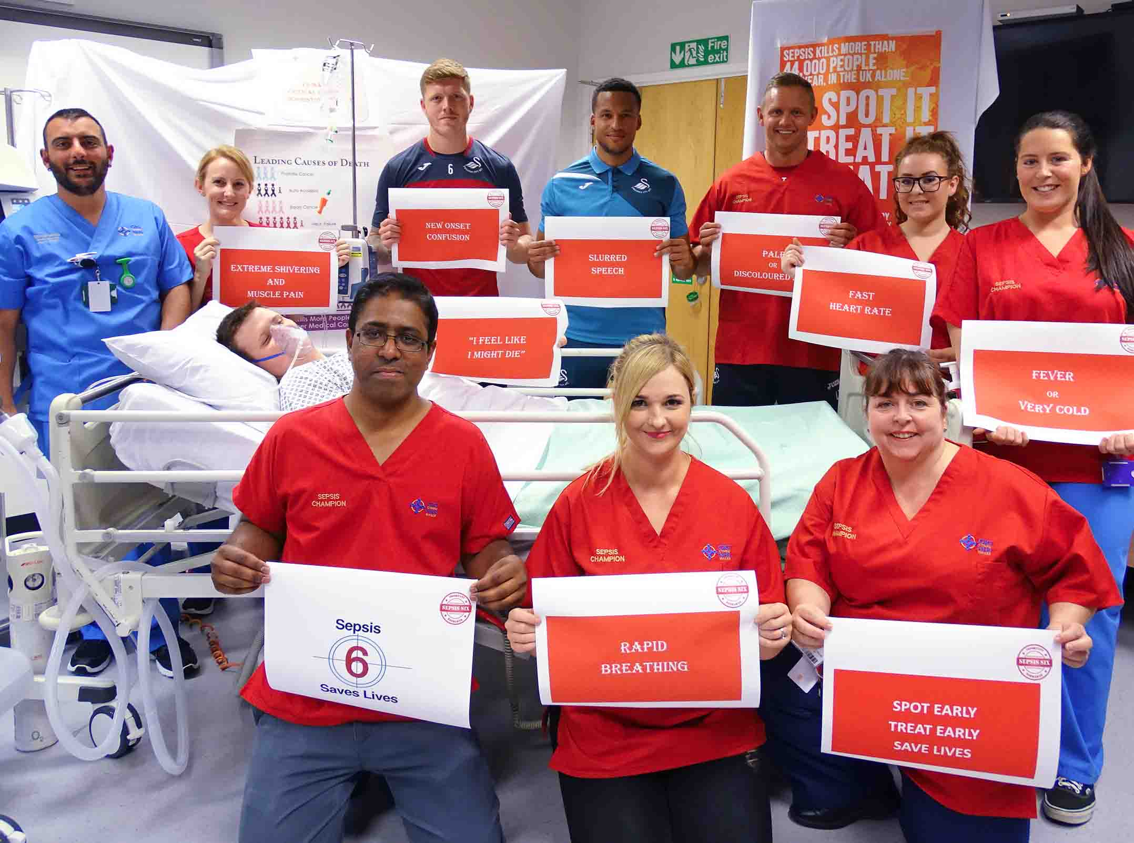
Left: Morriston Hospital’s campaign to promote the early diagnosis and treatment of sepsis is also highlighted

The Swans stars appear in photos for three months: one raising awareness of sepsis, another highlighting the importance of having the flu vaccine, and a third which – unsurprisingly – has a football theme.

Former striker Lee Trundle said it was great the club was able to help the hospital out.

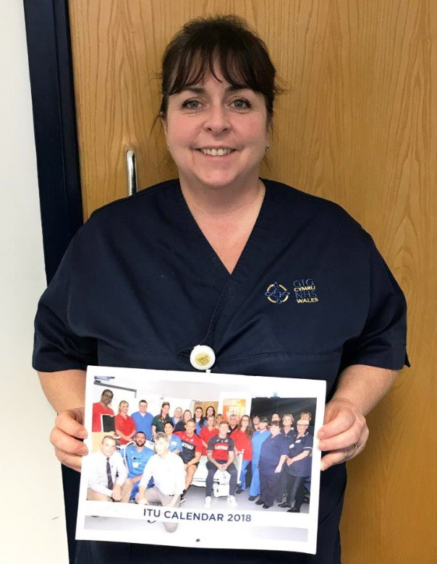
He added: “It’s important for people to look after their health in their everyday life. With this, it’s a great message to send out to the public and the city.

“We do a wide range of stuff, whether it is with schools, hospitals, different businesses, but it’s nice to come along to something like this and spend the afternoon with the staff. It’s been fun.”

Copies of the calendar can be ordered for £8 each. They are available by calling 01792 703447.

Melanie (pictured right with the new calendar) added: “We’d like to thank the Swans, staff and everyone who has supported us.”

Source: Abertawe Bro Morgannwg University Health Board

