Thanks to all who supported the Christmas Day lunch at NPT Hospital
Thursday, 28 December 2017
The Christmas Volunteer Lunch Project 2017 would like to offer a big thank you to this year’s volunteers.

It has been yet another successful year for the project which begun 14 years ago and has served over 370 lunches during this time.

The project originally catered for 15 mental health service users. However, with continued support from the local community and the generosity of ABMU staff the project has been sustainable and now caters for 30 people each year.
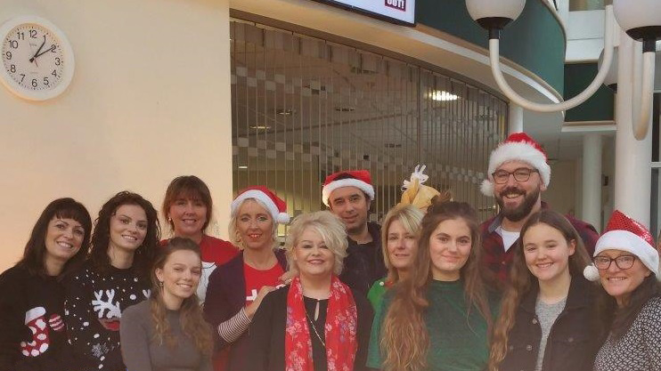
The project was nominated for an ABMU Chairman’s Award in 2015 and the support since has been overwhelming.

Left: Volunteers pictured at the Christmas Day lunch, which was held in the Neath Port Talbot Hospital atrium

The idea originated by CPN Sue Shannon Jones who retired in June 2013 and supported by Sue Dudgeon, Sian Davies, Diane Davies, Jane Briggs and Dr Annear.

Sue said she was driven to going the extra mile after speaking to service users who said they had not seen another human being over the Christmas period and had been desperate for company on Christmas day.

Organisation starts early in the year with the team sourcing funding for the lunches, donations of Christmas gifts, a take home Christmas supper and unpaid volunteers who give up their own Christmas morning/lunch to act as hostesses and entertainers.

The aim is to make Christmas day for those most vulnerable and alone a memorable experience full of warmth, love, affection and Christmas cheer.

Over the course of many weeks, donations of gifts will be accepted by staff, family and volunteer organisations – presents will be lovingly wrapped and packed ready for gift giving after the Christmas lunch.

A big thank you to all the volunteers and ABMU staff who have supported the project with their time and donations over recent years. Special thanks to the Volunteer Lunch Project Team/Mental Health staff who work tirelessly throughout the year to make this event a great success.

Thank you Jane Briggs (CPN), Wes Stewart (CMHT Manager), Sue Dudgeon (CPN), Jayne Whitney (Ward Manager) and Service Manager Donna Sharp for your continued support.

Wishing you all the very best in 2018 from the Christmas Volunteer Lunch Project.

Source: Abertawe Bro Morgannwg University Health Board

