Dietitian Debbie wins award for helping NHS staff manage the misery of IBS
Thursday, 6 December 2018
A dietitian has won a top award after helping dozens of people manage the misery of Irritable Bowel Syndrome.
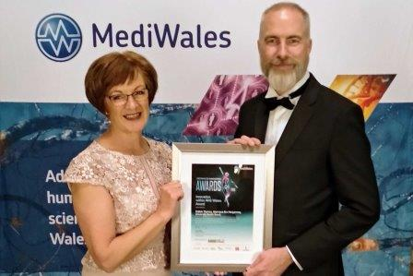
ABMU prescribing support dietitian Debbie Thomas triumphed in the Innovation in NHS Wales category of the MediWales Awards in Cardiff.

Debbie receives her award from Dr Rob Orford, the Welsh Government’s Scientific Adviser for Health

Debbie is already a Bevan Exemplar – part of a Wales-wide programme run by the Bevan Commission to support NHS staff leading projects that will improve patient care.

Last year, she was a finalist in the NHS Wales Awards for her work with five Bridgend GP surgeries on a pilot involving a diet which identifies and then eliminates trigger foods.

Debbie’s use of the low FODMAP diet has had amazing results since the pilot started in 2015, with more than three-quarters of the patients she saw reporting their IBS had eased or even disappeared.

That work with GP practices is continuing. However, due to its success, Debbie then started a separate pilot for ABMU staff.

This too has had resounding results, and led to Debbie being shortlisted for, and now winning, the MediWales Innovation Award.

“IBS can affect one in five people at some stage of their lives,” Debbie explained. “Based on national figures, around 79,000 people in the ABMU area will have it, including 2,400 staff.

“When I put the call out for people to take part in the pilot, I had so many responses for the first cohort that I had to start a waiting list for a second cohort, and I’m now working my way through the third.

“That shows the need is out there, and I see this award as being for the staff because without them I could never have done it.”

IBS can cause bloating, abdominal cramps and pain, excessive wind, diarrhoea with ‘urgency’ and constipation. It can have a huge impact on daily life.

Many sufferers report absence from work.

They often have to take medication to control the symptoms. Some may previously have been sent for a colonoscopy or endoscopy which, apart from being highly invasive, costs the NHS around £400 a time.

Others may get dietary advice such as looking at the regularity of their food, making sure they drink plenty of fluids and adjusting fibre. But, Debbie (pictured right) said, this had limited success.

FODMAP stands for Fermentable Oligosaccharides, Disaccharides, Monosaccharides and Polyols – carbohydrates that aren’t easily broken down and absorbed by the gut.

They ferment relatively quickly, releasing gases which can lead to bloating and other characteristic IBS symptoms.

High-FODMAP foods include some fruits and vegetables, animal milk, wheat products and beans.

People on the pilot projects usually see Debbie twice. The first is to remove all high-FODMAP foods from their diet.

The second, once symptoms have improved, is to start reintroducing them so they can identify trigger foods causing the problem.

So far, in the staff pilot cohorts, Debbie has seen 87 people, 62 of whom have completed the programme. All but one have had a reduction in symptoms.

One of those to have seen huge improvements is Senior Project Manager Tricia Jones, who works in ABMU’s strategy department and has had IBS for the past 10 years.

Tricia said: “The pain and discomfort are unbelievable. You wouldn’t think it of a tummy condition, but it’s really debilitating. It drags you down.

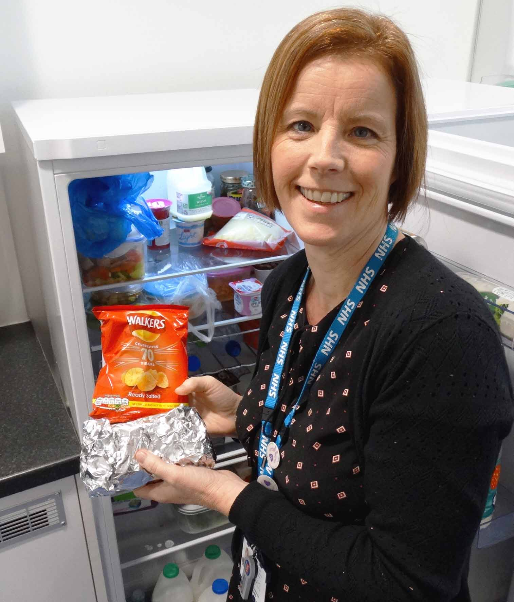
“You don’t really go out and eat things because you’re constantly looking for where the toilet is. It’s just life-changing.

“Now I go out, I know what I can eat and what I can’t eat so I’m not putting myself in a position to make me unwell. Deb and the diet have really transformed everything.”

Left: ABMU’s Tricia Jones now knows what she can safely eat – including a work lunch of a wheat-free sandwich and packet of crisps

Tricia, from Swansea, said some foods she thought were trigger-points turned out not to be – and vice-versa.

“You think you’ve been doing it right – but I’ve been doing it wrong. I wish I’d known about this diet 10 years ago. I still have some slight blips but I know how to deal with them now.

“It has been amazing.”

Debbie said there were many hidden costs associated with IBS, quite apart from the unpleasant symptoms.

For example, the 87 patients on the staff pilot had undergone 76 invasive examinations such as an endoscopy. With the average cost of £373 a time, this amounts to around £28,348.

“These invasive procedures are not without risk and pose a significant cost to the NHS, plus the indirect cost to the patient in time taken from work and recovery,” Debbie said.

Additionally, 87 members of staff had reported between them losing 293 work days in 2017 at an estimated cost to the organisations of £41,257.

Debbie said she was delighted not just to have won the MediWales Award but also to have made a difference to so many people’s lives.

“If staff are fit and healthy, they can look after patients more effectively and give them a better quality of care.

“They are not preoccupied with pain and discomfort, and worrying about where the toilet is.

“Hopefully, winning this award may help secure a long-term service for staff suffering from IBS, not just locally but across Wales.”

Source: Abertawe Bro Morgannwg University Health Board

