Digital innovation in Morriston renal unit under the spotlight during AM’s visit
Wednesday, 5 December 2018
Innovative use of digital technology at Morriston Hospital has come under the spotlight as part of a Wales-wide review.

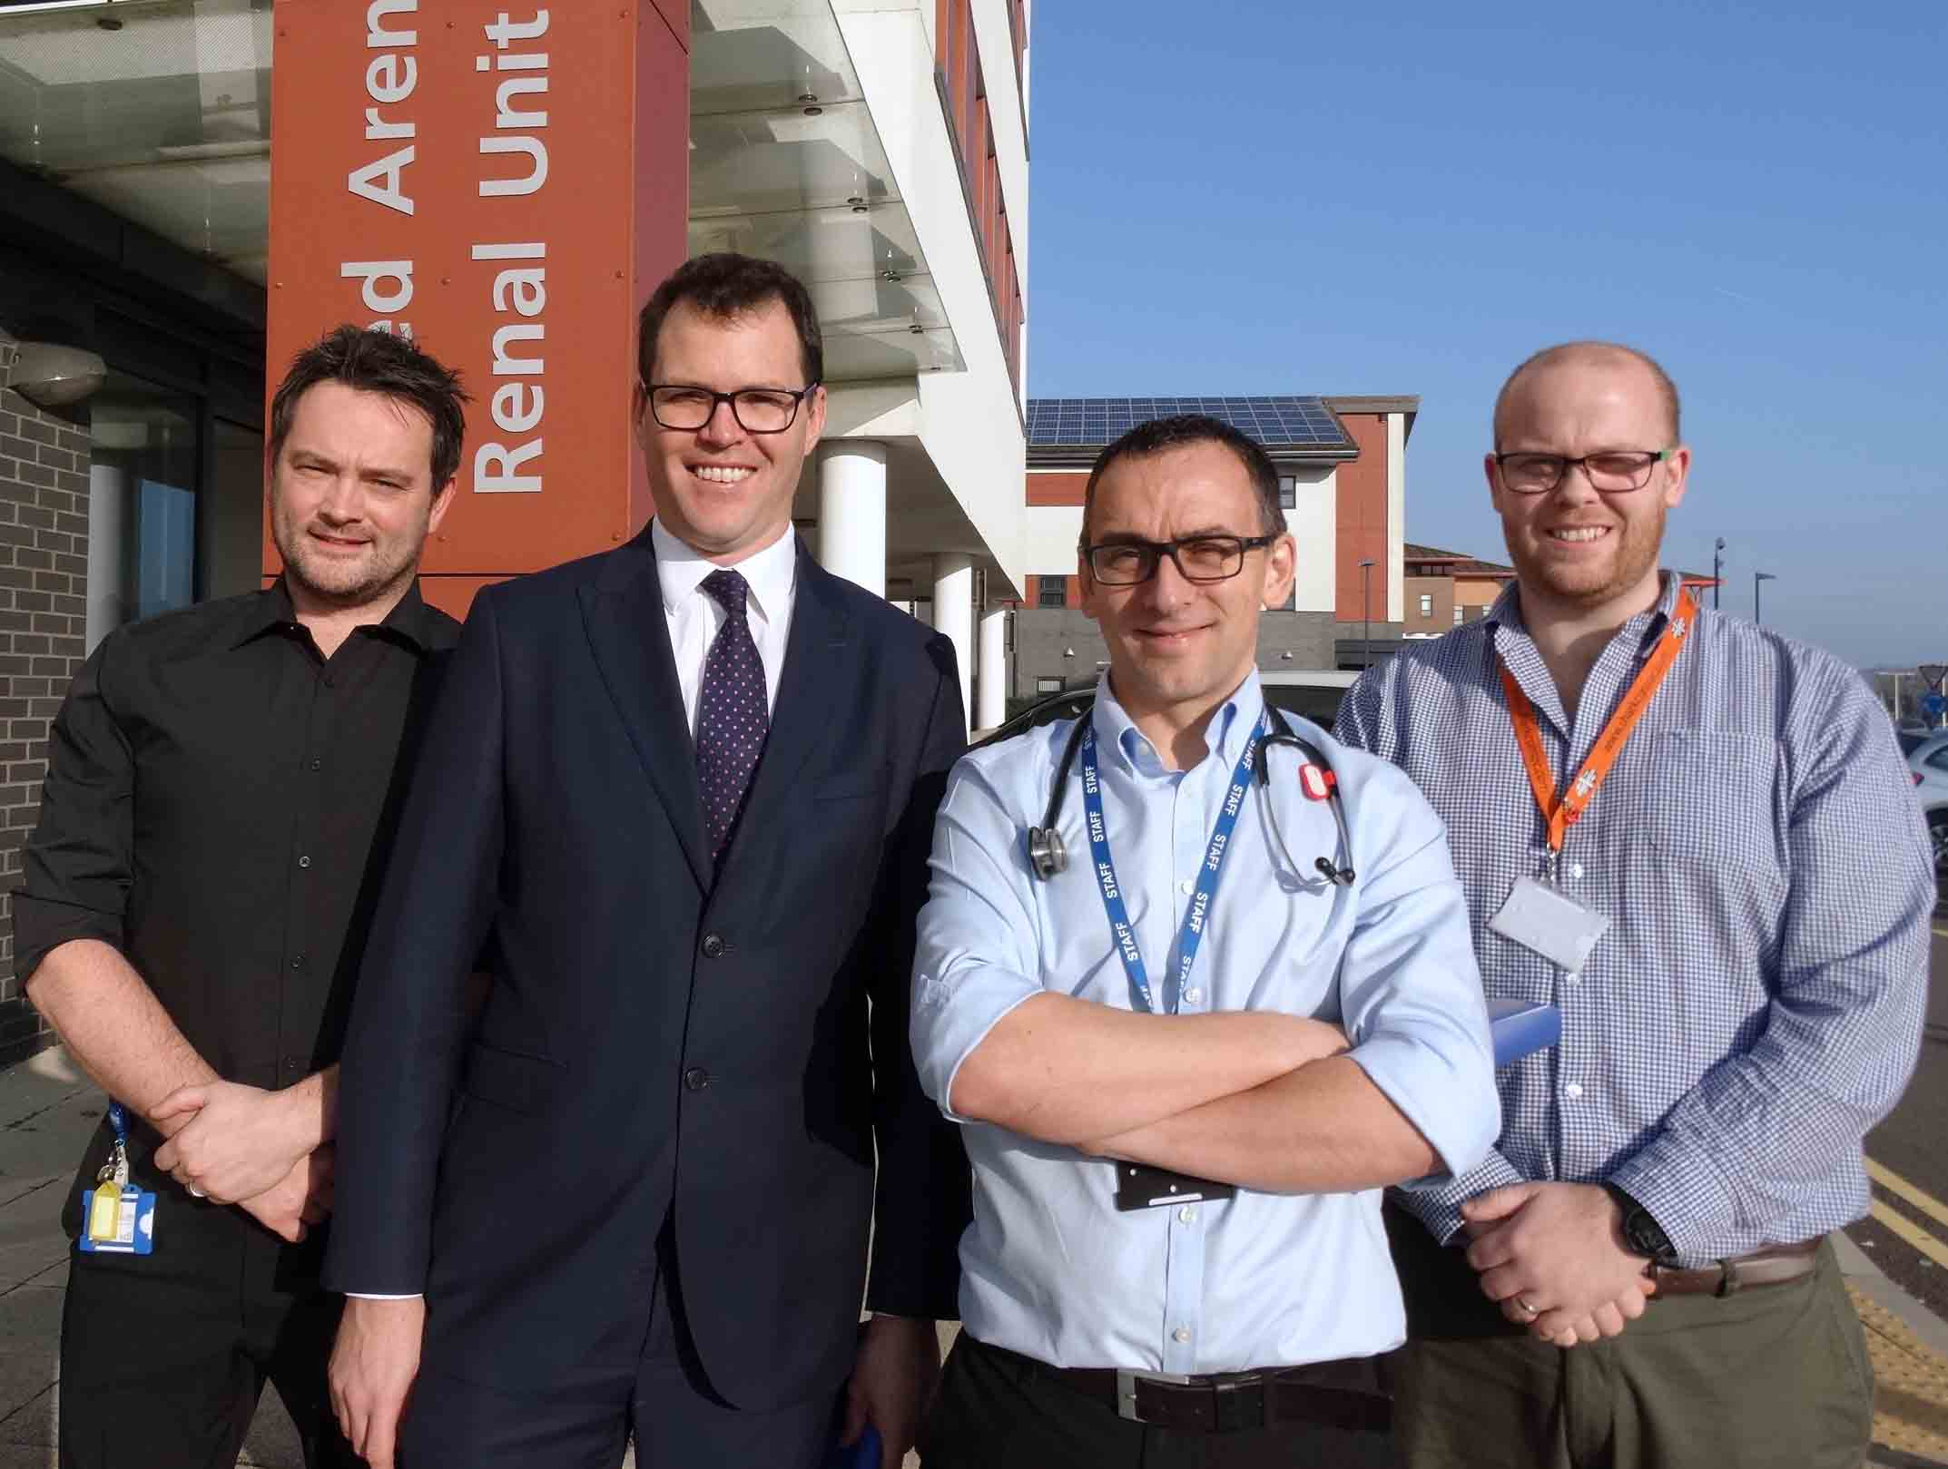
Llanelli AM Lee Waters is leading a digital panel into public service transformation on behalf of the Welsh Government.

Lee Waters AM (second left) with, l-r: consultant renal pharmacist Chris Brown, renal consultant James Chess and renal IT engineer Mike Wakelyn.

He visited Morriston Hospital where the renal unit has made pioneering advances in the use of digital technology.

This has not only improved the way care is delivered but also how people with kidney disease can access it.

Mr Waters saw the system in action and was given a presentation explaining how these improvements have been made over the years – and how clinical and IT staff came together to identify issues and find their own solutions.

This, the AM said, was what he found impressive. “It’s not just consultant-led or IT-led,” said Mr Waters.

“It was the whole team coming together and saying, how can we make what we do simpler and how do we develop new processes to make it smoother, for the benefit of patients?

“It’s a simple idea but devilishly complex to do. Yet they’ve been able to do it in Morriston, so if they can do it, others can do it too.

“What’s stopping that from happening is what the panel I’m leading is considering so we can make recommendations to the Welsh Government, hopefully in the next few weeks, of how to bring about change to the whole of Wales.”

Mr Waters met the team that made this happen: renal consultant James Chess, consultant renal pharmacist Chris Brown, senior renal pharmacy technician Dafydd James, renal IT engineer Mike Wakelyn, and renal sisters Debbie Hopkins and Melanie Jones.

Digital healthcare is vitally important because Morriston provides a regional renal service for thousands of patients across South West Wales.

This includes people needing dialysis or who have had a transplant, all of whom require complex and lifelong medication.

The renal unit has its own dedicated Renal Medicines Service, a specialist pharmacy team working with the nephrologists, nurses and the multi-disciplinary renal team to manage these treatments.

Chris Brown said the scale and complexity of the operation was astonishing.

He added: “Making our service digital is key to making high quality care possible. Digital tools are key to making our service and care records accessible to patients.”

The unit electronically prescribes and manages medicines through a module housed within a renal electronic patient record.

This e-record integrates every aspect of a patient’s care on a single platform, allowing for a highly efficient medicines management process.

It also puts patients at the centre of their own care, allowing them to make decisions about their treatments by giving them digital access to their information through their smartphone or computer.

The most recent development is an Electronic Prescribing and Medicines Administration (EPMA) system.

This will digitise the region’s hospital-based dialysis units in Swansea, Aberystwyth, Carmarthen and Haverfordwest.

Each week thousands of drugs and dialysis treatments are given in these units.

The renal EPMA is fully integrated into the e-record. This allows electronic prescribing and electronic recording of the administration of treatments in a single digital system – placing everything needed to deliver care at the fingertips of health professionals.

James Chess said: “The renal EPMA was designed in-house. This was not just a lower-cost option than buying a commercial system but also meant it could be developed specifically to meet the renal service’s requirements.”

Understanding what the entire clinical team needed ensured the EPMA met their requirements and was user-friendly – such as incorporating touch-screen technology so nurses can access it quickly at the bedside.

Mr Waters said: “The impressive thing about it is, it comes from the whole team; it has been an organic change driven locally.

“It isn’t some government minister saying I want you to do this.

“This is the people working on the front line saying, we think there’s a better way of doing this and we are going to show, locally, how that can be done.
“It’s real innovation in practice, overcoming all the barriers locally and showing there’s an alternative way to do it.”

Source: Abertawe Bro Morgannwg University Health Board

