Generous donation to lift spirits at Childrens ward this Christmas
Monday, 10 December 2018
Children in a Bridgend hospital can enjoy a range of new toys and games during their stay this Christmas, thanks to the generosity of a local choir.

Maternal Harmony have donated £1,000 to the children’s ward at Princess of Wales Hospital after raising the money at one of their concerts.

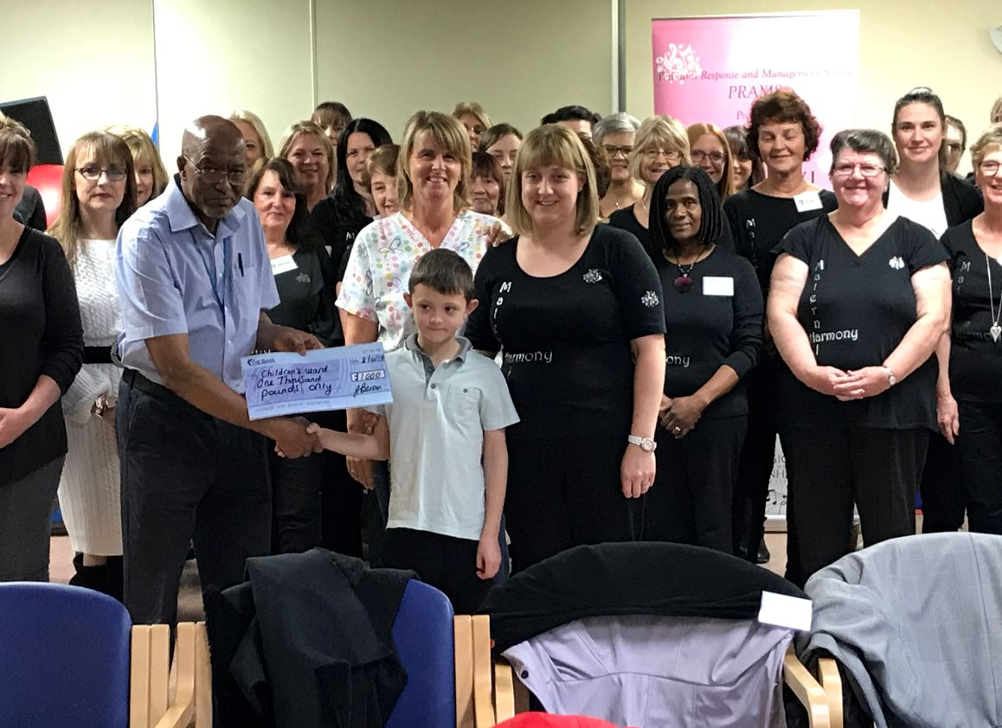
The new toys purchased came from a wish list written by eight-year old Thomas Bevan, a former patient at the ward.

Pictured left: Thomas and Maternal Harmony handing over the cheque to Dr Danladi Abubakar and ward staff.

Thomas spent last Christmas there following his diagnosis of post streptaccocol glomerulonephritis, which is an inflammation of the kidneys.

His mum Joanne is Maternal Harmony’s musical director.

The choir was set up in 2013 by the Perinatal Response and Management Service (PRAMS) at the Princess of Wales Hospital.

Joanne said: “The staff on the ward were amazing and did everything that they could for Thomas.

“He was obviously very upset that he was going to miss Christmas.”

While Thomas’s kidneys were trying to repair themselves, his blood pressure became very high.

Joanne said: “The staff at the ward were so on top of this.

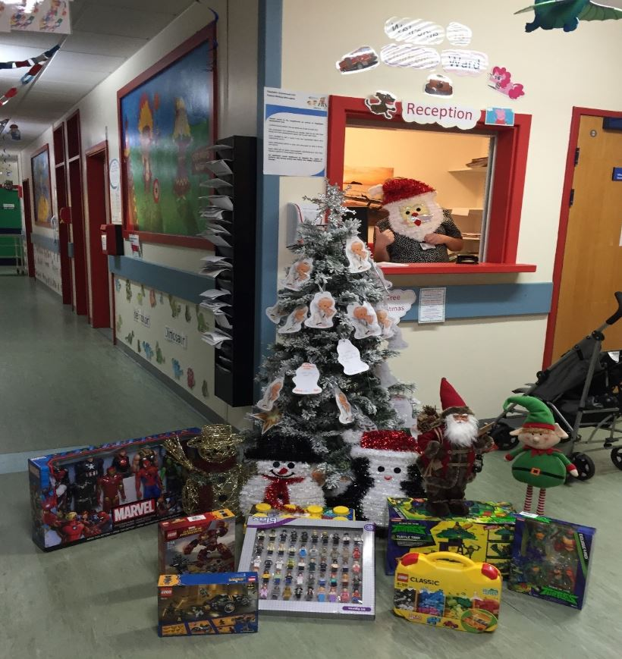
“Dr Danladi Abubakar became his main consultant and was so good with him. Thomas had to have so many blood tests that this became a big trauma to him and he would only let Dr Danladi Abubakar do it.”

Joanne explained that the toy room at the ward was what kept Thomas going during his time there, but she noticed that there was not a lot there to do for children his age.

Pictured right: the toys purchased for the children’s ward

She said: “That’s where I got the idea to donate the money from our concert, so that the children’s ward could buy more toys.”

Thomas, who is now fit and well thanks to the care he received at the ward, handed over the generous donation to staff from the children’s ward at Princess of Wales Hospital, including Dr Abubakar.

Ward manager Lisa Jenkins said: “We are overwhelmed with the donation.

“We have used the donation to start ticking off Thomas’s wish list and purchased several of his recommendations which are already going down a storm so we can’t thank him enough.

“We have also purchased some Christmas items to hopefully make the ward feel homely and Christmassy over the festive season for the youngsters staying with us.

“We want to say a massive thank you to Maternal Harmony for all of their support – it will really make a difference to the children’s Christmas this year.”

Source: Abertawe Bro Morgannwg University Health Board

