Key emergency information on your own fridge door
Tuesday, 18 December 2018
Do you ever worry about what would happen if you were suddenly taken ill or had a fall at home? Who would let your loved ones know and what would happen to your pet?

Well, there is no need to fret any longer because a new scheme called My Winter Health Plan is helping to take some of the worry out of keeping safe and well this winter.

My Winter Health Plan is ideal for anyone with a long term physical or mental health problem, especially if they live on their own, and older people who need support.

The plan is a simple form that you can fill in and keep at home to make sure that if an emergency medic is called to your house, they will have instant access to all your important medical information – thus making sure you get the best, fastest and most appropriate care.

Each form comes with a magnet so that you can stick it to the fridge or another prominent place, where it can easily be seen in an emergency.

The form asks for information about:
- Your health conditions and the medication you are taking for them
- Contact details for any specialist nurses or teams supporting you
- Location of your care notes and prescriptions
- Contact details for your GP
- Details of a relative, friend or neighbour to contact in an emergency
- Contact details for your usual pharmacy
- Details of any people or pets who rely on you so that alternative care can be arranged
The idea has been widely welcomed by GPs, carers and older people’s groups. They include Dr Rebecca Jones, from Dulais Valley Primary Care Centre in Seven Sisters, who said:

“I am really keen that people living with a long term health condition have a winter health plan, especially if they live on their own. It can be stored somewhere visible for visitors with the fridge magnet included and it will really help any health care professionals who need to visit in an emergency.

“There are a lot of older people and people with chronic conditions living in this area who could really benefit from using this plan.”

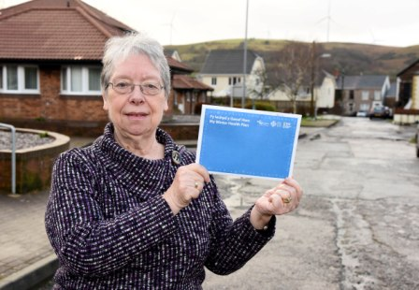
Mari Thomas, (left) chair of Cwmgors OAP Association, also thinks the plan is a great idea.

“People are living longer now and with an ageing population and the problems of dementia, the need for this is coming to the fore. A lot of old people live on their own and their families live away or are working… my own daughter lives 230 miles away and I know that is not unusual.

“When you have an accident or are taken ill you get disoriented and that’s why this scheme is so important because all your vital information is in one place.”

Janris Lightfoot, (below) who is also a member of Cwmgors OAP Association, said:

“I think this is a very good idea because if you have to have an emergency medic out they will know straight away what medicines you are on and who to contact.

“We are very keen to spread the word locally about the plan. People don’t like to admit that they can’t manage by themselves any more or need help, but filling in this form could help save valuable time if they are taken ill.”
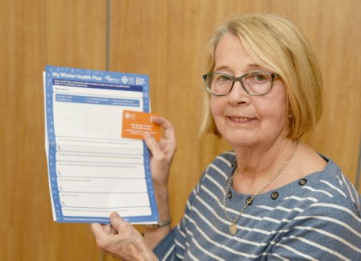
“If people don’t wish to leave the form on public display on the fridge, they can use the magnet to pin a card to the fridge saying where the form is kept,” added Mari Thomas.

The My Winter Health Plan packs are being handed out in a variety of venues including community pharmacies, voluntary organisations and GP surgeries. They are also available online.

Helen Evans, of the Council for Voluntary Service (CVS), is spreading the word in the Neath Port Talbot area.

She said: “The plan is a really good idea. It brings all the information together in one place where it can easily be found. It’s been welcomed by voluntary groups that support carers and older people groups and they are keen to spread the word about it.

“It’s also reassuring for people. It’s not always possible to remember all the medication that you take, so it’s helpful to know the information is there for whoever needs it.”

Filling in the form also makes sure your pet will be cared for if you are taken ill, as there is a section to give instructions about who to contact.

“I walk a dog for a couple who are both in their 90s,” said Dr Rebecca Jones. “They both ended up in hospital and there was no-one to care for their dog. Luckily the couple’s daughter soon had it all under control, but making sure emergency health workers know who to contact about your pet will provide peace of mind.”
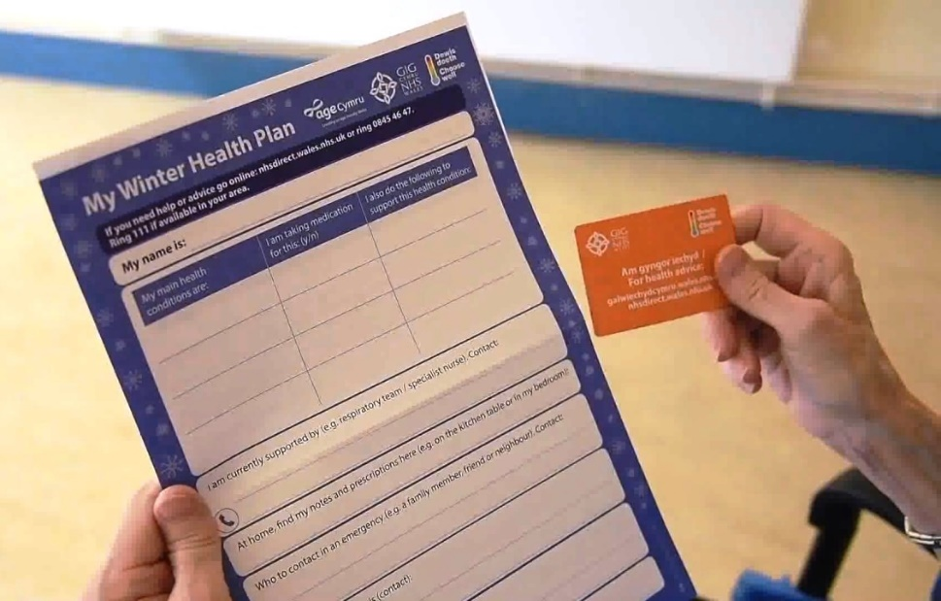
The form can be filled in by the patient, their carer, relative or medical professional. It’s important that it is completed in block capitals, to make sure it is easy to read.

*The packs are available across the ABMU health board area (Swansea, Neath, Port Talbot, Bridgend) and you can pick one up from your local pharmacy, doctor’s surgery,
and from voluntary organisations.

They are also available from the district nursing service, as well as audiology, speech and language, chronic pain, muscular skeletal and podiatry departments.

*You can also download a pack from the NHS Direct website:
http://www.nhsdirect.wales.nhs.uk/livewell/lifestylewellbeing/winterhealthplan

*To find out more about services and support in your area, you can also visit the 111 Directory of Services: https://www.nhsdirect.wales.nhs.uk/LocalServices/Default.aspx

Keeping safe and well this winter

The My Winter Health Plan pack also contains useful tips on keeping well in winter, such as wearing layers to keep warm, making sure you eat at least one hot meal a day and getting rid of baggy old slippers to avoid falls.

It also advises checking if you are entitled to a free flu jab, and stocking up on tinned and frozen food so you don’t have to venture out in icy weather.

Helen Evans, of Neath Port Talbot CVS, also suggests people wear a Lifeline alarm which can be pressed in case of a fall or a medical emergency.

“I would also suggest keeping a mobile phone fully charged even if you don’t normally use one, to call for help if there is a power cut. Keeping a torch handy is also a good idea,” she added
.
*More information about obtaining a Lifeline alarm in the Neath Port Talbot area can be obtained by ringing 01639 686802 or at

www.npt.gov.uk/media/4919/crt_assistive_technology_leaflet_eng.pdf

*In Swansea ring 01792 648999 or see https://www.swansea.gov.uk/article/6028/Community-Alarms-Lifelines
*In Bridgend ring 01656 642279 or see www.ageingwellbridgend.co.uk/falls-prevention/telecare-mobile-response-team

You can also watch the video: https://www.youtube.com/watch?v=lI5SuehlHro

Source: Abertawe Bro Morgannwg University Health Board

