School pupils spread Christmas cheer to patients
Thursday, 20 December 2018
Children from a local school have brought smiles to the faces of many patients at Neath Port Talbot Hospital.

They made Christmas cards for each patient to help cheer them up during what can be a lonely time of year.
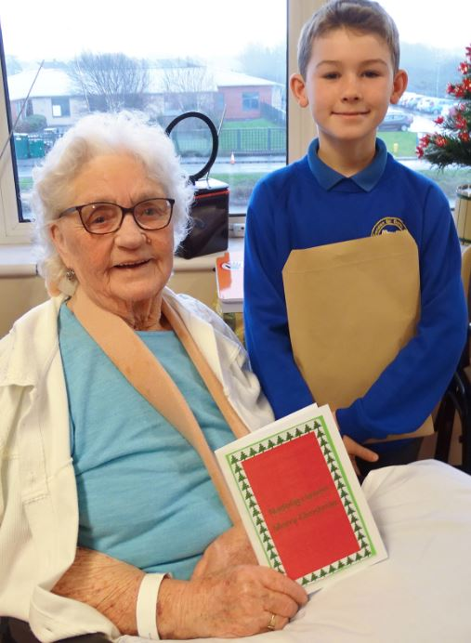
This week the pupils, who are from Ysgol Y Ferch o’r Sger, made a very special visit to hand deliver their cards.

Pictured left: Year 6 school pupil Rowan Clark handing over his Christmas card to patient Margaret Jones.

Unit Nurse Director Lesley Jenkins said: “Christmas can be a difficult time for lots of our patients, many of whom are frail and elderly.

“Being on a hospital ward, some people can feel as though life is going on outside without them.

“It was heart-warming to see the love and Christmas cheer that the pupils brought to every one of our patients.

“It reassured them that someone cares”.

As a Welsh medium school, pupils from Ysgol Y Ferch o’r Sger first visited the hospital back in April to learn about the use of Welsh language in the NHS.

Headteacher Rhiannon Dixon said: “It was on our visit back in April where we thought it would be nice to come back and do something for the patients.”

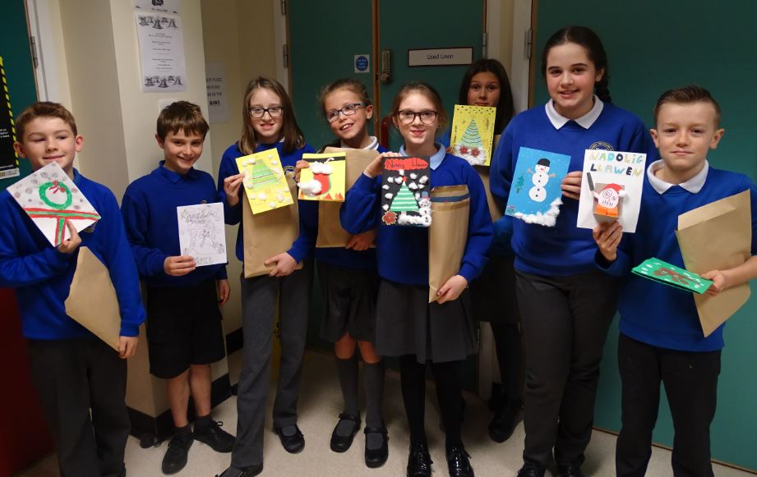
Pictured right: Year 6 pupils before they entered the ward at Neath Port Talbot Hospital

Patients also enjoyed time away from their beds, as they listened to a range of Christmas carols in the atrium also sung by the school children.

Lesley said: “The patients loved hearing the school children singing.

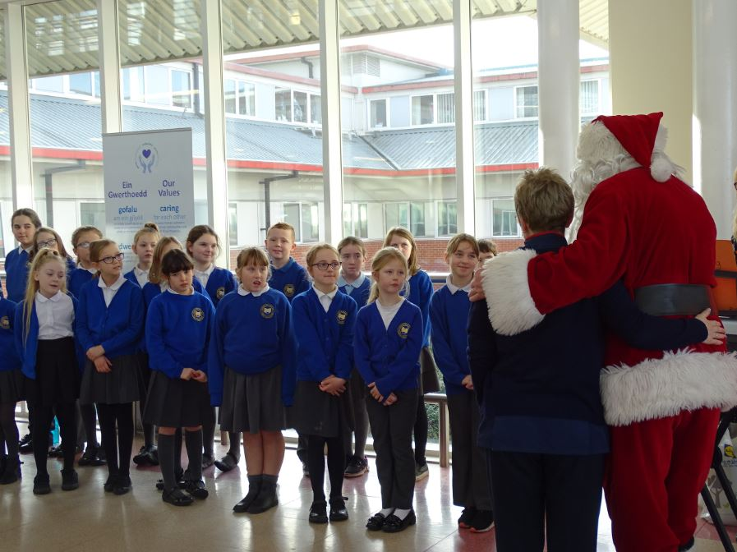
“It was a really nice change to their day.

Pictured left: Father Christmas and Senior Matron Olwen Morgan watch as the pupils sing Christmas Carols

“The Welsh carols were particularly special to many of our Welsh speaking patients in the hospital.”

Doreen, Nancy and Mary thoroughly enjoyed the carol service.

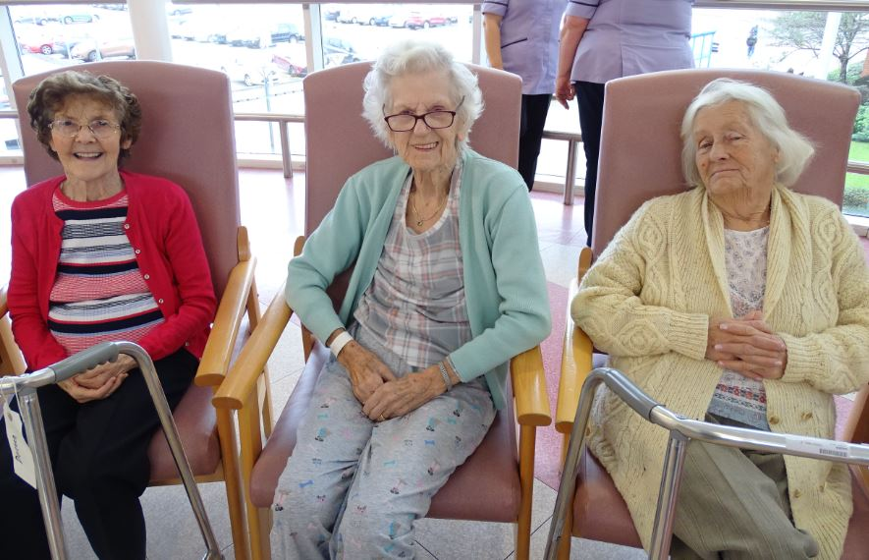
Doreen said how touching it was to hear the carols. She said: “I was almost in tears. They were wonderful.”

Pictured right: Patients Doreen, Nancy and Mary enjoying the carol service in the atrium

Ms Dixon added: “The children had a lovely time.

“It was really important for them to see that Christmas is not only about receiving presents –that it’s about giving and caring for others.”

Lesley said: “As a hospital we thank them from the bottom of our hearts for this lovely gesture and we are sure it made the patients day and Christmas.”

Source: Abertawe Bro Morgannwg University Health Board

