Sporting stars surprise patients at children’s wards
Friday, 21 December 2018
Christmas came early for patients on the children’s wards at Morriston Hospital in Swansea.
They had a surprise visit from both Ospreys rugby and Swansea City football stars who handed out goodies.
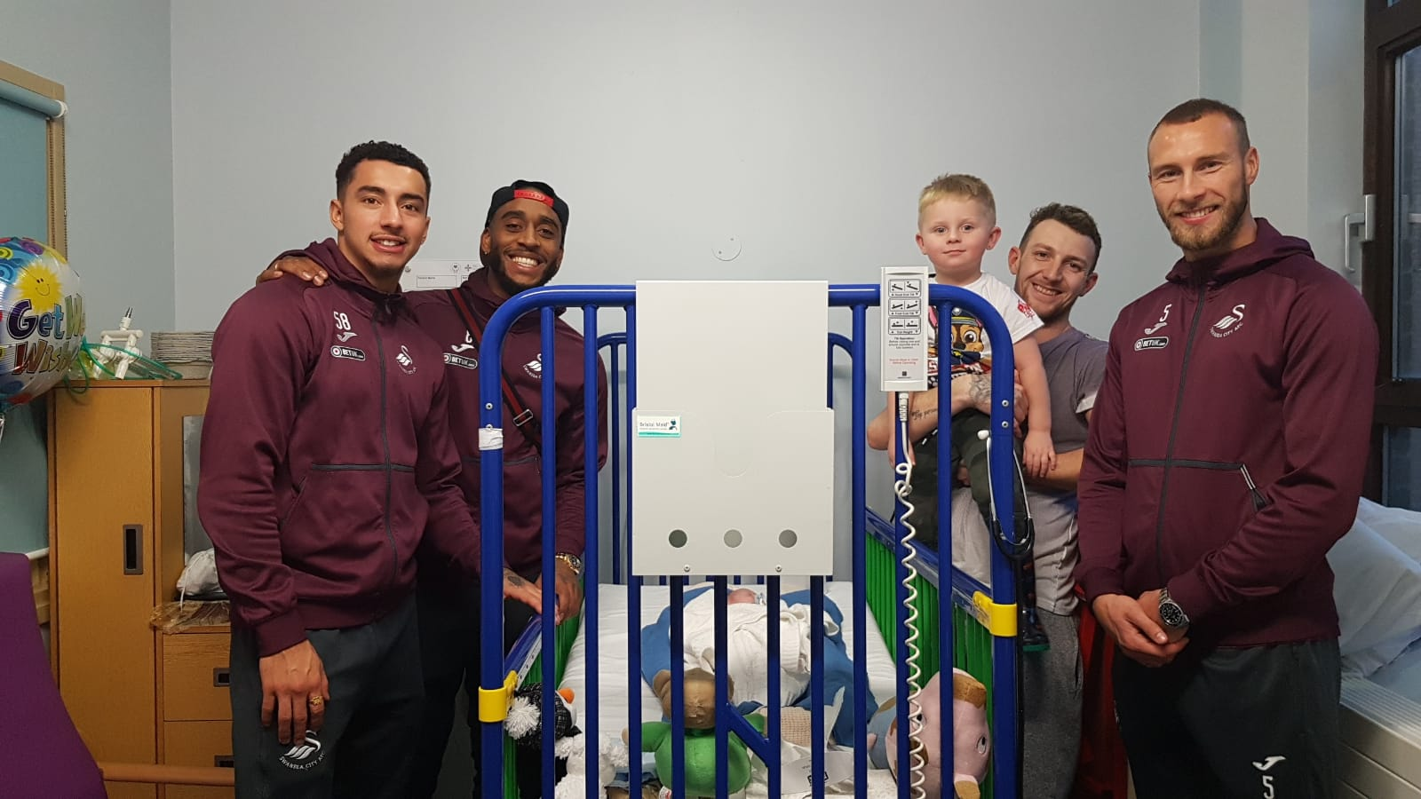
Pictured left: Swans players with patients from the children’s ward

There was excitement across the ward as players spoke to patients and posed for selfies.

Children’s Services Matron Vicki Burridge said: “The patients were thrilled to meet the players.

“We told them in the morning that they were coming, and they were so excited.

“Christmas can be a really tough time for them being in hospital whilst their friends are at home enjoying Christmas. So it was lovely to see the smiles on their faces and the parents.”

The ward also received a donation from the Ospreys, which will go towards the purchase of beds for the parents.

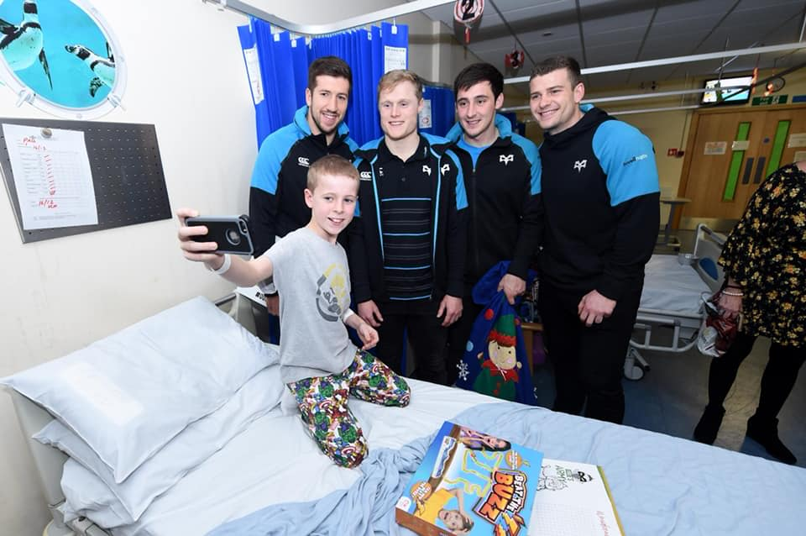
Pictured right: Ospreys players with a patient

Vicki said: “We are so grateful for the generous donation.

“At the moment we only have six beds for parents to sleep in, so many parents do not have anywhere to sleep whilst their child is in our care.

“This money will go a long way to helping parents feel more comfortable and will hopefully lift some stress from them knowing they have somewhere to sleep close to their child.

“We’d like to say a big thank you to both the Ospreys and Swansea City for making our patients smile this Christmas.”

Source: Abertawe Bro Morgannwg University Health Board

