Volunteers honoured for their massive contribution
Thursday, 6 December 2018
A seasonal celebration brought together an army of volunteers to thank them for their hard work with hospital patients and their families.
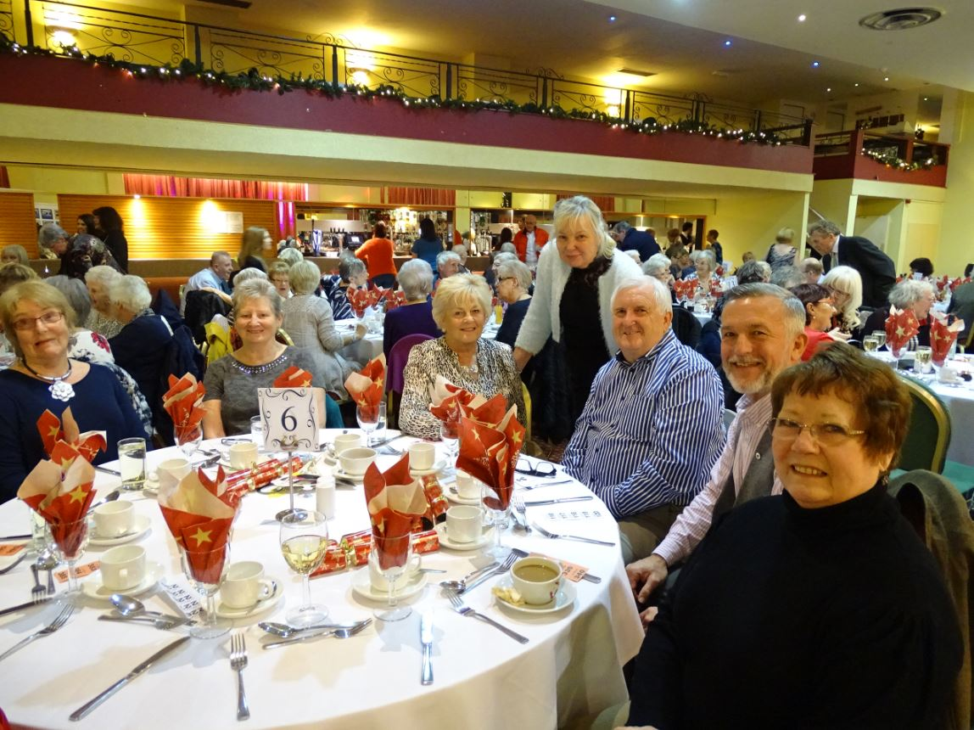
They were guests of honour at a festive lunch held as a thank you by ABMU Health Board at Aberavon Beach Hotel, Port Talbot.

ABMU Chairman Andrew Davies praised the work of the volunteers, who undertake various roles.

He said: “From giving visitors a warm welcome to providing spiritual support, from enabling patients to participate in a therapy group, to playing music on our wards, from sharing expert knowledge on a reference group – to driving a patient to an appointment.
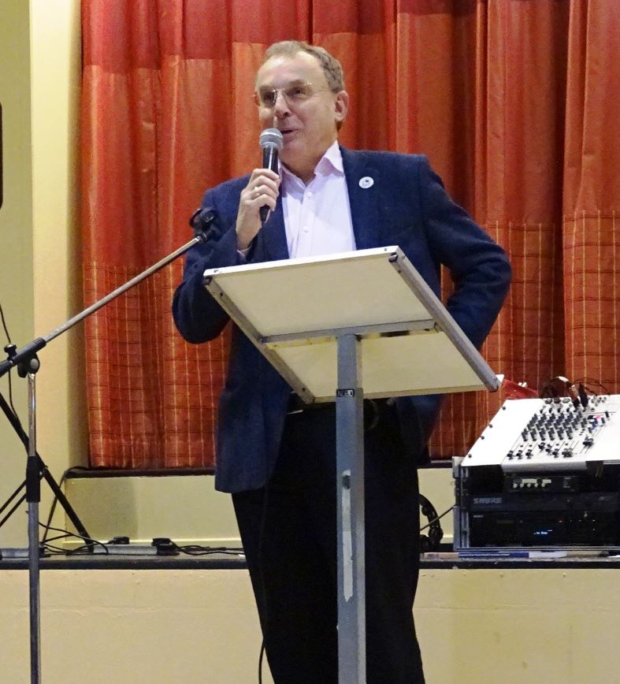
“Whatever your role – you play an important part in enhancing patient, visitor and family experience within our services.

“Your dedication and commitment as well as the passion you show for your role shines through. Today is all about you – us thanking you.”

Pictured right: Chairman Andrew Davies

Paul Richards was one of the many volunteers at the celebration.

Paul has been volunteering at Morriston Hospital for just over two years.

He spends his time speaking to patients and helping them feel at ease.

He was inspired to volunteer after undergoing heart surgery there.

He said: “I was a patient in the Cyril Evans cardiac ward 10 years ago where I received excellent care before, during and after my operation.

“While I was in, I was afraid to ask about certain tests, procedures and typical things.

“Looking back, I thought, how much positivity and assurance I would have felt being able to speak to someone who’d also been through heart surgery.

“I honestly feel that I get as much out of the volunteering and talking with others as hopefully I can give to them.”

ABMU Chief Executive Tracy Myhill also addressed the volunteers.

Touching on the success of the first year of ABMU’s volunteering strategy and looking ahead to the second, she said: “We are looking to not just grow the number of volunteers who support us but to ensure our offer is diverse and inclusive for everyone who wants to join in.

“People have told us they want volunteering to be more flexible and fit in around their lives – so we plan to introduce more short term, even one-off volunteering opportunities, where people can dip in and out when they can.”

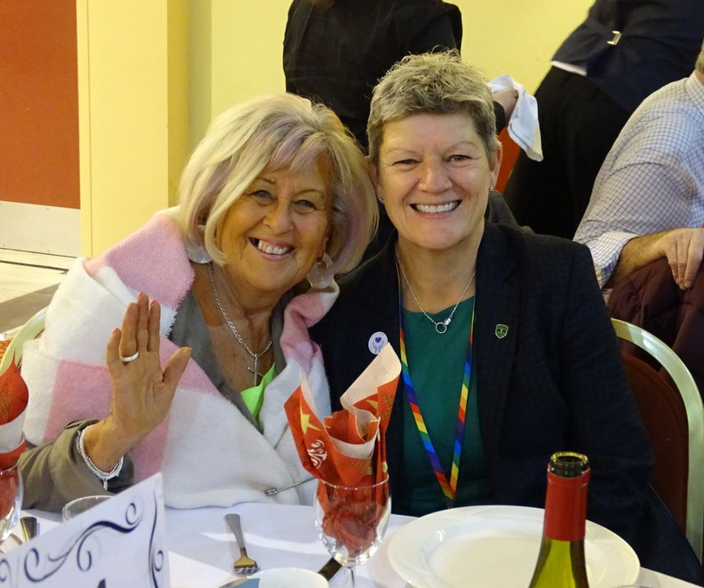
She added: “Central to our work is also ensuring each and every one of you has the best experience possible as a volunteer with us – and I want to say how thankful we are for donating your time.”

Pictured left: Chief Executive Tracy Myhill as she enjoys the dinner with our volunteers

Many volunteers have felt that their volunteer journey has helped them to make lifelong friends.

Chris Warlow decided to start volunteering seven months ago when he retired.

He speaks to patients and their families in the outpatients department at Princess of Wales Hospital every Friday.

He said: “I look forward to my Friday and feel I have made some genuine friends.

“It gives the patients a chance to speak to someone who is removed from their illness and treatment, and a chance to relax and talk about something else.

“I have not regretted for one minute becoming a volunteer. I feel like I actually get more out of it myself than I put in. I would highly
recommend becoming a volunteer.”

Volunteer services manager Joanna Parry said the volunteers are invaluable to the health board and that ABMU is always eager to enlist new recruits.
She said: “Our annual event is a great way to show our appreciation for our volunteers and how much they mean not just to us, but most importantly the patients.

“They are our greatest asset and we are always looking to grow our army of volunteers.

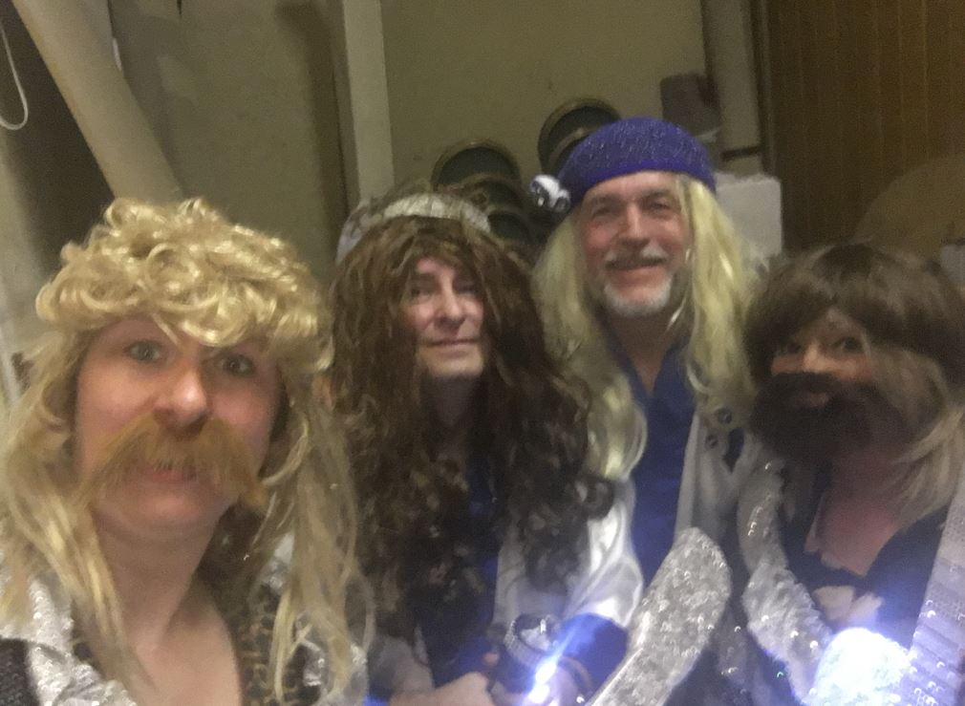
Pictured right: Volunteer services manager Jo Parry (far left) joins the fun with volunteers dressing as ABBA

“Research proves that volunteering is good for us so, at this time of year as people begin to consider their New Year resolutions, we’d love them to think about making one to become a volunteer in 2019!”
If you would like to find out more about volunteering opportunities get in touch with volunteer.centre@wales.nhs.uk or call our Volunteer Centre on 01656 753781.

Source: Abertawe Bro Morgannwg University Health Board

