Courses helping transform quality of life for lung disease patients
Wednesday, 22 February 2017
Patients battling the breathing problems caused by lung diseases say specialised courses are helping them cope with their symptoms and improving their quality of life.
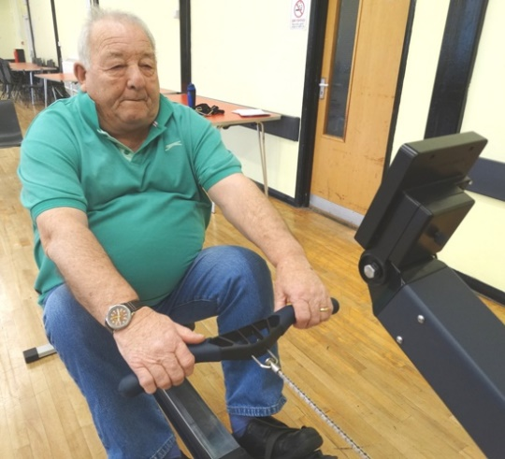
After attending sessions, organised by ABMU’s pulmonary rehabilitation team, they say they are already seeing – and feeling - the benefit.

Bob Watson, (left) from Porthcawl said: “It’s been the best thing I have ever done. My body is more supple and I can see it making a difference after just a few weeks.”

He is among a group of patients with COPD who attend a course at North Cornelly Community Centre led by specialist respiratory nurse Catherine Stracy.

It is one of a series of six-week courses which invites patients to get together twice a week for exercise and lifestyle advice from a multi-disciplinary team.

COPD, or chronic obstructive pulmonary disease, is the name given to a collection of lung diseases including chronic bronchitis and emphysema which all make a patient’s breathing more difficult.

They also often experience a cough, wheezing and chest tightness and, as these symptoms get worse, daily activities can become increasingly difficult. There is no cure but specialist rehab courses like those being run by ABMU can help patients deal with their symptoms.

Welsh Government funding has led to the setting up of the pulmonary rehabilitation team which covers Swansea, Neath Port Talbot and Bridgend.

Catherine said: “We know patients who exercise more, eat healthily and understand their condition will be able to manage their condition better at home and this can help reduce hospital admissions.

“The funding means we can run these programmes in the community, so we can give patients the tools to manage their condition – they learn about exercise and healthy eating as well as receiving emotional support to help them cope and this will hopefully make them feel less anxious about their condition.”

The pulmonary rehab team is headed by Nicola Perry-Gower and is made up of physiotherapists, occupational therapists, dietitians, nurses, exercise instructors and technicians in line with guidelines laid out by the British Thoracic Society.
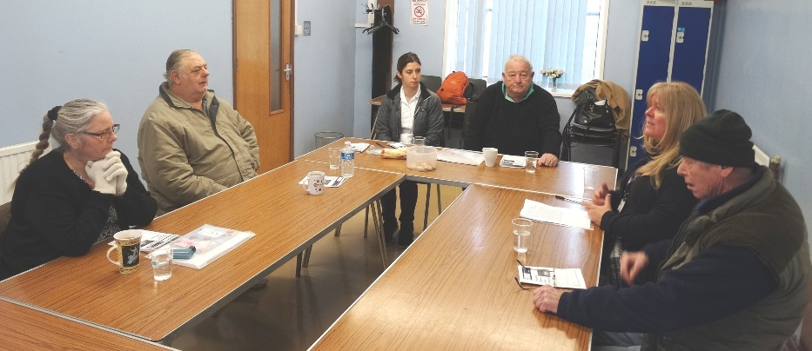
Occupational therapist Tracey Eldred (second right) talks about ways of dealing with negative thoughts with the group members.

Catherine explained that patients are referred on to the classes, which run at various locations across the three areas, by their GPs.

She said: “They are often people who feel guilty about their condition and have become very isolated. They could be people who have lived very full lives but are no longer able to do the basic things for themselves.

“However, if they are fitter then their self-esteem grows. We have had some fabulous results and that is very satisfying.”

Her current North Cornelly group would agree.

“It’s not easy but the exercises and information have been very helpful,” said Bob, who added that since attending the course he had been able to dance on a night out for the first time in years

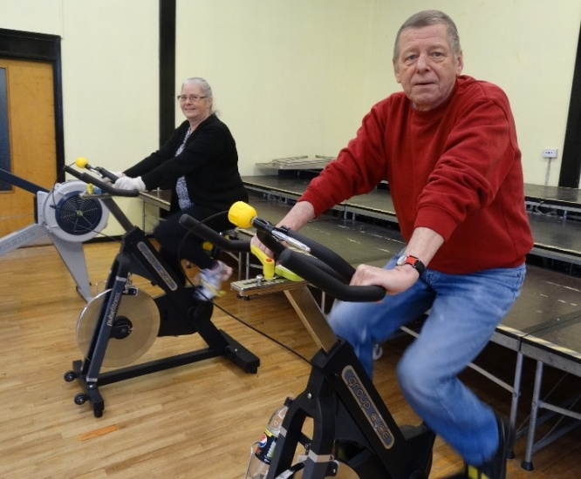
Mick Brookes, of North Cornelly added: “The help the team has given me has been fantastic. I would urge anyone else to give the course a go if they get the chance. You meet different people who are in the same boat which is helpful.

“I wasn’t sure if it would be for me, but I’ve come along and it’s made a difference and I’ve realised yes, it is for me.”

Patients Maria Christian and Mick Brookes.

He added: “It has helped me get my sense of humour back again.”

At the courses each two-hour meeting is made up of a fitness session concentrating on cardiovascular and muscle strengthening exercises followed by wellbeing advice on topics such as relaxation and nutrition.

Patients attending pulmonary rehabilitation are supported by a dietitian who will assess their individual nutritional needs. The dietitian also provides advice to optimise their respiratory health and supports them before, during and after the programme.

Guiding the patients through their exercises at North Cornelly is instructor Lewis Pengilly who says he enjoys working with such specialised patients.

“It has been nice to concentrate on one kind of group. We use exercise bikes and rowing machines here but we also show them simple exercises that can be done at home using chairs for support or bottles of water as weights,” he said.

Alyn Clarke, of Porthcawl, enjoys working with Lewis: “I never thought I would be doing things like this but it all makes sense and I am finding it really helpful.”

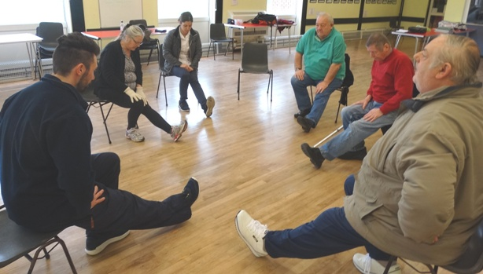
Fitness instructor Lewis Pengilly takes the group through some stretches.

Catherine added: “Without exception when they start the course I always have patients who say ‘I won’t be able to do any exercise’. But it always surprises me how good people get.

“Some of them just need a bit of guidance, others need to be given some confidence. We had one patient who was a wheelchair user when she started who ended up being able to walk her child to school again.”

The Pulmonary Rehabilitation team in Bridgend is based at Ward 16 of Princess of Wales Hospital, while the Neath Port Talbot team works out of Waterside Surgery in Briton Ferry and the Swansea team is based at the Grove Surgery in Uplands.

“We are now very proud of what service we offer our patients in ABMU,” she added.

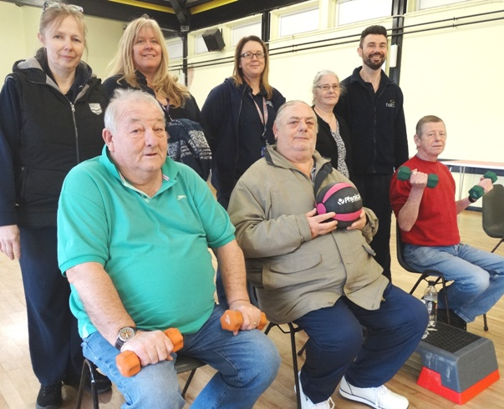
Specialist respiratory nurse Catherine Stracy, occupational therapist Tracey Eldred, rehabilitation technician Claire Williams, Maria Christian and fitness instructor Lewis Pengilly, (front) Bob Watson, Alyn Clarke and Mick Brookes.

Source: Abertawe Bro Morgannwg University Health Board

