Dad owes life to sister and Morriston Hospital trauma team
Tuesday, 21 February 2017
A young dad owes his life to his sister who was first on the scene when he suffered horrendous injuries in a road crash. Advisory note: contains graphic images.
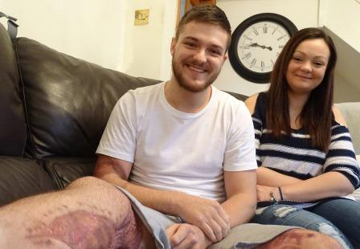
Luke James, who lives in the upper Swansea Valley, almost severed his right leg completely and would have bled to death if his sister Sammy-Jo James, a trained first responder, hadn’t been driving past.

Left: Luke and Sammy-Jo James

Sammy-Jo had her kit in her car and applied a tourniquet to stop the bleeding before emergency services arrived.

Luke, aged 25, underwent hours of specialist trauma surgery at Morriston Hospital and faces another operation and long months of physiotherapy.

He said: “I could have lost my leg, but thanks to everyone at Morriston Hospital I’m walking again.

“Without them I would be non-mobile and in a chair. I have an 18-month-old daughter, Ava Grace, and I wouldn’t be able to play with her or follow her about.”

Luke spent Christmas, New Year and his 25th birthday in hospital after he lost control of his van and plunged through a road bridge and down an embankment a few hundred yards away from his home in Caerbont.

At the time of the crash, Luke and Sammy-Jo both worked for private ambulance company All-Wales Ambulance, though Luke is currently unable to work due to his injuries.

While he has no memory of the accident, Sammy-Jo will never forget it.

She said: “I saw there had been a crash and when I went down to look I could see it was my brother.

“There were people at the roadside and I could hear them saying his leg was hanging off – which it was.

“I’ve done first responder training and I had my kit in the car. I shouted at someone to get my bag.

“They brought it down and I put the tourniquet on his leg, then gave him oxygen. My training kicked in and I kept a calm head.”

The fire service, ambulance and the EMRTS – or Wales’s flying doctors – all attended the scene.
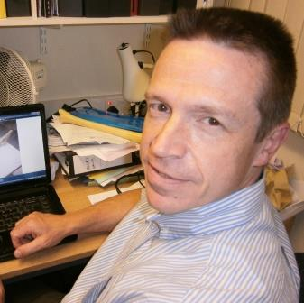
Luke had suffered an incomplete traumatic amputation to his leg – in other words, it was almost severed. His femur was broken and sticking out through his leg, ripping through muscle and skin. He also had serious arm injuries.

Morriston Hospital trauma consultant Ian Pallister (right) said: “He lost a very serious amount of blood and if it hadn’t been for his sister’s intervention, I doubt he would have made it to hospital at all.

“She saved his life. For her to be on the scene, with her training, was absolutely incredible.

“Thanks to his sister, the paramedics and the EMRTS team he received excellent care, which continued when he arrived at Morriston Hospital.”

Professor Pallister said there had been a very real danger Luke could have lost his leg.

“We know that the vital thing is the time that elapses from when you are injured to when the blood flow is restored. That took place in Morriston Hospital as quickly as humanly possible.”

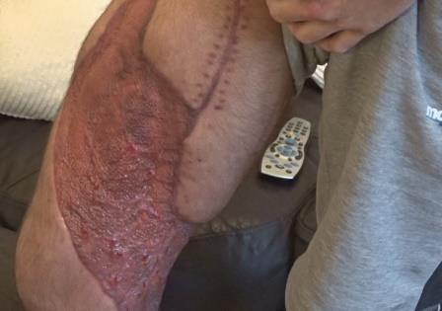
Luke underwent emergency surgery to control the bleeding, restore the blood flow to his leg, realign and stabilise the broken femur with a titanium rod, and to clean the wounds.

How Luke’s upper leg looks two months after the accident

Over the next few days he had several more operations on his leg and arm, as well as plastic surgery.

Luke thanked Professor Pallister, trauma and orthopaedic consultant Paul Taro Hak and all the other surgeons and Morriston staff who cared for him during his 30 days in hospital.

He is receiving continuing physiotherapy and will need further surgery to try to improve the movement in his leg.

“I want to get back to work. It’s going to be a long process but I know how lucky I am – it could have been a lot worse.”

Luke said he was very fortunate that his accident happened a relatively close distance to Morriston Hospital.

“If I’d had to go to another hospital further away it would have taken longer for them to get me there. Apart from that, the extra travelling would have been a nightmare for my family.

“They and my friends wouldn’t have been able to visit me and it would have made me feel a lot worse, not seeing anybody.”

https://www.youtube.com/watch?v=G1_UKrgJMzQ

Source: Abertawe Bro Morgannwg University Health Board

