Devoted daughter gets her running shoes on to honour dad's memory
Wednesday, 8 February 2017
A lifelong aversion to running couldn’t stop a Port Talbot woman finishing her first half-marathon in memory of her beloved dad.

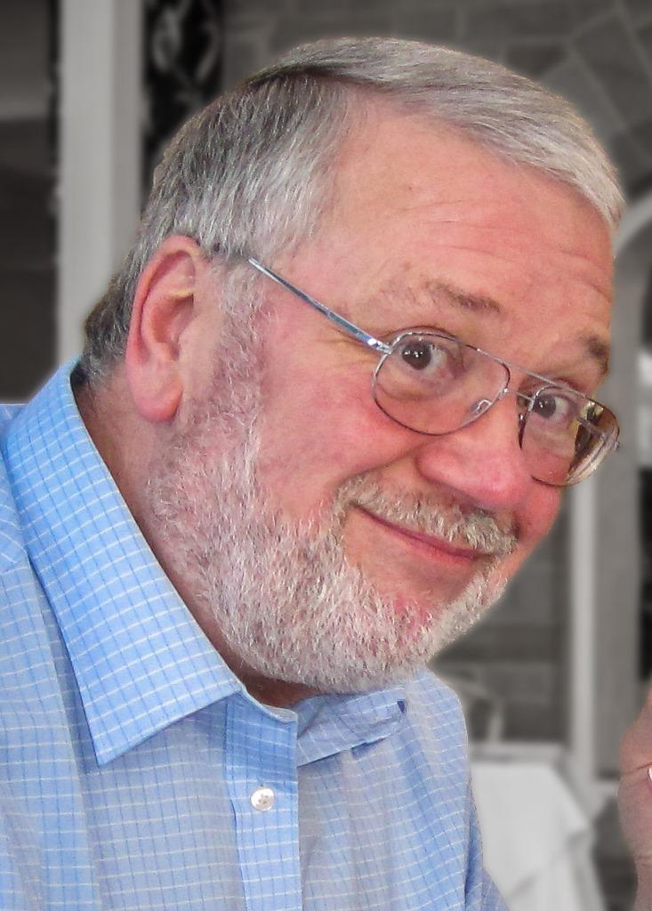
Gary Gardner, from Port Talbot, was diagnosed with oesophageal cancer in September 2013 – just two weeks before daughter Leanne’s wedding.

By the time Leanne returned from honeymoon, the news was even worse as Gary (left) was given just 12 months to live.

Due to his fighting spirit and determination Gary held on for 22 months, passing away in July 2015.

During his illness, district nurses and the acute clinical team for Neath Port Talbot looked after him at home, while the elderly day unit at Neath Port Talbot Hospital provided blood transfusions on an outpatient basis.

All this meant Gary was in hospital as little as possible and was able to spend his final days exactly where he wanted – at home in Aberavon with his family.

This led to Leanne, originally from Port Talbot but now living in the Vale of Glamorgan, and husband John Ross deciding to raise money for the three teams – and have now donated £1,000 to each of them.

Leanne said: “We wanted to thank everyone involved in providing this excellent care and for treating us like friends rather than patients when we needed this the most.”

Gary’s nickname was Rolfie. So the couple launched the Running for Rolfie appeal, with Leanne putting aside her aversion to the sport to get training for the Disneyland Paris Half Marathon.

She said: “I’m not a runner. I hate running. I did it mostly because my father would think the idea of me running was hilarious.

“But if I was going to ask people to part with their hard-earned cash, it was only fair that I worked hard for it.”
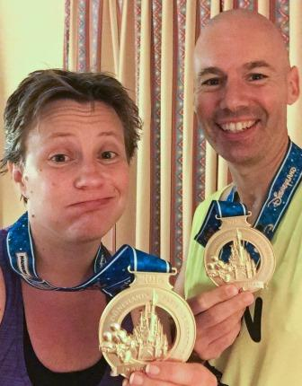
The half-marathon took place last September, on what would have been Gary’s 67th birthday so was doubly emotional for Leanne.

John is a seasoned runner who would usually have completed the course in around 90 minutes, but who slowed his pace so Leanne could keep up.

“It took me three hours and 27 minutes,” said Leanne, pictured right with John and their half marathon medals.

“We crossed the finishing line together. It wasn’t easy for me and I have to admit I was in tears all the way around the course, but I felt such a sense of achievement afterwards.

“I felt we had achieved something and done something good in Dad’s name.”

The half-marathon was Leanne’s challenge, while for his part John ran the Snowdonia Trail Marathon – a challenge that took more than six hours.

Between them the couple, who live in Sully, raised £3,000 which they have now presented to the three teams.

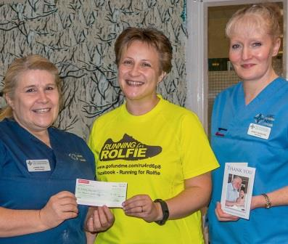
Leanne said: “We can’t thank them enough. Dad really didn’t want to be in hospital and the little things made all the difference, especially towards the end.

“He was so uncomfortable, but being in his own environment made him feel so much better. The care he received at home was amazing.”

Leanne presents a £1,000 cheque to elderly day unit ward manager Lynne Hall, watched by staff nurse Tracy Gowling

Neath Port Talbot Hospital elderly day unit ward manager Lynne Hall said she remembered Gary fondly, and Leanne had done her dad proud.

Lynne added: “It was nice to be reminded of what we do and the effect our care can have on our patients.

“Gary taught me a lot about the unique feelings each person has and how we must be flexible and adaptable to meet their needs.”

Source: Abertawe Bro Morgannwg University Health Board

