Occupational therapist Sara honoured for her dedication to profession
Wednesday, 8 February 2017
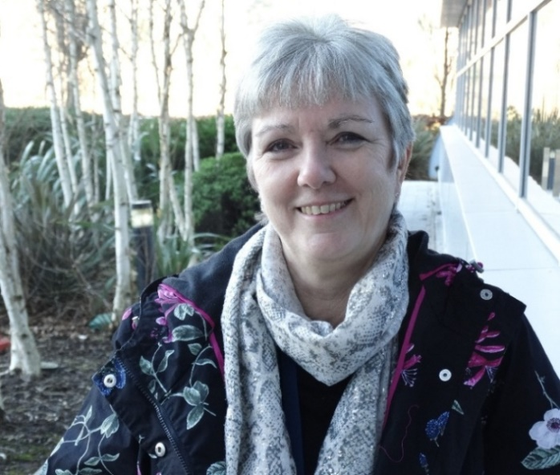
ABMU’s head of occupational therapy has been recognised for her outstanding contribution to the profession.

Sara Forster, who is based at the Princess of Wales Hospital, has been honoured with the College of Occupational Therapists’ Merit Award following a nomination by colleagues.

“I have no idea who nominated me. I am delighted to have been recognised but I have always felt like I have just been doing my job, even though it is a job I love,” she said.

Sara has spent the past 36 years working in Bridgend, moving there soon after qualifying and has seen the profession grow, there are now 350 staff working across ABMU.

When she first started at the old Bridgend General Hospital she was its only occupational therapist and also covered community hospitals at Maesteg, Maesgwyn, Cefn Hirgoed and Blackmill.

“I am happy to say one of the things that has changed most during my career is the recognition the profession now enjoys,” said Sara who has served as a council representative and as Chair of the British Association and College of Occupational Therapists.

She will receive the award, established to celebrate excellence by peers, at a celebration event in London later this year by which time she will have retired from post.

“I didn’t ever set out to become a manager but I do still have some time for clinical work and the most satisfying part of the job is always working with patients.

“Over the years there has been a complete change in how we deal with patients – we look at functional and cognitive ability but the tools we use are different, technology has changed things, - now OTs use iPads with specific apps and computers.”

Sara, who is originally from Ferryside but now lives in Cardiff, added: “What OTs do really can make a difference to people’s lives and the job sees you dealing with every kind of patient – from newborns to those who are coming to the end of their life.

“Being an occupational therapist you are helping people to live the way they want to live. I am very proud of my profession and my career in it.”

Source: Abertawe Bro Morgannwg University Health Board

