Parents offered homely surroundings after hospital accommodation gets a makeover
Tuesday, 28 February 2017
More parents of babies receiving care at Singleton Hospital’s neonatal intensive care unit are now able to stay close to their little ones in specially renovated accommodation.

Five houses on the Swansea site, which were previously earmarked for doctors’ families, have been given a major makeover and are now being used by grateful mums and dads from all over South and West Wales.

The development means Singleton’s neonatal intensive care unit (NICU) has become the first in Wales with enough accommodation to meet national guidelines.

The hospital provides specialist care for high-risk infants from an extremely wide geographical area - some babies are referred from other parts of Wales and England - and the nature of their conditions means they may face a lengthy stay in Swansea.

Being close to their babies is vital for new parents but there are only two dedicated family rooms where mums and dads can stay on the unit itself.
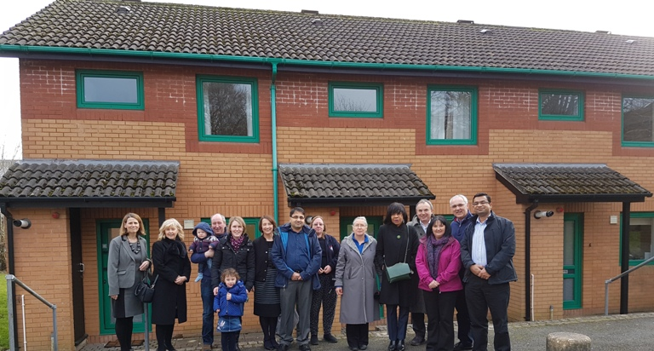
Guests including the Williams family from Pembrokeshire, neonatal staff and ABMU Chairman Andrew Davies at the opening of the refurbished houses at Singleton Hospital.

Now, as a result of the 18-month-long renovation project the houses are available, just a stone’s throw away on the other side of the staff car park.

One mum who has already benefited from the extra accommodation since it was officially opened earlier this month is Clare Fisher whose daughter Ada is being looked after there.

She said: “We have stayed in one of the houses for a few weeks now. It has been life-saving for us. The unit is just a few minutes’ walk away from the houses so it has saved us from frantic daily drives from Lampeter. I have been able to focus on my daughter and on expressing milk for her.”

She added: “We’d like to say a big thank-you to everyone who has made it possible. But our thanks doesn’t come close to expressing how grateful we are to have this accommodation.”
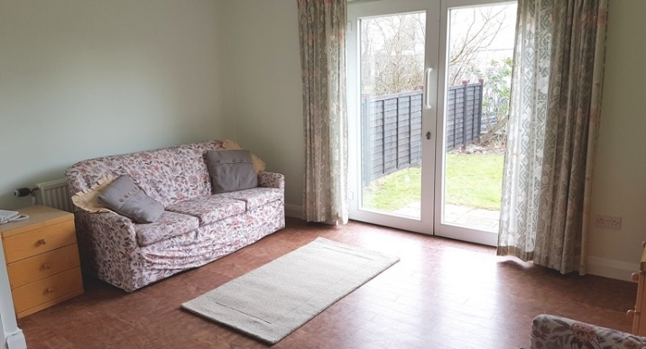
The work on the two-bedroomed homes, which have basic kitchen facilities and lounges, was paid for by charitable donations, many from families whose babies had been treated at the unit and know from personal experience the value of being able to remain close by.

Consultant neonatologist Geraint Morris said: “The provision of accommodation for families of these infants is extremely important as often they are far from home for long periods of time while their babies are on the unit.

“Being able to stay close to their babies allows mothers and their partners time to develop emotional bonds and is crucial for successful production of breast milk and breastfeeding, which can be life-saving for sick, premature babies.”

In a report released last year UK charity for newborn infants BLISS criticised the severe lack of parent accommodation for neonatal units in Wales.
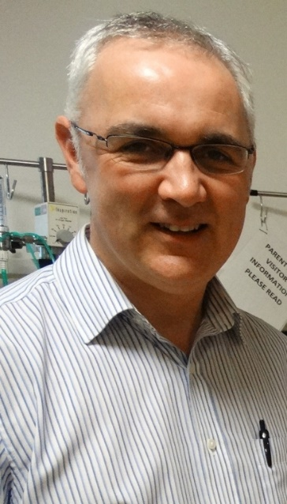
Dr Morris (left) explained that if no accommodation is available often parents had to pay for somewhere to stay near the hospital or face the high cost of travelling long distances, at a time when they are already under severe stress with an ill baby on the neonatal unit.

The British Association of Perinatal Medicine, the body which sets the standard for neonatal care across the UK, calls for units to have one family room per intensive care cot. Singleton is the first in Wales to provide enough accommodation to meet those recommendations.

He added: “The staff from the children’s services and estates departments have worked very hard to refurbish this accommodation to a high standard and as a result the houses are very comfortable.

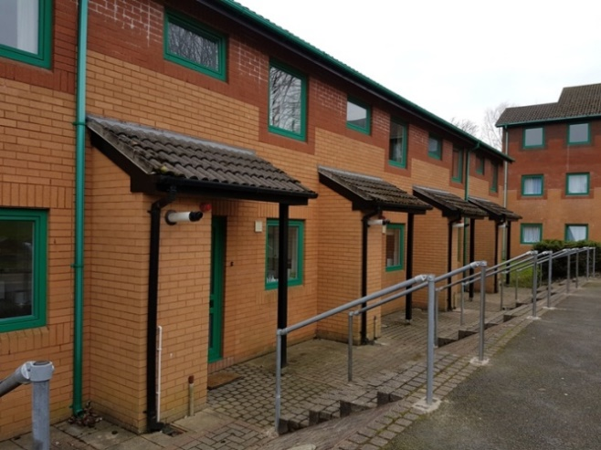
“We are delighted and very proud they are now available to families and will offer more comfortable surroundings to them at a difficult time – more like a home away from home.”

A special event to mark the opening of the accommodation was held at Singleton and among those attending were ABMU Health Board Chairman Andrew Davies, neonatal staff, parents of babies on the unit and Joanne Stewart from BLISS.

Also there to see the transformed houses were Wyn and Catrin Williams and their children from Llangolman in Pembrokeshire. They had presented staff with £10,000, which was used to towards the refurbishment, in memory of their little son Ifan who was cared for at Singleton.

When they returned to the unit to hand over their donation, raised at a variety of local events, Catrin said: “We never thought we would have a premature baby and we wanted to do this to support other babies.

“Whatever they need, we want to help the staff to provide it.”

Source: Abertawe Bro Morgannwg University Health Board

