Patients star in new video to help combat pressure ulcers
Wednesday, 1 February 2017
Patients are taking a starring role in a new video in the hope it could spare others the same painful condition they have endured.
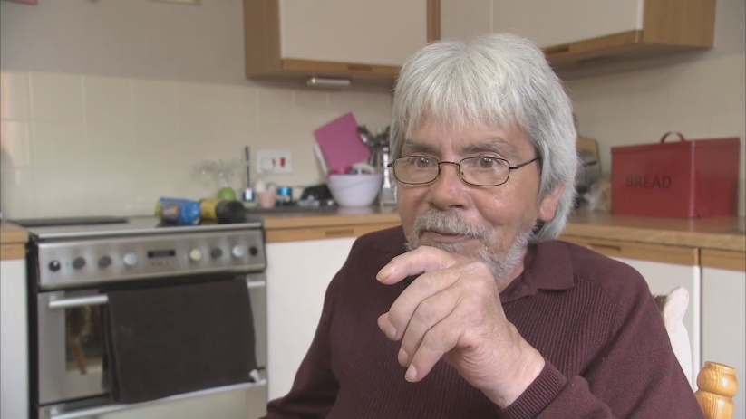
The video explains what people with pressure ulcers can do to encourage healing – and how to help prevent ulcers occurring in the first place.

Alfred Kennedy, from Bridgend, one of the patients who took part in the video

It has been produced by ABMU’s Morriston Hospital-based Pressure Ulcer Prevention and Intervention Service (PUPIS) in collaboration with eHealth Digital Media.

District nurses are showing the eight-minute video to people with pressure ulcers – or potentially at risk – in their own homes.

The idea came about after ABMU was given a Welsh Government grant to develop and evaluate a pressure ulcer care app.

The team saw the need for a video that could be shown to patients at the bedside to promote recovery and avoid recurrence.

The most effective way of getting the messages across was by having them come from patients who’d had pressure ulcers.

PUPIS clinical nurse specialist Susan Flavin enlisted three people to talk about their experiences on-camera.

Susan said: “They had absolutely no problem at all with taking part, and they were excellent.

“They wanted to do anything they could to help prevent someone else going through what they had gone through.

“Because they had experienced it, the information was much more profound than if it had come from a healthcare professional.”

Pressure ulcers can occur in people with limited mobility, who may sit or lie in one position for long periods of time.
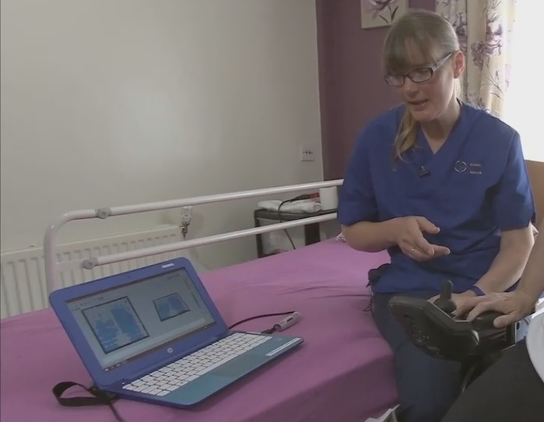
With blood flow restricted to bony parts of their body, there can be severe tissue damage.

Right: PUPIS clinical nurse specialist Susan Flavin features in the video, here demonstrating pressure mapping to a patient

The impact on the patient can be devastating and in some cases may lead to major surgery.

Key messages within the video include the importance of moving, keeping your skin clean, and looking out for redness on the skin over bony areas and seeking help quickly if any occurs.

Susan said: “If patients have enough information, delivered in the right way, they can manage themselves and come up with their own routines and strategies.

“We educate patients about how they can incorporate that into their daily routine.

“And it is a daily thing. With pressure ulcer prevention you can’t take your eye off the ball. It’s constant.

“You’ve got to remember where you are, who you are and what’s happening to your body.

“Hopefully, having this video available will make a massive difference – because it’s coming from the heart.”

One of the patients who took part was Alfred Kennedy from Bridgend.

Mr Kennedy said: “I did it so other people would know they are not alone. I was happy to help in any way I could and wanted to give advice from what I’d been through.”

ABMU head of rehabilitation engineering Dr Lorna Tasker said the video was aimed at patients who had developed a pressure ulcer, and those at risk.

“That presented quite a challenge. How do you get the message over to someone that’s never had a pressure ulcer when you also want it to be relevant to someone who has?

“We really had to think how we could achieve that in a relatively short film. I think the team has managed this very well.”

The video is also available to ABMU staff as part of a wider pressure ulcer awareness campaign.

Susan said: “We’re trying to get the message across that we all have a role to prevent pressure ulcers.

“It really hits home when you listen to a patient talking about it rather than me telling you about a patient. Seeing them face to face is much more personal.”

Source: Abertawe Bro Morgannwg University Health Board

