Princess of Wales Hospital pledges support for John's Campaign
Friday, 3 February 2017
ABMU has pledged its support for John’s Campaign, which recognises the important role carers have in the lives of people living with dementia.

The Princess of Wales Hospital in Bridgend is the first hospital in the health board area to sign up.

The campaign, founded in November 2014 by Nicci Gerrard, recognises and champions the right of carers to stay with and continue supporting their loved one during their time in hospital.
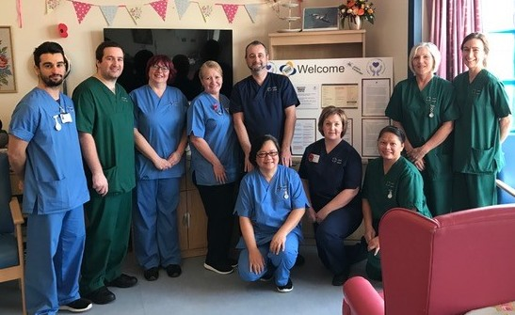
Support from family and carers is essential for anyone to live well with dementia. It is recognised that an admission to hospital for someone with dementia can be a stressful and disorientating experience.

John’s Campaign is a request for access and recognition for carers so they are welcomed on hospital wards at any time, day and night.

Princess of Wales Hospital’s Nurse Director Debbie Bennion said: “We recognise that the loved ones of patients with dementia know them best. Relatives and carers will be welcomed and encouraged to be involved at every point of care in the patient’s journey.

“We know that hospitals can be a frightening place for our patients living with dementia, so it is incredibly important that we do everything we can to make them feel as comfortable as possible and deliver high quality, personalised care.”

The hospital has rolled out John’s Campaign on Ward 18, 19 and 20 and ward managers Sara Ralston and David Maggs are pictured with their teams who have pledged to:
- Ensure patient’s loved ones and carers are supported to be involved in all aspects of their care while in hospital including the right to stay overnight with them;
- Provide a passport in the form of a credit card enables carers 24-hour access to the hospital, including being able to stay overnight with their loved one; and,
- Encourage the involvement of the carer in initiatives such as afternoon tea, music concerts and interactive exercises.

One carer with first-hand experience of the policy is John Grant whose wife Margaret is a patient on Ward 18.

He said: “On my visits I am made welcome by staff and requests for assistance for my wife are promptly and professionally met.”

Mr Grant said he felt able to bring minor ailments to the staff’s attention and to advise them about problems his wife was having. He praised them for their discretion with female patients and the range of social activities that are available.

“Staff are always polite to me and understand my emotions in times of distress,” he added.

Victoria Rodwell, of Bridgend Carers Centre added: “It is fantastic to see wards and staff at Princess of Wales Hospital supporting John’s Campaign and welcoming carers on to the wards.

“It makes such a difference to carers, knowing they can visit at any time, will be listened to, supported and recognised as a carer by staff.

“We are delighted by this development and proud to be working in partnership with the wards to ensure that carers are fully supported.”

To find out more about John’s Campaign, please visit www.johnscampaign.org.uk

What is available for carers?

- Reach Out to Me documentation - this documentation is to be implemented for patients with a diagnosis of dementia or a cognitive impairment with the next of kin’s approval;
- Access to meals - carers will be provided with a meals passport that allows them to purchase food for the same price as staff;
- Access to the wards out of hours - carers have access to the ward at all times;
- Carers’ safety checklist - a safety checklist is to be completed for carers who wish to participate in the campaign;
- Overnight accommodation - carers are able to stay on the ward with the patient;
- Car parking information;
- Carers’ passport - any carer who is happy to sign up to the campaign will be provided with a carer passport; and,
- Access to carers support - all carers have access to the carers support team at the Princess of Wales Hospital

Source: Abertawe Bro Morgannwg University Health Board

