Service offers day treatment to save patients from stay in hospital
Tuesday, 7 February 2017
A day care service treating patients with a debilitating lung condition so they can avoid being admitted to hospital is going from strength to strength.

The Ambulatory Pleural Procedure Service (APPS), based at Singleton Hospital, cares for people with pleural effusions – a build-up of fluid next to the lungs.

One of the main aims of the service, launched in September 2015 by consultant Narendra Chinnappa, is to help avoid unnecessary hospital admissions, especially for cancer patients suffering with pleural effusions.

It also provides a safe diagnostic and therapeutic service for patients with pleural disease. It can reduce delays in diagnosing and treating pleural malignancies in patients referred by their GPs as well as helping other specialties such as oncology with patient management.
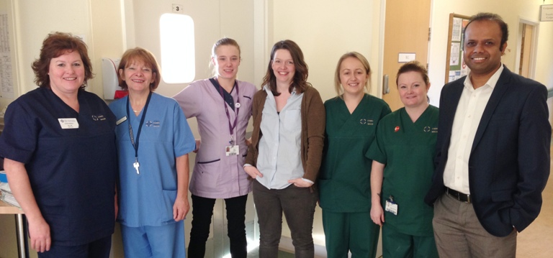
Dr Narendra Chinnappa (right) with members of the Ambulatory Pleural Procedure Service based at Singleton Hospital’s Ward 5 day unit.

Dr Chinnappa had seen a similar scheme in place in his previous job and when he joined ABMU he was determined to get a service off the ground here.

“I realised it was a much-needed service and we are very pleased with how well it is going.

“Word is spreading - we are taking patients not only from Singleton but also from Morriston and Neath Port Talbot hospitals while my colleague consultant Emma Watkins is heading up a service at Princess of Wales Hospital,” he said.

He said the service offered one-stop clinical assessment, imaging and intervention, with a view to early diagnosis and improved patient care as well as helping to avoid admission.

In the past pleural patients who needed diagnostic work or drainage would have spent an average of two to three days in hospital. Those patients with urgent suspected cancer could have expected to be in for longer while their diagnosis took place.

Since the service was launched it has seen almost 300 patients.

“Nearly half of them received pleural procedures as an outpatient rather than as inpatient, preventing admission inconvenience and saving a total of 1,160 hospital bed days,” explained Dr Chinnappa.

Having the dedicated service had also reduced the number of unnecessary pleural procedures carried out and improved both patient outcomes and experience, he said.

Everyone who uses the service is asked to fill out a 10-point questionnaire about their experiences and Dr Chinnappa said the team had received excellent feedback from grateful patients.

Among the many positive comments received were: “The staff and care level are the highest you could hope for! We are very lucky to have this facility in our city” and “I could not be more grateful and happy with the service and the staff.”

Another added: “I am feeling much better after the procedure, glad I am going home without needing to stay in hospital.”

Dr Chinnappa said: “The feedback we have had from patients has been very satisfying - it is so encouraging to see that we can make a difference to patients.”

The team is now sharing the service’s success so far with colleagues across the health board and say it has been very well received.

“We are seeing referrals from community and other medical specialties, especially from oncology, helping to achieve a smoother patient journey for cancer patients.

“The average time from referral to clinic appointment is around a week which indicates the efficiency of this clinic,” he said.

He also paid tribute to Ward 5’s day unit nursing staff and clerk Sian Owen, clinical nurse specialist Sarah Dawkins and his secretary Jenny Travers who are all involved in the service.

“Everybody has worked hard towards establishing this. We really are delighted by how well the service is doing and we would like to see it expanding in future to take on more diagnostic work,” he added.

Source: Abertawe Bro Morgannwg University Health Board

