Singing out to help send Iestyn on his dream holiday
Monday, 13 February 2017
A choir has been hitting the high notes to help make a young leukaemia patient’s dream come true.

Maternal Harmony has donated the proceeds of its latest charity concert to an appeal to pay for little Iestyn Baldwin to visit Disney World in Florida.

Six-year-old Iestyn, of Bridgend, was diagnosed with acute lymphoblastic leukaemia in June and his family is hoping to take him away for a holiday to recover from his treatment.

His mum Anna is a former member of the choir which is dedicated to helping raise the spirits of its members as it raises awareness of emotional issues during and after pregnancy.

Originally set up by the Perinatal Response and Management Services (PRAMS) at Princess of Wales Hospital and aimed at women with postnatal depression, the choir now welcomes those with other mental health issues, their family members or anyone who just wants to support the cause.
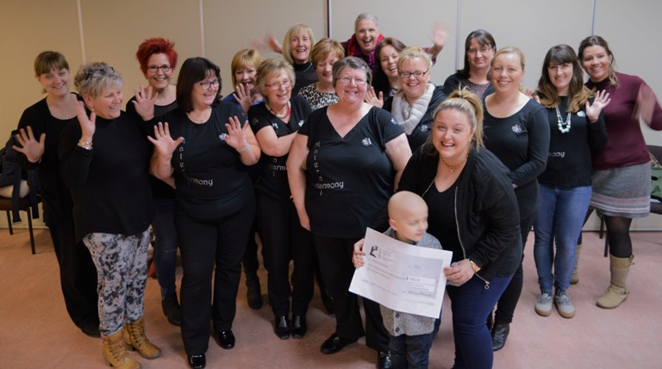
Iestyn and his mum Anna Baldwin with members of the choir at their concert.

Gail James, lead nurse for Prams, said: “We wanted to do something to help because Anna is one of us.

“We have known Iestyn since he was a baby and he is a smashing little boy.”

The concert raised £400 toward Iestyn’s trip of a lifetime.

Gail added that the choir was now on the hunt for extra voices to join its ranks.

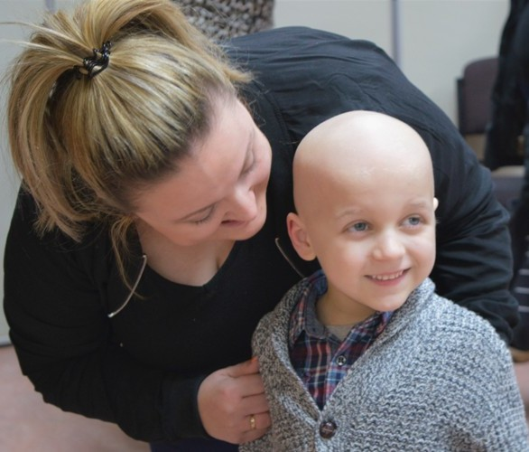
“We would love to see some new members signing up. You don’t need to have been referred by the PRAMS team – you don’t even have to be able to sing – you just need to be supportive of our cause and want to spend your time making music with a great group of people.”

The choir rehearses every Thursday from 7pm to 9pm in the Communal Residences Hall at Princess of Wales Hospital.

For further information contact Gail on 07960 602383

Iestyn and Anna Baldwin.

Source: Abertawe Bro Morgannwg University Health Board

