Take a peep into the past as cabinet of curiosities goes on show
Tuesday, 14 February 2017
Clanking keys and curling toe nail clippings are among the oddities and artefacts contained in a cabinet of curiosities set to go on show at Morriston Hospital next week.

The Wunderkammer – a 12-drawer wooden chest – is filled with items gathered from various clinics and hospitals that are now part of ABMU Health Board and aims at providing a little snapshot of the area’s healthcare history.

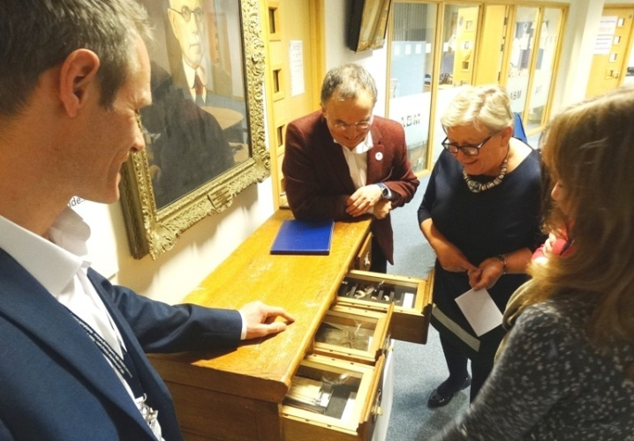
It is the latest project carried out by the health board’s Heritage Group which was set up to preserve many important historical healthcare items for future generations.

ABMU Chairman Andrew Davies and Director of Therapies and Health Sciences Christine Morrell take a closer look inside the Wunderkammer.

In fact, the chest itself is one of those items discovered as health services in the area are modernised and developed.

It was once used to hold patient record cards at the former children’s clinic at Phillips Parade in Swansea and has been adapted to show off items, with bilingual information details in museum-standard individual drawers.

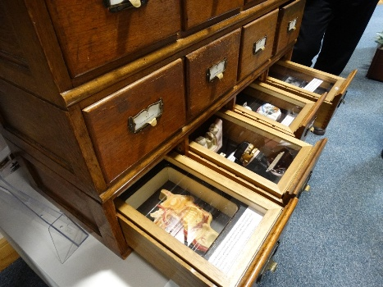
Preparing the Wunderkammer – which means collection of curiosities or rarities – has been a real labour of love for Martin Thomas, who leads the heritage project, and he has been devoting his free time to renovating and adapting it

Martin, is ABMU’s strategic manual handling advisor, said: “When I started work on the heritage group, our amazing collections were quite literally hidden in attics and basements and completely inaccessible to staff and the public, so protecting and sharing our heritage was very important to me and became our project aims.

“Heritage volunteer Rebecca Kelly suggested the concept of a pop- up museum. It’s also interactive as it invites staff and the public to get involved sharing artefacts and stories.

“Building the Wunderkammer and setting out the collection has been a stark contrast to my clinical role and a breath of fresh air to work on. It’s generated lots of discussion and I’m pleased to say is now taking on a momentum all of its own.

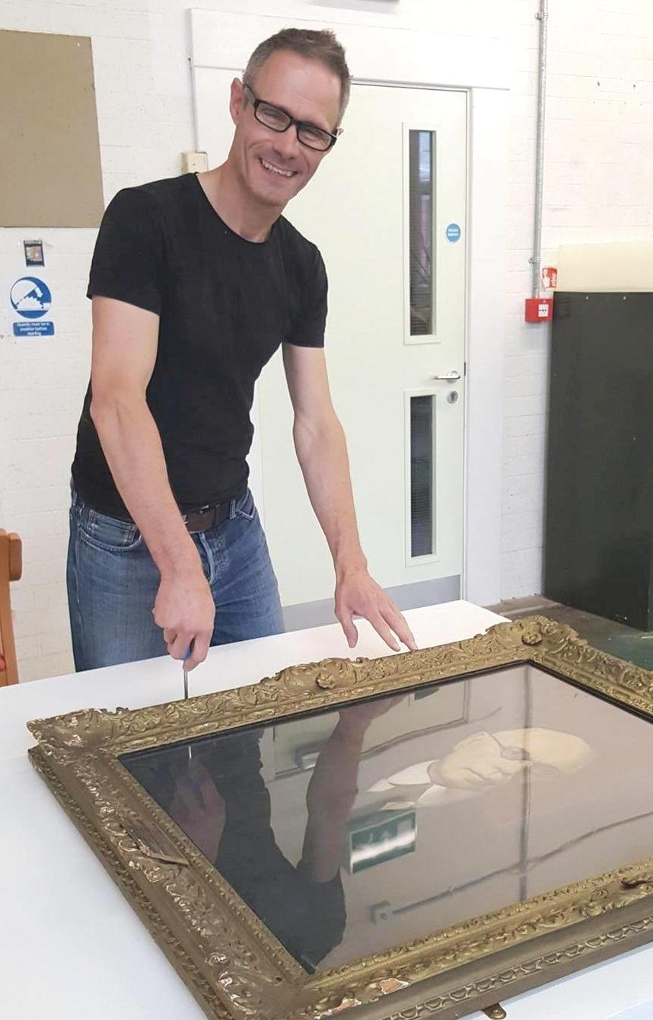
Items on display include a leather mitten with lock and key from Glanrhyd Hospital dating back to the 1900s which was used to stop a patient from self-harming as well as the ornamental trowel used by the Sir Frederick Alban to lay the foundation stone of Singleton Hospital in 1958.

There are also toe nails cut for the comfort of a female patient when she was admitted to Parc Hospital in Bridgend in the 1950s and a glass slide of opera singer Adelina Patti visiting wounded First World War soldiers at Swansea General Eye Hospital.

Another drawer is devoted to a more recent development - 3D printed guides used by maxillofacial surgeons to create a cheek implant for an accident victim in 2014.

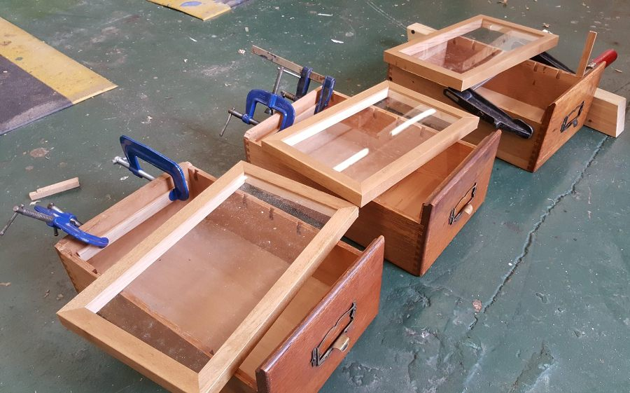
Martin Thomas working on one of the display items and (right) the cabinet drawers during renovation.

The cabinet is currently on show at the health board’s HQ at Baglan before being moved to Morriston Hospital for its official launch on Monday, 20th February.

ABMU Chairman Andrew Davies will be unveiling the Wunderkammer in the outpatients waiting area at 5pm and it will remain on display there for the next few months.

Professor Davies said: “It really does provide a fascinating glimpse of how we looked after our patients in the past.

“I hope our public and staff enjoy taking the opportunity to have a good look at the items inside and find out a bit more about their weird and wonderful history.”

It is now planned to take it on tour to other health care sites with the Heritage Group changing its contents slightly each time so they remain particularly relevant to its location.

Martin and Rebecca are currently involved in preparing a detailed bid for National Heritage Lottery funding to protect the artefacts the group has been collecting for the future.

It is hoped this would also increase access to them to allow research about the social history of healthcare in South Wales and benefit schools and the wider community.
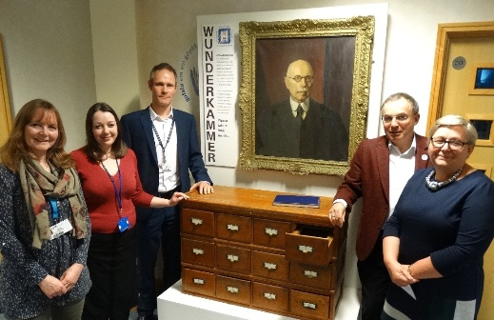
Fiona Edwards, of ABMU’s Arts in Health, Rebecca Kelly and Martin Thomas, of ABMU’s Heritage Group, Chairman Andrew Davies and Director of Therapies and Life Sciences Christine Morrell with the Wunderkammer.

The Heritage Group is always keen to hear from any member of staff who may have spotted other treasures from the past that could be of interest.

Martin added: “I love the excitement of being presented with a dusty old box, not knowing what gruesome old medical oddment I am going to see next!

“The interest sparked goes right across the board - I have had calls from the public, retired staff, secretaries, consultants and board members, all absolutely passionate about protecting their fragment of our heritage and sharing it.”

As discoveries come to light they also share details on the group’s dedicated Facebook page. To find out more go to https://www.facebook.com/ABMheritage/

Source: Abertawe Bro Morgannwg University Health Board

