The Coffin Dodgers get kitted out to help cardiac team
Friday, 17 February 2017
Swansea heart patients with a dark sense of humour have been doing their bit to raise money for the staff who cared for them.

Calling themselves The Coffin Dodgers, the group’s members are all former cardiac patients who work out at the Wales National Pool gym in Swansea as part of their rehabilitation.

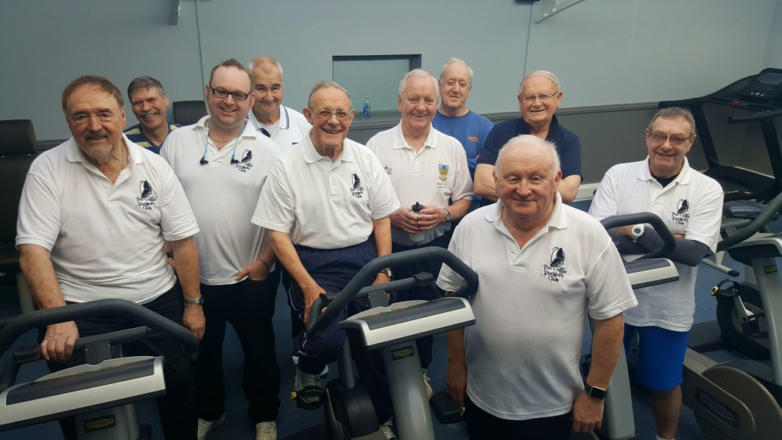
Peter Thomas and Chris Luxton returned to Morriston Hospital’s Cyril Evans Ward, where they were both treated, to hand over a cheque for £155 on behalf of the group.

Peter Thomas (fifth from left) and Chris Luxton (standing front) with their fellow Coffin Dodgers at the gym.

While working up a sweat at the gym Chris cooked up the idea to have polo shirts embroidered with The Coffin Dodgers.

He said: “Well, it’s true - we are! I wouldn’t be here if it wasn’t for the fantastic treatment and care I have received from cardiac services.

“From the time I was brought in as an emergency, then into theatre, cardiac ITU, Cyril Evans Ward and then cardiac rehab, it’s all been fantastic.”

Clinical nurse specialist Carolyn Cude, of Singleton Hospital’s cardiac rehabilitation team, referred Chris to the gym and initially he found it really hard to motivate himself.

“If it hadn’t been for the rehabilitation team’s training and the amazing encouragement and camaraderie from the other Coffin Dodger like Peter Thomas I am sure I would have just sat on the sofa,” added Chris.

Peter ordered the shirts from graphic design company Pentagon Designs which donated its artwork for free.

He said: “I really look forward to my gym sessions with the other Coffin Dodgers and helping to raise this money for the ward has been a fantastic motivation for me.

“People have come forward and donated because it is such a good cause so we are not stopping here.”

Peter said the group will continue to sell the polo shirts to raise more money for the ward and the Cardiac Unit.

“After costs we add £4.50 to the price of each shirt which all goes into our collection.

“Anyone would like to help by buying a polo shirt or raising money should get in touch or join us at the gym - if you can keep up that is!”

Cyril Evans Ward manager Louise Jenvey and her staff ward were thrilled to see their former patients Peter and Chris in such good shape when they came back for the presentation.
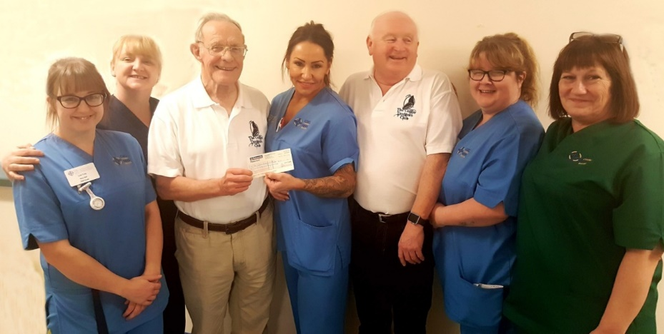
Pictured with Peter Thomas and Chris Luxton are (from left) staff nurse Lois Tully, sister Louise Jenvey, staff nurse Sammy Bradley, staff nurse Mandy Williams and healthcare support worker Jackie Rogers.

They handed the cheque over to staff nurse Sammy Bradley who couldn’t resist giving their operation scars a quick check and was very impressed by the pair’s progress.

Louise said: “All of us here on Cyril Evans Ward are extremely grateful for the inspirational efforts of this fantastic group. Thank you so much for thinking of us, Coffin Dodgers, you are brilliant!”

To find out more about the Coffin Dodgers or to buy a polo shirt please contact Peter on 07971806327

Source: Abertawe Bro Morgannwg University Health Board

