Fantastic Plastic Sam shares the love with sixth Valentine's fundraiser
Friday, 2 February 2018
A local legend is still sharing the love for Swansea’s Morriston Hospital six years after staff there saved his life.

Every year, city-based DJ and musician Plastic Sam organises the Valentine’s Thank You fundraiser for the hospital’s urology department following his cancer diagnosis on St Valentine’s Day in 2012.

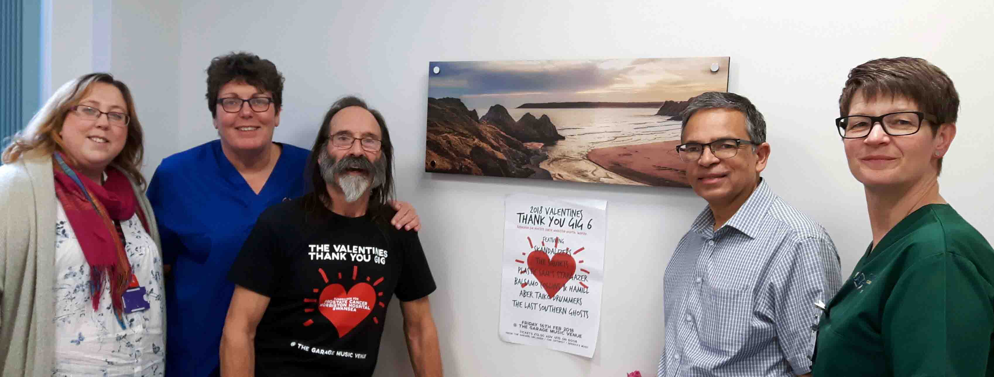
The sixth event will this year be held in The Garage music venue in Uplands on Friday 16th February.
L-r: Vicky Jenkins, secretary to the clinical nurse specialist; Cath Dixon, lead stoma care specialist nurse; Plastic Sam; consultant urologist Pradeep Bose; and Vanda Robbins, enhanced recovery after surgery nurse

Sam underwent surgery at Morriston Hospital after being diagnosed with cancer in his kidney and bladder.

He said: “Everything is okay now, touch wood.

“I’m on regular medication and go back for check-ups but otherwise I’m fine. I’m so grateful to the team at Morriston for sorting me out.”

The first Valentine’s Day gig came about after a friend of Sam’s mentioned he was opening a new venue.

“This was about nine months after my surgery, while I was in recovery,” Sam recalled. “I decided I wanted to do something to thank the people who saved my life.

“It went ahead and it went down really well. At the end of the show I asked if people wanted another one and they did, and we’ve done it every year since.

“There’s an old Travelling Wilburys song I sing with my band Stargazer, called End of the Line.

“It has a line in it that goes, ‘Don’t have to be ashamed of the car I drive. I’m so happy to be here, so glad to be alive’. So true.”

Sam’s most recent visit to Morriston Hospital was to present a cheque for £2,250 to the urology department, the proceeds of the 2017 fundraiser.
Each year he raises between £2,000 and £3,000, which is used for equipment for urology patients, including a bladder scanner.

He also donated a picture to the urology surgical quiet room where patients and relatives can be taken for news following procedures.

Tickets are now on sale for this year’s sixth Valentine’s Thank You gig.

It features Skandalizers, The Squirts, Plastic Sam’s Stargazer, Balsamo Collins and Hamill, Aber Taiko Drummers and The Last Southern Ghosts.

Lead stoma care nurse Cath Dixon is among the Morriston staff who have been invited to attend the annual gigs.

Cath said: “Due to the financial strains on the NHS, it is fantastic that patients go above and beyond to raise funds to help support their local hospitals.

“Over the years, Sam has donated a large amount of money that has helped with buying equipment for the urology department.

“It also supports members of staff to undertake study sessions which are not NHS-funded but improve specialist urology care.

“I feel very honoured when I am asked to attend these fantastic nights and give a speech thanking the people who help provide the entertainment and to the people who pay to attend.

“We hope more people take the opportunity to attend this year’s event to help support a great local cause.”

Source: Abertawe Bro Morgannwg University Health Board

