Ironman Rob keeps on running to help hospital centre
Thursday, 1 February 2018
Fundraising soldier Rob Jones has handed over his second bumper donation to the Breast Care Centre at Singleton Hospital.

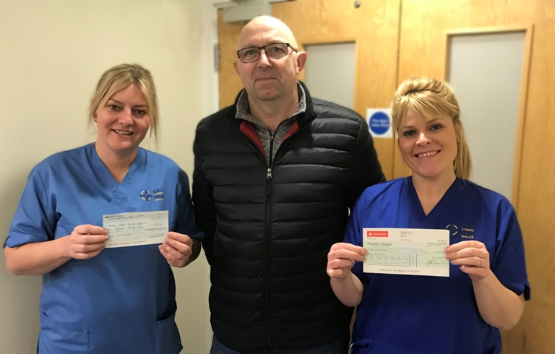
After his mum Catherine was treated at the centre in Swansea, Rob pledged to do all he could to support the staff as a way of saying thanks for her care.

Rob Jones hands over the donations to Breast Care Centre staff Nicola Sharp and Andrea Jones.

Rob, a staff sergeant with 1st The Queens Dragoon Guards, knew the perfect way to drum up cash while putting his fitness to the test. In 2016 he donated more than £4,000 after taking part in Ironman Wales.

Now he has just returned to the centre with another £4,370, collected after completing the gruelling Tenby-based physical challenge again.

Dad-of-two Rob, from Ammanford, said: “It was my fourth Ironman event and second one raising money for Singleton.

“The centre helped, and continues to help, my mother Catherine after her diagnosis and I really feel I should contribute something back.”

His fundraising efforts, which saw him complete a 2.4-mile swim, 112-mile bike ride and full marathon, were boosted with a donation from the Williams Brown Hill Charitable Incorporated Organisation which was set up to provide funds to Welsh worthy causes.

Based at Llys Cennen Solicitors in Ammanford, it makes grants to individuals and organisation and supported Rob’s last efforts.

Rob handed over the money to staff nurses Nicola Sharp and Andrea Jones when he returned to the Breast Care Centre.

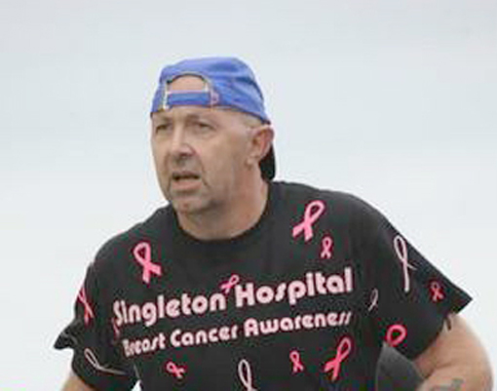
Rob Jones during the Ironman Wales event.

Consultant breast surgeon Marianne Dillon said: “I am extremely grateful for and humbled by Rob’s continued commitment to raise money for the Breast Care Unit in Singleton and can assure him that it will be used to improve patient care and comfort when diagnosed with breast cancer.”

Meanwhile Rob is refusing to take things easy, he has already signed up to continue fundraising at this year’s Ironman.

The event will be another landmark date in significant year for Rob. He is about to leave the army after 32 years to launch a civilian career.

Source: Abertawe Bro Morgannwg University Health Board

