New hub boosts access to community care
Monday, 12 February 2018
Patients are giving the thumbs up to a new health setting in Neath that offers them the specialist care and advice they need nearer their homes.

The Primary Care Hub, which has just opened in a new building off Dyfed Road, is aiming to provide people with easy access to health services in their community, as an alternative to seeing their GP.

Patients are referred to the hub by their doctor, who assesses their needs to see if they need to see a GP face-to-face or would be better off seeing one of the health care professionals at the hub.
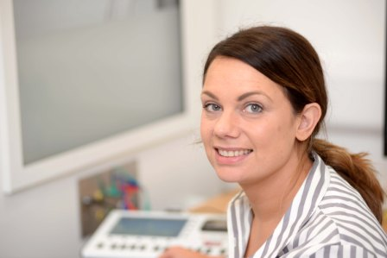
They include audiologists Debra Kelshaw, right, and Suzanne Houghton who treat people with hearing problems, tinnitus, or wax build up. Debra said: “Patients really like the hub because they are seen quickly, within one or two weeks max, and most often the problem can be dealt with here, rather than them having to go to hospital.”

Richard Collins, 52, was treated by Debra after suffering hearing loss. “I rang my GP because I’d gone deaf through wax build up and he sent me here. I am pleased with the service and the staff are great. If I need to see Debra again I can go back and it’s very convenient for me because I only live in Cimla.”

As well as audiology, the centre also offers physiotherapy and mental health support, and more services are in the pipeline.

Rhys Wilkes from Neath was at the hub seeing physiotherapist Alex Tincombe because of a rugby injury to his knee. “I had an operation so I’m trying to get back to fitness. The service here is great so we’ll see how it goes now,” he said.
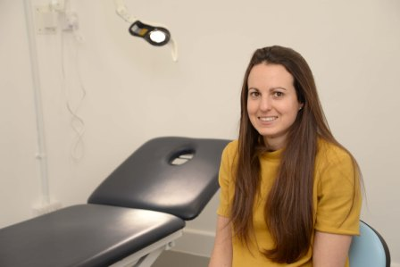
Hannah Williams, right, another specialist physiotherapist at the hub, said: “People prefer to be seen near their own homes. Previously they would have had to travel to Neath Port Talbot Hospital. Now I can see patients within a maximum of a week, and sometimes on the day.”

Carl Dunning, below, a mental health support worker, is also based at the hub where he’s making a big difference to people’s lives by advising them on a wide variety of social and mental health needs.
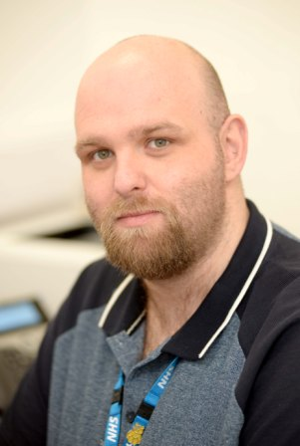
He said: “My role is to help people with low levels of mental health and wellbeing. Lots of patients ring their GP for an appointment when they don’t actually need medicalisation. They may have lost a loved one, be suffering from anxiety or stress at work, or have financial worries.

“They can come and talk to me for an hour and I will signpost them to where they can get the help they need. If they need more, I can refer them back to the GP, but I have to do that in very few cases.”

The Primary Care Hub is also improving communication between the eight Neath surgeries by operating a specialist software system that allows patient information to be updated immediately at the hub to keep GPs informed of the outcomes of the consultations.

On a visit to the hub soon after its opening, Emma Woollett, vice chair of the ABMU health board, welcomed the way the hub was making more efficient use of NHS resources to improve patient care.

“This is such an exciting development,” she said. “With growing demand on the health service, we need to turn the way we think about things on their head and this sort of initiative is key to that.”

The idea of the hub has been evolving since 2016, but the team has only just moved into its brand new home in a dedicated building at the rear of the Dyfed Road surgery in Neath.
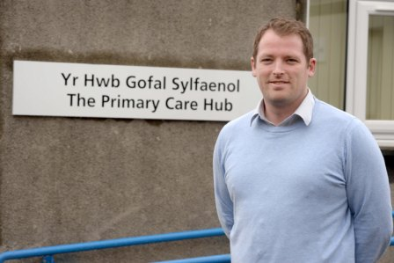
Owain Gimblett, right, operational manager at the hub, said: “Now we are all together under one roof we have got plans and space to expand and we are really keen to get the message out to tell people what we are developing.”

The hub is already making a big difference to the way people access care. Since it was formed in 2016 the physiotherapy team has seen 2,345 people, while the Wellbeing Service has been accessed by 459 people. The audiology service, which was added last July, has seen 448 patients.

The future could see the hub offering services like smoking cessation, counselling, drug and alcohol therapy, podiatry, blood tests, injection therapy and chiropody.

“There is also a big focus on helping patients to better manage their health through effective lifestyle advice,” said Owain. “Our objective is to not only assist with current symptoms, but to help our patients avoid a deterioration of symptoms through better self-care.”

One example of this is how the physiotherapy team is working with staff at Neath Leisure Centre – which is right next door to the hub – to improve patients’ health. Under the National Exercise Referral Scheme, they can send patients to the leisure centre to join a supervised programme of exercise as part of their treatment and recovery.

The hub has also won approval from GPs. Dr Heather Potter, of Skewen Medical Centre, said: “General practice is going through enormous changes with increasing health awareness and health anxiety. There are also increasing pressures from an ageing population, often troubled with chronic illness. All this is impacting on primary care and GP’s are finding it difficult to cope with patient demand.

“We feel there is an increased quality of service by the patient seeing the hub team and there is an add-on benefit in that it leaves more time for the GP to spend on diagnosing complex medical illness.”

The Neath-based hub has been such a success that that the model is being considered for further expansion within the Abertawe Bro Morgannwg University Health Board area.

“We are transforming the way we deliver services and this idea has seen positive benefits. We’ve tested it and we know it makes a difference,” said Kate Kinsman, GP cluster development manager.

“We will add to the services provided and we plan to invite more partners to be part of this innovation. Now we want to open a dialogue with patients so that people quickly become aware of the hub and it purpose.”

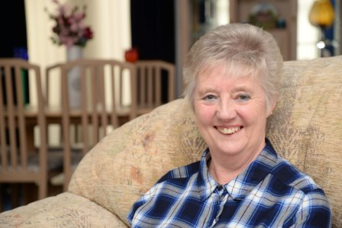
Once they do, the new approach is an immediate hit with patients. Margaret Phillips from Neath was at the hub seeing an audiologist to have a possible ear infection checked out.

She said: “I live up the road from here so it’s marvelous. It’s lovely here, so convenient. Much better than having to go to hospital.”

Notes:

The eight Neath surgeries involved in this scheme are: Alfred Street; Victoria Gardens; Skewen; Tabernacle; Briton Ferry (two practices); Dyfed Road and Castle Surgery.

https://www.youtube.com/watch?v=NuitM2CPiLI

Source: Abertawe Bro Morgannwg University Health Board

