Royal celebration for Morriston Hospital League of Friends
Friday, 23 February 2018
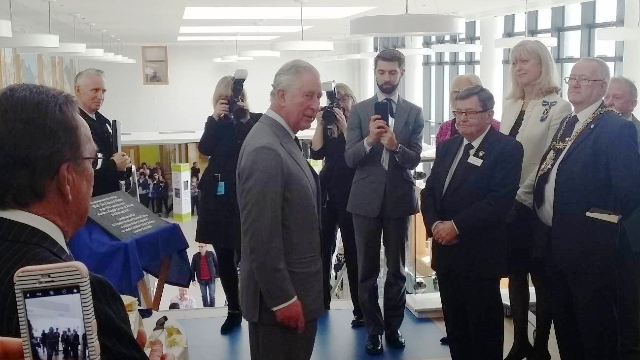
Morriston Hospital’s dedicated League of Friends has been given the royal seal of approval as it celebrates its 75th anniversary.
Morriston Hospital’s dedicated League of Friends has been given the royal seal of approval as it celebrates its 75th anniversary.

Prince Charles paid a special visit to the hospital to meet the team and get a close-up look at some of the equipment and services their hard work has paid for.

His Royal Highness also chatted to staff, volunteers and patients in the hospital’s outpatients department and education centre.

Patient Denzel Lewis, aged 88, from Skewen was there with his granddaughter Melanie Hitchings. The pair were delighted when the prince stopped to say hello.

Mr Lewis said afterwards: “He asked was I visiting or here as a patient, and I said I was here to have my wound checked and then staying for lunch.”

Melanie added: “It was so lovely that Prince Charles took the time to stop and say hello.”

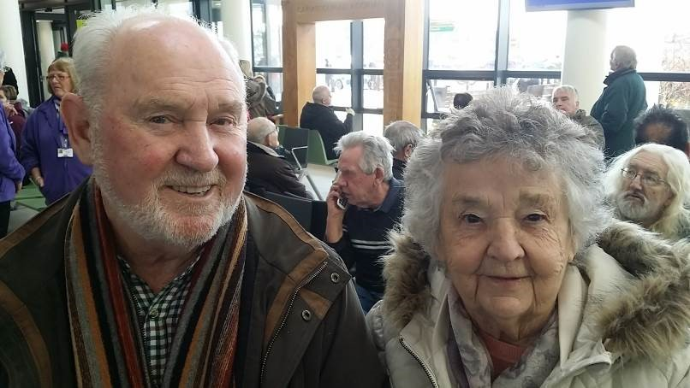
Outpatient Derek Hopkins and his wife, Gwyneth (pictured right), both aged 84, from Morriston, also met the prince.

“We had quite a surprise to turn up and see him here,” said Mrs Hopkins.

“He asked us how long we’d been married and I told him 61 years, and he said I must be looking after him alright!”

Mr Hopkins said: “He asked if we came here often, and I said we did, and that it was a fantastic hospital.”
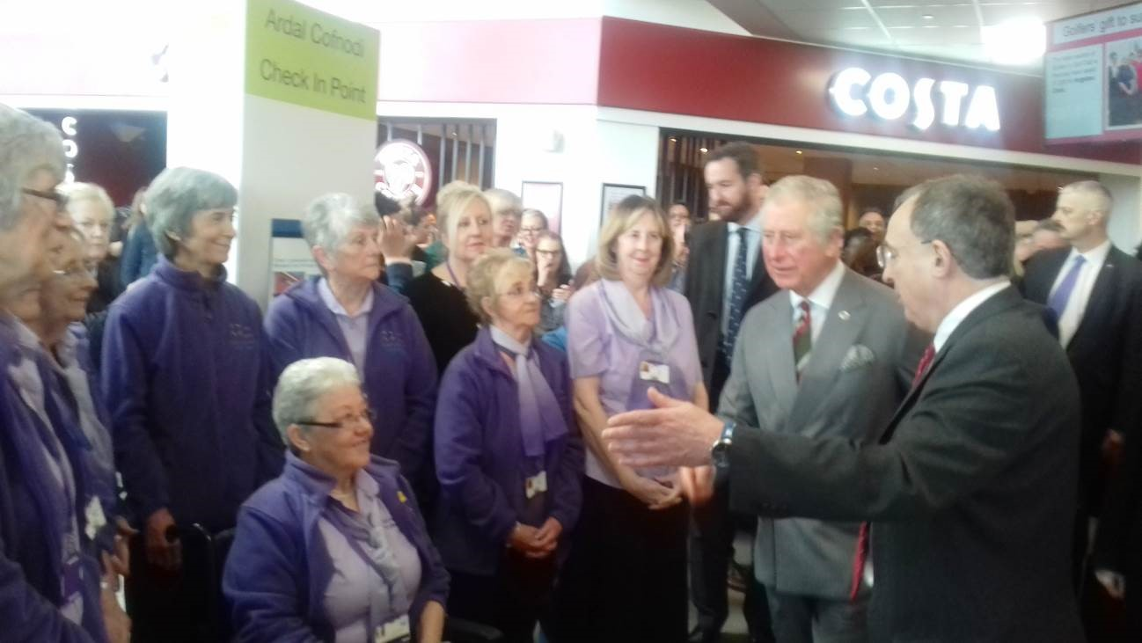
Outpatient volunteers also met Prince Charles, including Brenda Broad, the hospital’s longest serving volunteer.

“He asked me how long I had been a volunteer here and I told him 28 years,” she said.

Fellow volunteer Ann Harrison said; “He was so lovely to talk to. He said we looked very smart in our uniforms.”

During the visit the Prince also met the health board’s Chief Executive, Tracy Myhill and Chairman, Andrew Davies. He also met Morriston Hospital Nurse Director Nicola Williams and Medical Director Mark Ramsey, along with other clinical and managerial staff.

However the focus of the day was on Morriston League of Friends. The Prince cut an anniversary birthday cake, and unveiled a plaque to mark the occasion. He was also presented with a League of Friends badge.

Now the oldest hospital league in the UK, over the years the group has been responsible for raising a remarkable £2,100,000 which has gone directly into supporting patient care.

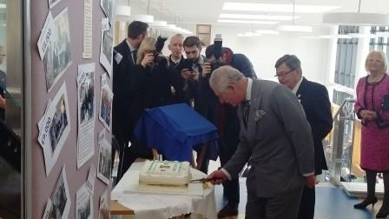
Pre-dating the NHS, it was established to provide film shows and concerts for wounded servicemen and the very first pieces of equipment it bought were headphones for each hospital bed.

Now its seven stalwart volunteers, many with close family connections to the League’s earliest members, carry on the tradition of caring for patients.

The members told him about their fundraising activities, including a popular annual golf tournament, craft fairs, cake and Christmas card sales, which all help to buy vital equipment for departments across Morriston.

The League has also provided a small Christmas present for every patient and member of staff for more than 60 years and it is a tradition the members are proud to continue.

They are responsible for providing accommodation for families so they can stay on site close to their loved ones as well as transporting patients in wheelchairs/beds to weekly services in the hospital’s multi-faith centre.
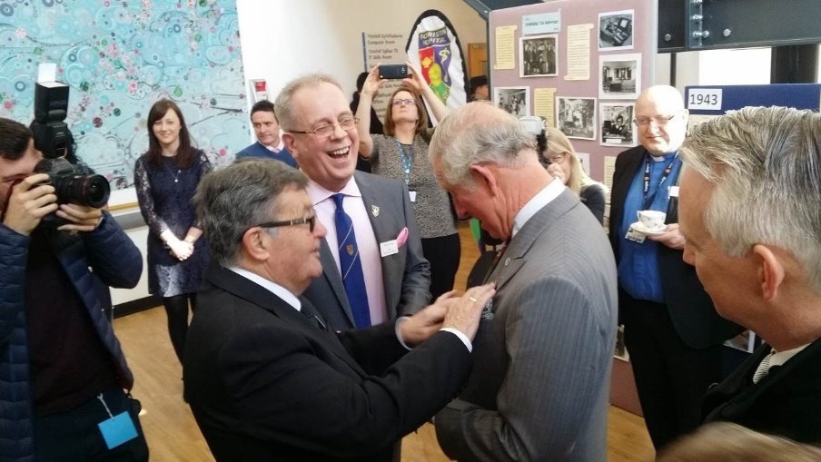
Among those welcoming the Prince was League chairman John Hughes, whose father William Randall Hughes was a founder member back in 1943.

Mr Hughes said: “We are so honoured and very grateful that His Royal Highness found time to come and find out more about our work here at Morriston.

“We are now only a small group but we are very proud of everything that the League has been able to achieve over the decades.

“Our aim has always been to do whatever we can to help the patients. Morriston Hospital remains such an important part of our community and our dedication to support it is as strong now as it was 75 years ago.”

Morriston Hospital Medical Director Dr Mark Ramsey added: “The dedication and support of the League of Friends and their fundraising has been incredible. The impact their donations have made over the decades cannot be underestimated.

“We were so pleased to have welcomed Prince Charles and given him the opportunity to see why our League is so special.”

If you would like to help continue the League of Friends’ work, the committee meets bi-monthly on the first Wednesday and would welcome new members.

Contact Douglas Thomas on 07957 494958 if you are interested in finding out more.
Source: Abertawe Bro Morgannwg University Health Board

