State-of-the-art GP surgery set to open in Swansea in March
Wednesday, 7 February 2018
A state-of-the-art new GP surgery is on target to open its doors to patients in Swansea by the end of next month.

A state-of-the-art new GP surgery is on target to open its doors to patients in Swansea by the end of next month.


The surgery in Mayhill is part of a wider complex, which also includes a pharmacy and family centre.

Pictured during a visit to the new surgery are (l-r) Jonathan Parker, ABMU Primary Care Estates Manager; ABMU Head of Primary Care, Swansea, Sharon Miller; ABMU Chairman Andrew Davies; and Ashley House Head of Design Mark Giles

It will replace the existing Mayhill Surgery, which does not meet modern standards and is too small to allow for any future expansion.

Work is now nearing completion on the complex on Mayhill Road. It will be twice the size of the current surgery, a former residential property on nearby Pen-y-Graig Road.

Features include four ground-floor consulting rooms and a further two on the first floor; two treatment rooms; a phlebotomy room; reception; waiting areas; offices; and associated staff rooms.

The GPs have agreed to name it Mountain View Health Centre.

Practice manager Julie Hayes said: “We will be moving to a much larger building, doubling up in size of our existing practice.

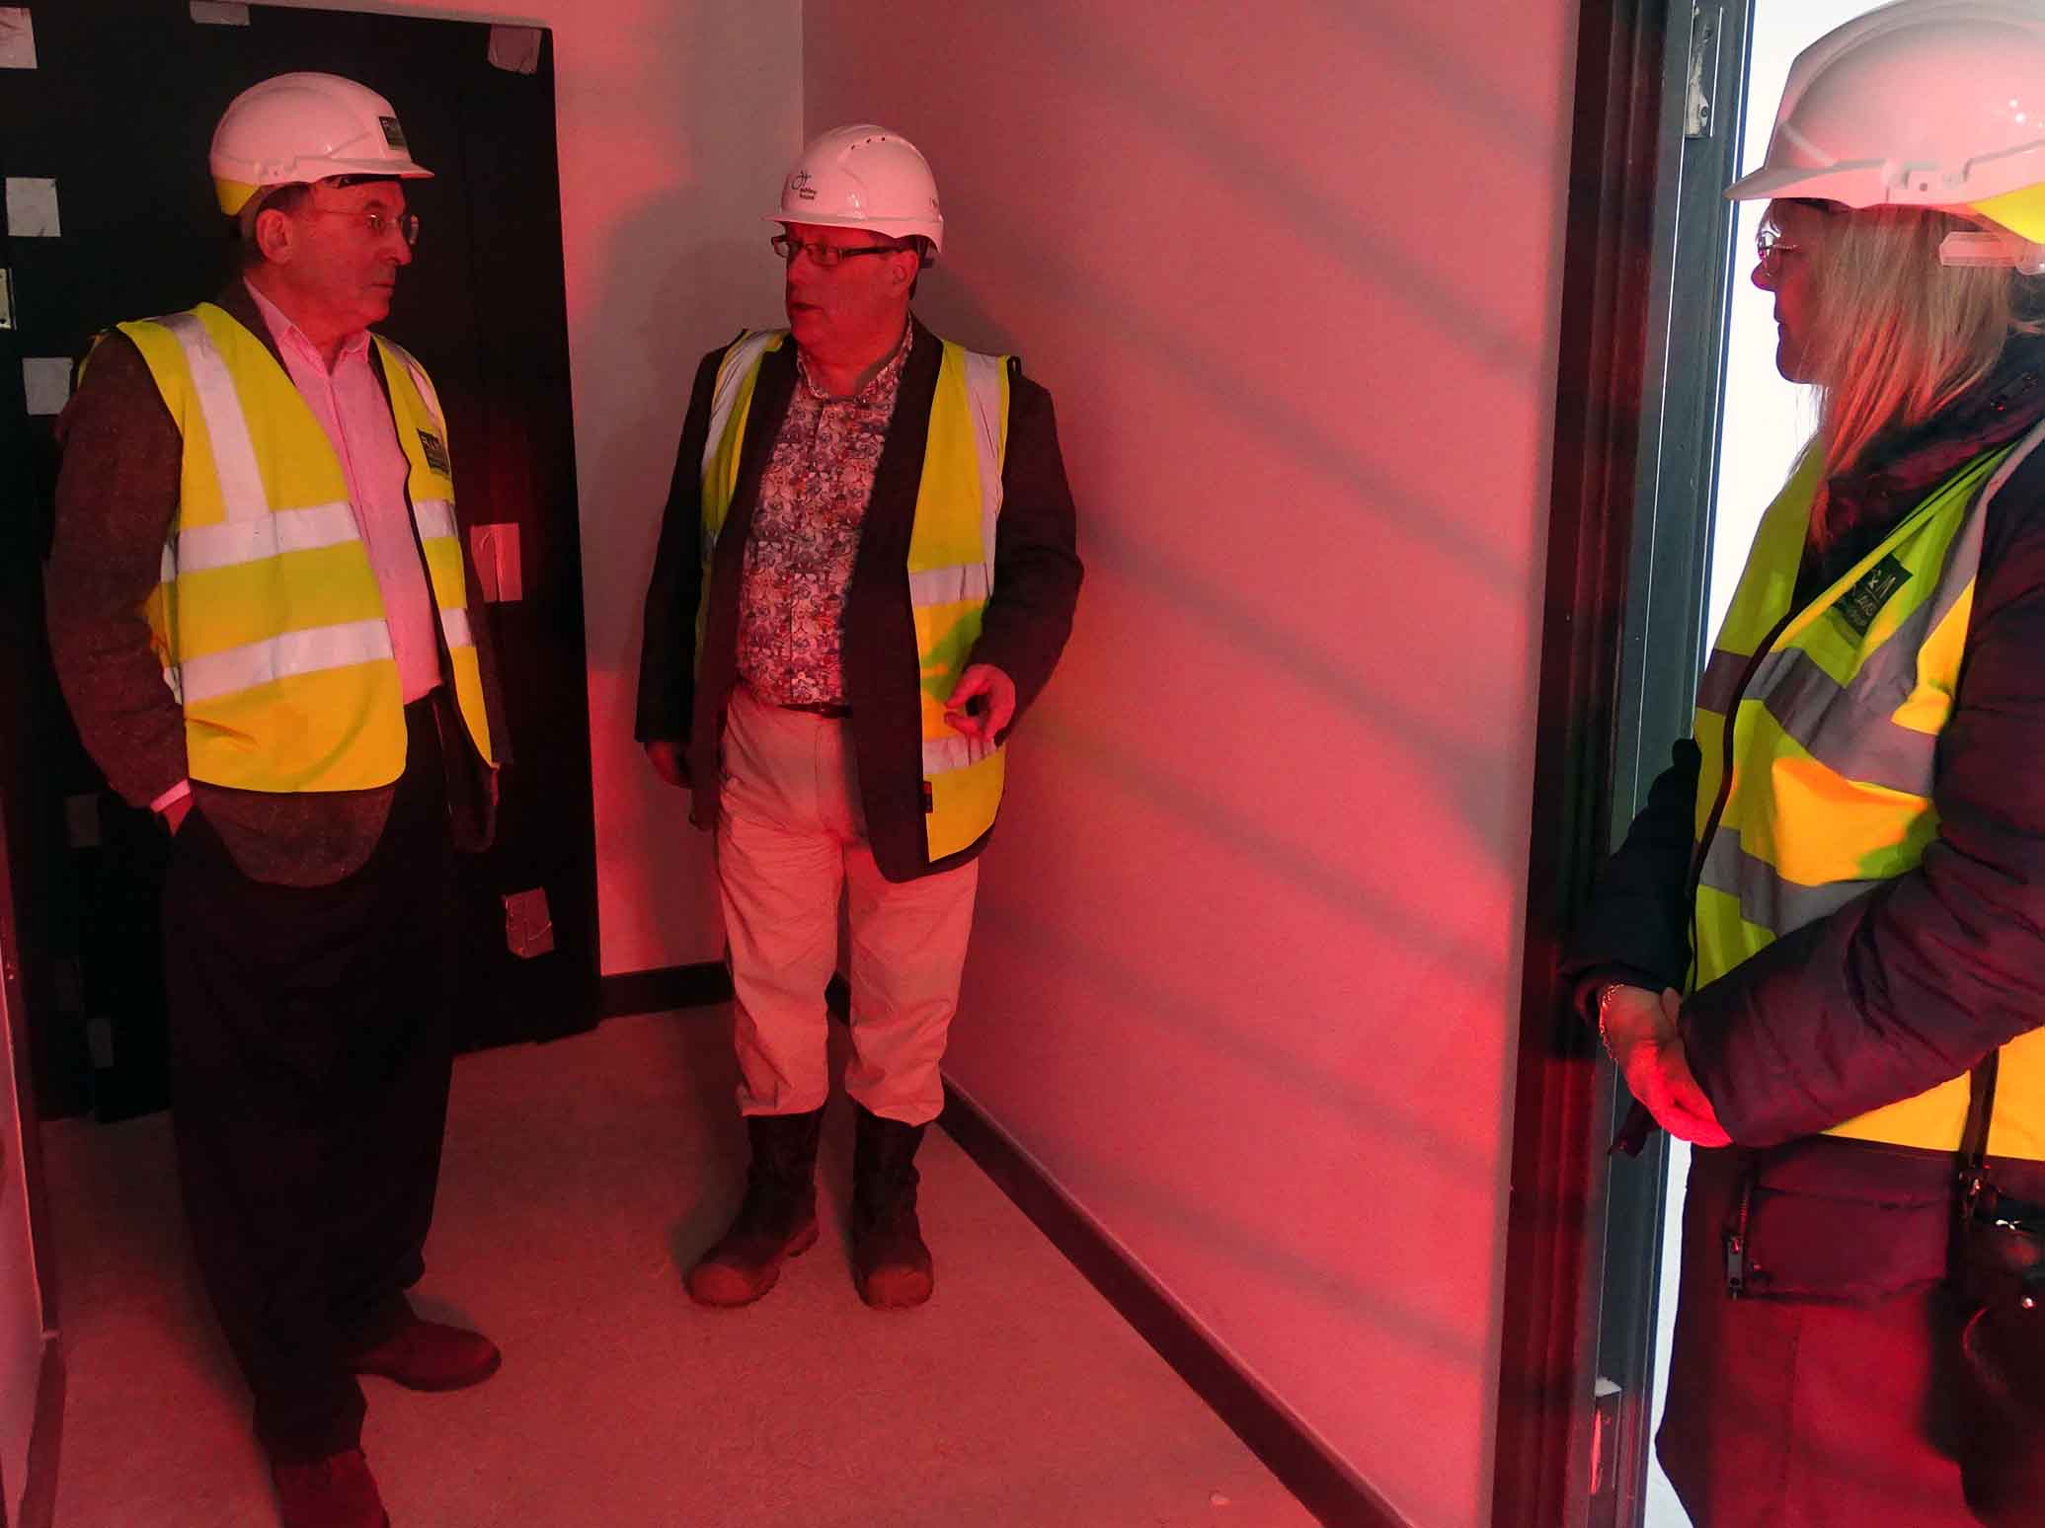
“We will have a facility with the extra space to offer more services to our patients in the future.

“The GPs and staff are very excited and looking forward to this move.”

The new complex is the first of its kind in Wales. It is being delivered in partnership by ABMU Health Board and Swansea Council.

ABMU is providing funding for the GP surgery part of the scheme, while the Welsh Government is contributing £567,000 towards the family centre element of the project.

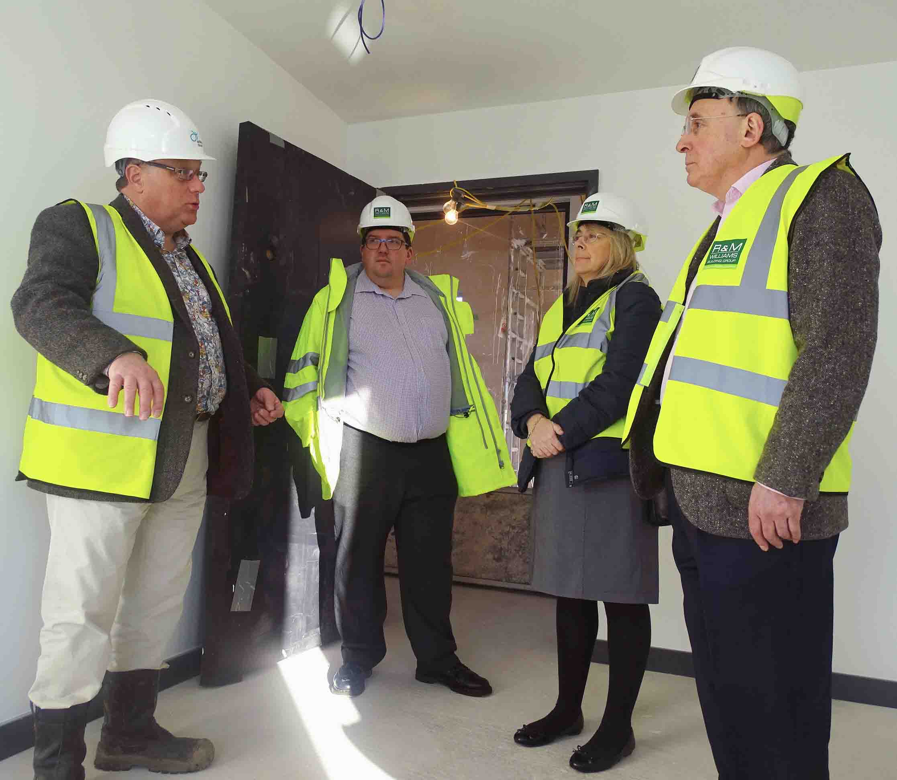
ABMU’s Head of Primary Care for Swansea, Sharon Miller, said: “We are delighted with this development in the Mayhill community.

“We look forward to working in partnership across agencies to provide the best level of care and services.”

Health and social care specialist Ashley House is developing the new complex, which will replace the existing family centre on Mayhill Road as well as the Mayhill GP Surgery.

The building is due to be handed over on March 12th, which will be followed by a two-week commissioning period ready for the surgery to open on March 26th.

ABMU Chairman Andrew Davies said: “This is about providing excellent services for the community and for local families.

“It is another example of collaborative working between the health board and local authority, providing first-class services in state-of-the-art facilities.”
Source: Abertawe Bro Morgannwg University Health Board

