Welsh sculpture unveiling is ABMU's first event to mark the NHS at 70
Monday, 5 February 2018
Music, poetry and storytelling gave ABMU’s first event to mark the 70th anniversary of the NHS a distinctly Welsh flavour.

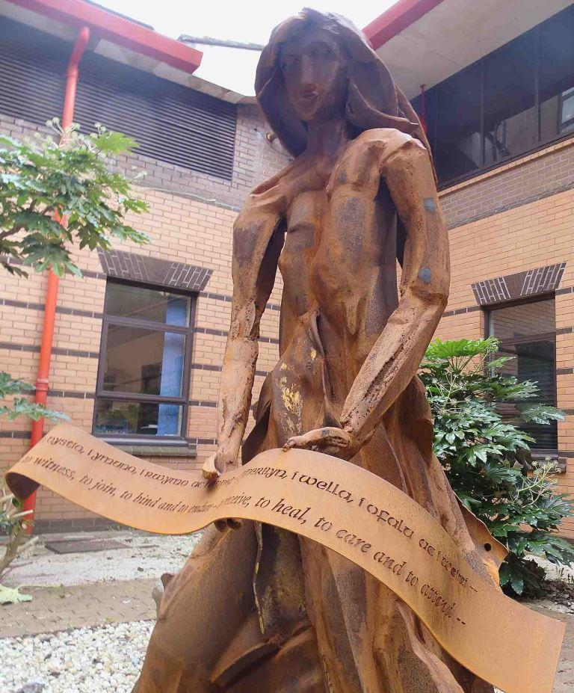
It saw the unveiling of a visually stunning sculpture in a courtyard at Morriston Hospital’s Welsh Centre for Burns and Plastic Surgery.

The rusting steel sculpture, the Lady of Llyn y Fan Fach, uses the themes of regeneration and healing.

It was inspired by the Lady of the Lake from Welsh mythology and embodies the close relationship between the centre and Port Talbot’s steelworks.

The sculpture, created by West Wales-based artist Sarah Tombs, was paid for by Community, the principal trade union at Port Talbot steelworks, using materials donated by Tata Steel.

The longstanding link between healthcare provision and industry in South Wales is being highlighted by a specially-created miners’ lamp, which will be the symbol of ABMU’s celebrations throughout the anniversary year.

In 2014, the Welsh Centre for Burns and Plastic Surgery celebrated its own landmark anniversary – 20 years since the service moved from St Lawrence Hospital in Chepstow to a purpose-built site in Morriston.

Consultant burns and plastic surgeon Bill Dickson, who retired in 2015, was one of the original members of staff who transferred from Chepstow.

Mr Dickson, among the guests at the sculpture unveiling, recalled: “The reason the service moved was because St Lawrence was a single-specialty hospital.

“It had plastic surgeons and maxillofacial surgeons. If you wanted a medical opinion you had to seek it from other hospitals.

“Linking the service to a large district general hospital with a whole number of other medical, surgical and paediatric disciplines has certainly been hugely beneficial in terms of patient care.”

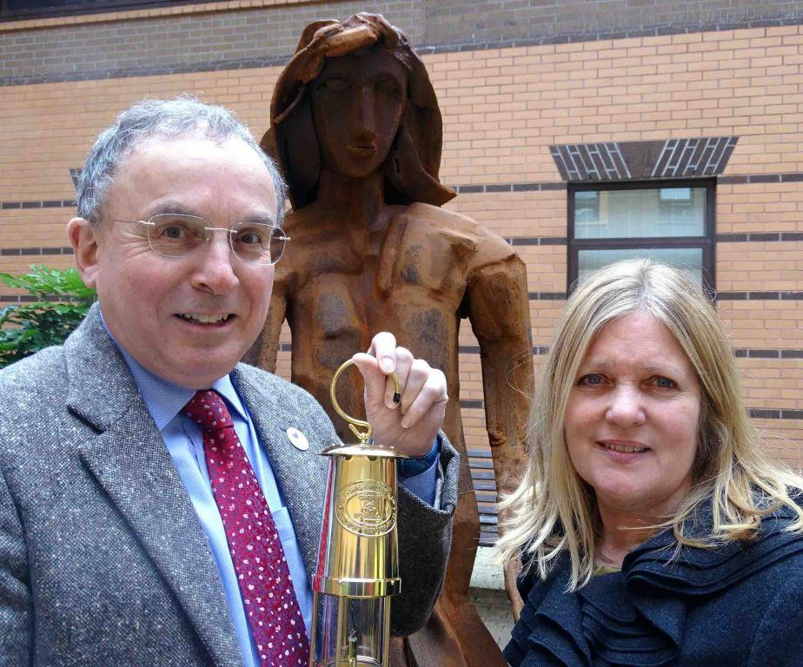
The centre started with six consultants in 1994. Today it has 17, along with an array of specialist clinicians including anaesthetists, nurses, physiotherapists, occupational therapists, psychologists and support staff.

It provides a service for the people of South, Mid and West Wales – and beyond.

Right: ABMU Chairman Andrew Davies, with the NHS at 70 commemorative lamp, and artist Sarah Tombs

In 2010 it was designated the adult burn centre for the South West UK Burns Network, responsible for a population of 10 million as far afield as Aberystwyth, Portsmouth and Oxford.

Although the team treats children with quite severe burns, those with more extensive injuries are transferred to a specialist facility in Bristol.

The Welsh centre’s director, consultant burns and plastics surgeon Peter Drew, said the number of serious burns – particularly those involving children – and major industrial accidents had decreased.

“There are fewer patients but we can do more for them. They are surviving with very extensive burns – we recently treated a patient with 90 per cent burns who is doing very well.

“Compared to Chepstow we have much more advanced intensive care input, which I think is what has made the difference. We also have access to donor skin, which is a huge benefit for patients.

“Medicine and science have moved on, and our understanding of wound infection and microbiology now is much better. The outcome for patients with serious burns has vastly improved.”

Although the centre has links with industries across the region, providing advice and information, and treating any injuries, it has a particularly close relationship with the Port Talbot steelworks.

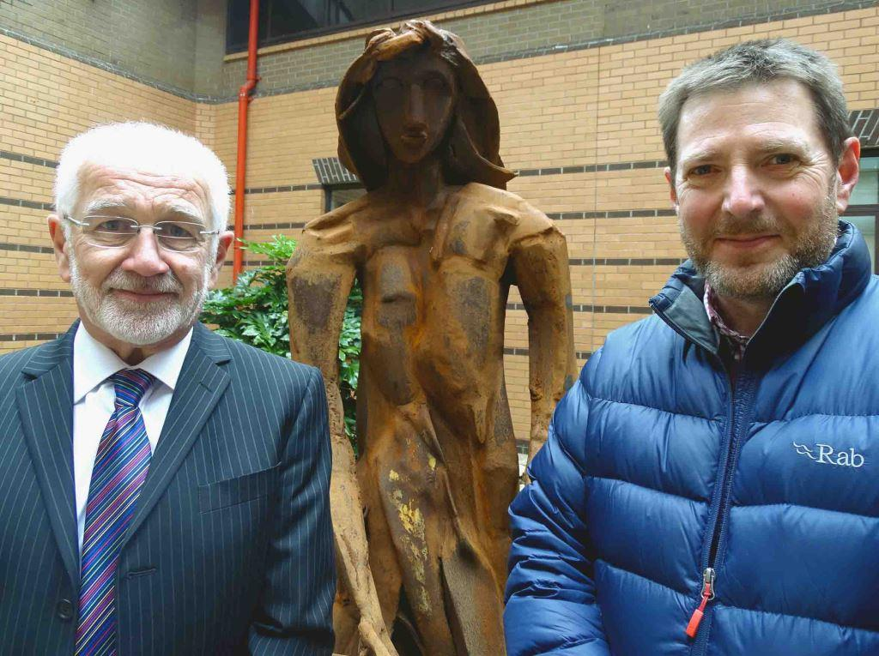
The sculpture launch featured music, a poem by William Ayot, which was developed with contributions from Port Talbot steelworkers, and a tale from storyteller David Ambrose.

Bill Dickson (left) and Peter Drew
He recounted the legend of The Lady of Llyn y Fan Fach, mother of the Physicians of Myddfai who used herbs and magical powers to heal. The story was originally told in The Mabinogion and The Red Book of Hergest.

Sarah Tombs spent around 18 months working on the sculpture, deciding to leave it to rust. “I wanted the steel to come through and oxidisation is a natural process,” she explained.

“It’s softer and less industrial than something that has been galvanised or painted. It will change as time passes and I like that too.”

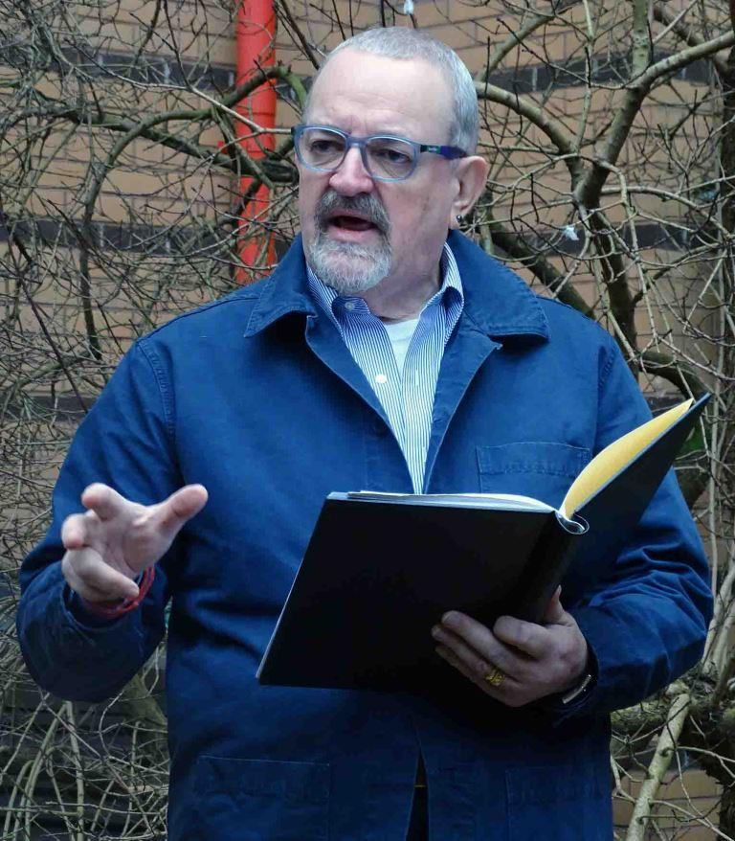
Alan Coombs, of Community in Port Talbot, said: “We are proud to be supporters of the Welsh Centre for Burns and Plastic Surgery at Morriston Hospital.

“This sculpture represents the close ties we have with the centre, which provides an essential service to the community and is a leader in its field.”
Tata Steel’s Community Liaison Manager, Wales, Lucy James said: “We have had a close relationship with the centre for many years.

“We are delighted to have been able to work in partnership with our colleagues in Community and with ABMU in the creation of the Lady of Llyn y Fan Fach in recognition of this.

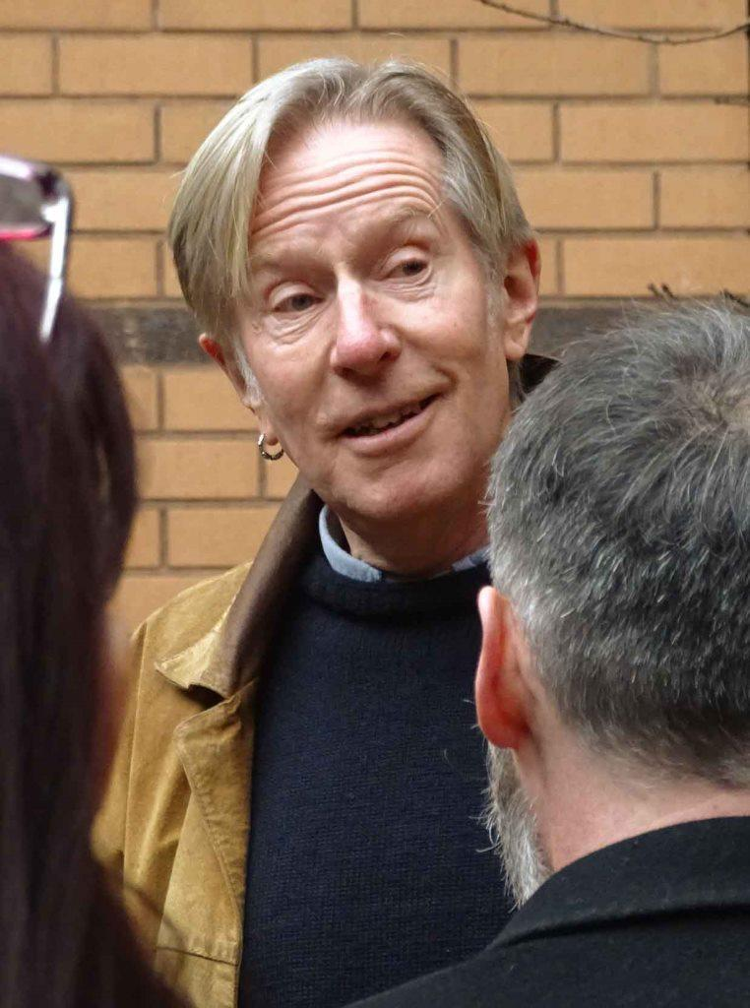
“With the NHS celebrating its 70th birthday this year, we continue to be grateful for the care, support and clinical expertise our NHS service provides to our employees and local communities.”

Left: David Ambrose and (right) William Ayot

ABMU Chairman Andrew Davies came up with the original idea for the sculpture some years ago, and was supported by then-Aberavon MP Hywel Francis in making it a reality.

Professor Davies said: “The sculpture is a reminder of the origins of the NHS but also that injuries and death in industry, while reduced, are something we still have to deal with.

“That is why the Welsh Centre for Burns and Plastic Surgery is crucial to this region.

“It is a global centre of excellence that has put Morriston on the map for world-class, cutting-edge treatment and research.”
Source: Abertawe Bro Morgannwg University Health Board

