Youth panel picks up top honour just 11 months after launch
Monday, 12 February 2018
ABMyouth, the first youth health advisory panel in Wales, is celebrating after scooping a high-profile award for its groundbreaking mission.

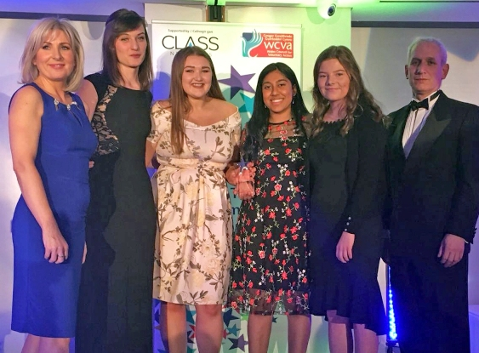
The panel, made up of youngsters aged from 14 to 24 was named joint winner in the Health, Social Care and Wellbeing category at the Third Sector Awards Cymru 2017.

ABMyouth’s Sophie Millar, Catrin Davies, Aisha Peerbaccus and Sheona Thomas at the awards.

Judges were impressed by ABMyouth’s aim to help the health board develop and improve its services for young people and to highlight different issues from a child’s perspective.

Receiving the award chair Sophie Millar, who was accompanied to the ceremony in Cardiff by Catrin Davies, Aisha Peerbaccus and Sheona Thomas, said ABMyouth was honoured to have been recognised among so many other worthy entries.

It shared the award with Carmarthenshire People First, an organisation which supports adults with learning disabilities.

The award is the highlight of what has been a remarkable 11 months for the group. It was launched in March 2017 at the same time as ABMU unveiled its pioneering Children’s Rights Charter which sets out the basic rights children and young people can expect when they use health services.

Head of nursing neonatal and children’s services Eirlys Thomas and paediatric patient experience nurse Janette Williams came up with the idea of creating a panel made up of youngsters from across Swansea, Neath Port Talbot and Bridgend.

Since then, with support and guidance from Neath Port Talbot Children’s Rights Unit, the now 20-strong panel has drawn up a constitution, designed its own logo and developed a work plan.

Its members have also held talks with Welsh Health Secretary Vaughan Gething about their plans to play a key role in shaping care for the future.
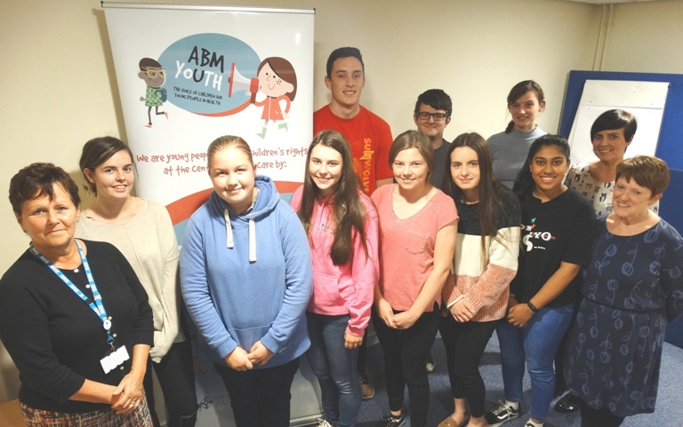
Members of ABMyouth with (left) paediatric patient experience nurse Janette Williams, project coordinator for the Children’s Rights Unit Jannine Smith (second right) and head of nursing, women and child health Eirlys Thomas (right).

A delighted Sophie said: “Winning this award is such an honour. It was a lovely event and we were pleased to be a part of it.

“We really feel that young people are an untapped resource. We can bring enthusiasm and new ideas and are so grateful that ABMU staff have been so open to working with us.

“This award has really made us even more eager to continue our work and look for new projects to get involved with.”

Eirlys Thomas said: “We are very proud of ABMyouth’s success at the awards.

“We can’t make positive changes or improve our care unless we find out what young people really think of us, that is why this panel is so vital to us.

“To have its work recognised at such a high-profile event really shows how important its role is and how lucky we are to have it.”
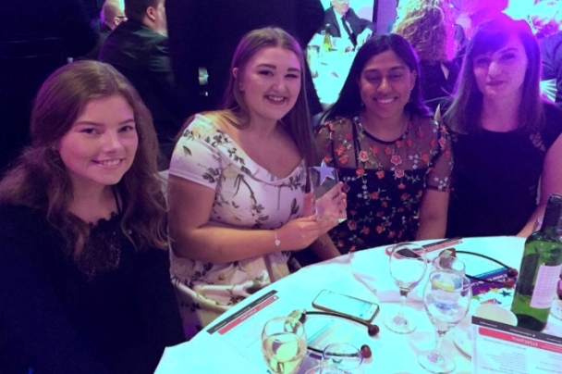
Sheona Thomas, vice-chair Catrin Davies, Aisha Peerbaccus and chair Sophie Millar at the awards

The panel, which has just launched its own website, is turning its attention to developing a questionnaire specifically for younger hospital patients, interviewing patients about their personal experiences and continuing to take part in 15 Steps Challenges. These see them giving staff a child’s-eye view of what they encounter when they first walk – 15 steps – onto a hospital ward.

Find out more about the group at www.abmyouth.wales

.

Source: Abertawe Bro Morgannwg University Health Board

